**IMAGES AND OPTICAL INSTRUMENTS**

**Exercises**

**Section 31.1 Images with Mirrors**

**17. Interpret** This problem is about image formation in a plane mirror. We are to find the angle at which the mirror should be inclined so that it is possible to see one’s feet when standing 50 cm from the mirror’s base.

**Develop** Consider the sketch below. A small mirror (*M*) on the floor intercepts rays coming from a customer’s shoes (*O*), which are traveling nearly parallel to the floor. The angle to the customer’s eye (*E*) from the mirror is twice the angle of reflection *α*, so

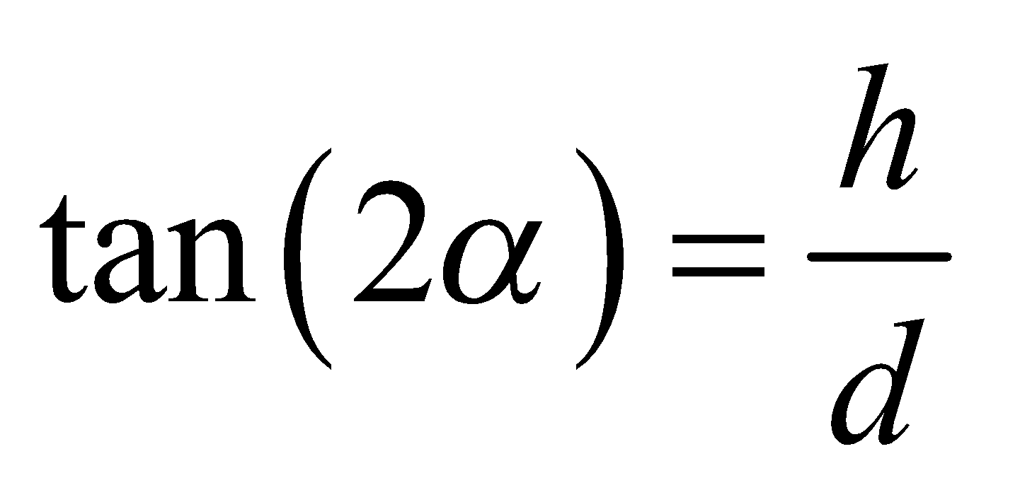



**Evaluate** Solving for the angle *α*, we find

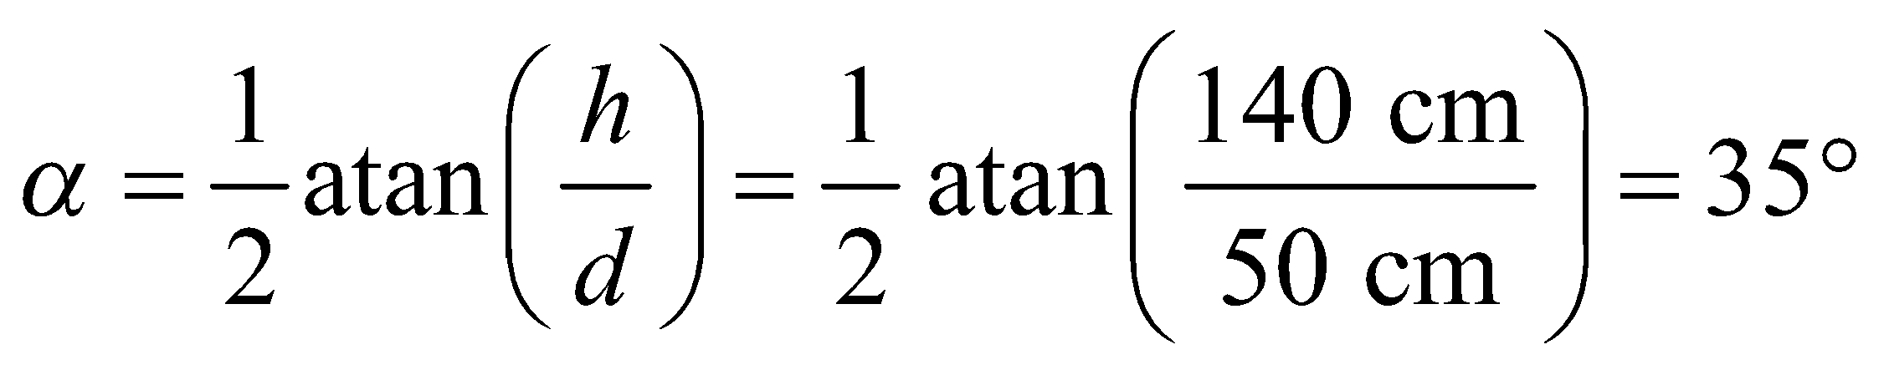

for the given distances. Therefore, the plane of the mirror should be tilted by 35° from the vertical to provide the customer with a floor-level view of her shoes.

**Assess** The angle decreases if *d* is increased, and vice versa. This is consistent with common experience.

**18.** **Interpret** We are to analyze optical properties of a concave mirror by finding its image, comparing the image and object sizes, and determining if the image is real or virtual.

**Develop** Apply the mirror equation (Equation 31.2, 1/*s* + 1/*s*′ = 1/*f*) to find the image distance *s*′. The object distance is *s* = 36 cm and the focal length is *f* = 15 cm. To compare the image and object size, use Equation 31.1 M = −s′/s, to find the magnification, which is the ratio of the image to object size.

**Evaluate** **(a)** The image distance is

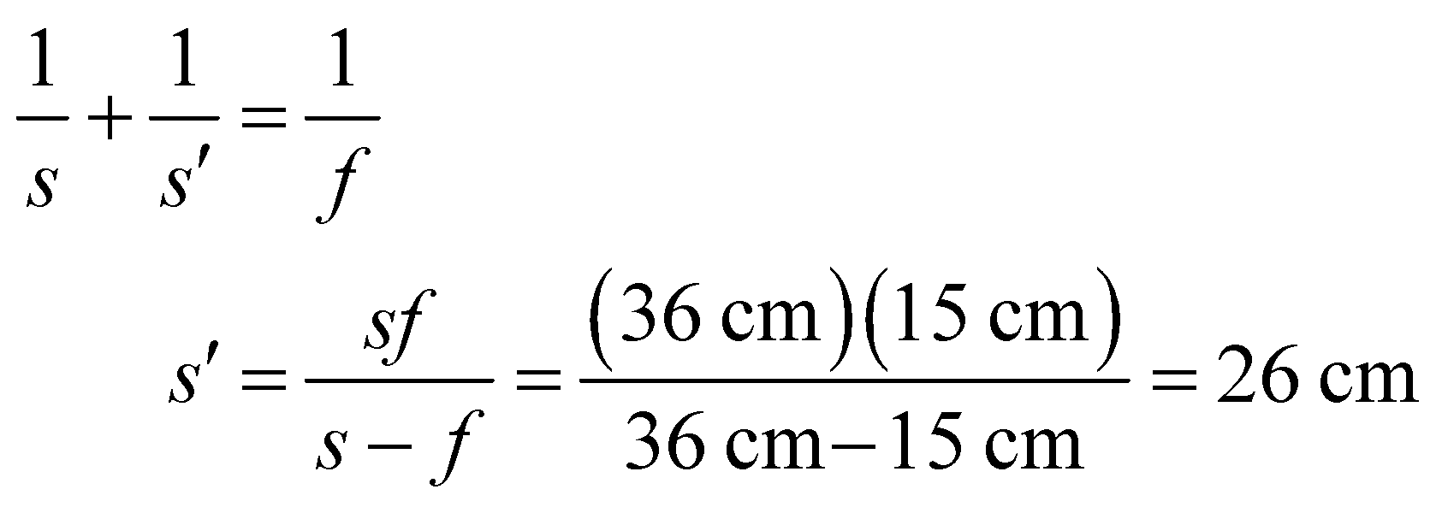

**(b)** The magnification (Equation 31.1) is  (the image is reduced in size and inverted).

**(c)** Since s′ > 0, the image is real.

**Assess** Ray tracing, as in Table 31.1, confirms these conclusions.

**19. Interpret** This problem involves image formation by a concave mirror. We want to know the orientation of the image as well as its height compared to the object.

**Develop** The magnification *M*, which is the ratio of the image height *h*′ to object height *h*, is given by Equation 31.1:

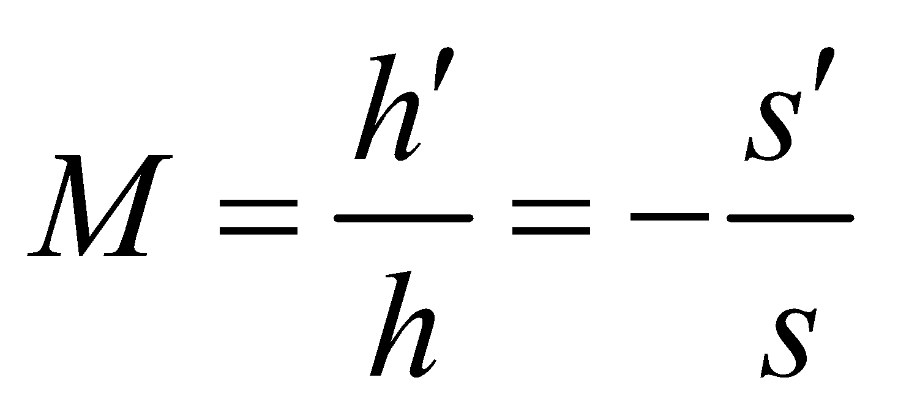

where *s* and *s*′ are object and image distances to the mirror. The two quantities *s* and *s*′ are related by the mirror equation (Equation 31.2):

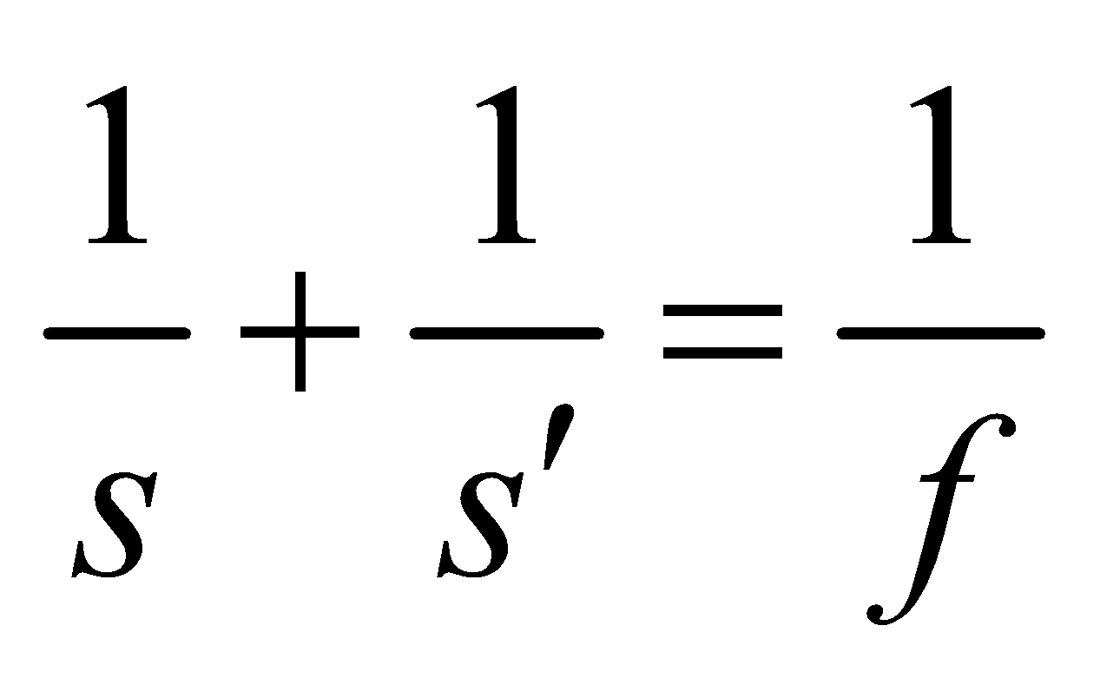

where *f* is the focal length of the mirror.

**Evaluate** **(a)** One can solve Equation 31.2 for *s*′ and substitute the result into Equation 31.1 to find

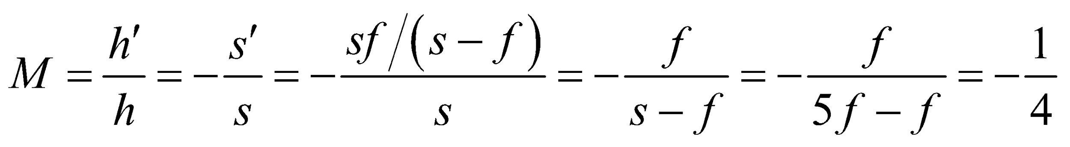

**(b)** A negative magnification applies to a real, inverted image.

**Assess** The situation corresponds to the first case shown in Table 31.1. From the ray diagram, we see that the image is real, inverted, and reduced in size. Since *s*′ > 0, the image is in front of the mirror.

**20.** **Interpret** We are to find the object distance and the magnification for a concanve mirror with a virtual image 40 cm behind the mirror.

**Develop** Apply the mirror equation (Equation 31.2) to find the object distance and Equation 31.1 to find the magnification.

**Evaluate** **(a)** The mirror equation gives , so the object is located 12 cm in front of the mirror.

**(b)** Equation 31.1 gives 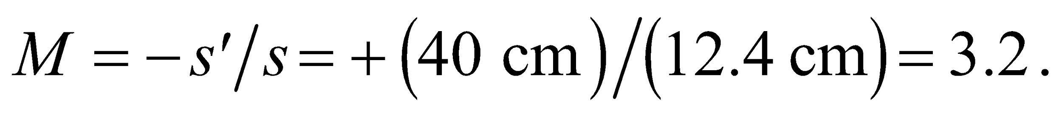

**Assess** The fact that *s* > 0 tells us the object is in front of the mirror and the fact that *M* > 0 means the image is not inverted.

**21. Interpret** This problem is about image formation in a concave mirror. We want to find the object distance needed to form a full-size image.

**Develop** The magnification *M*, the ratio of the image height *h*′ to object height *h*, is given by Equation 31.1:



where *s* and *s*′ are object and image distances to the mirror. A full-size image means that 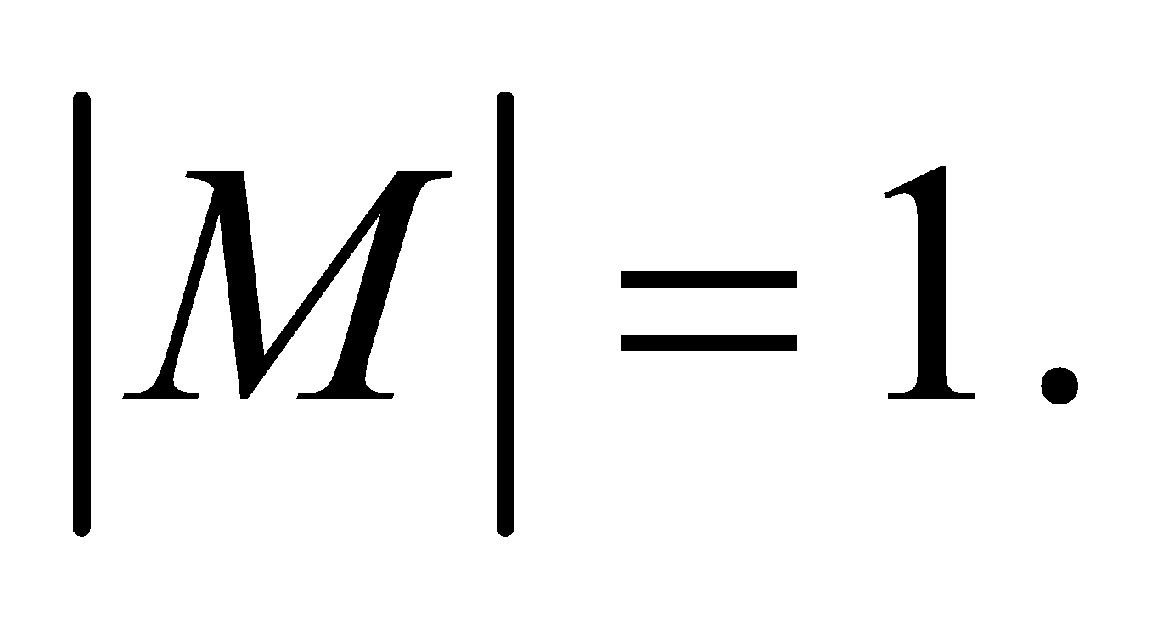

**Evaluate** **(a)** For a full-sized image, we require

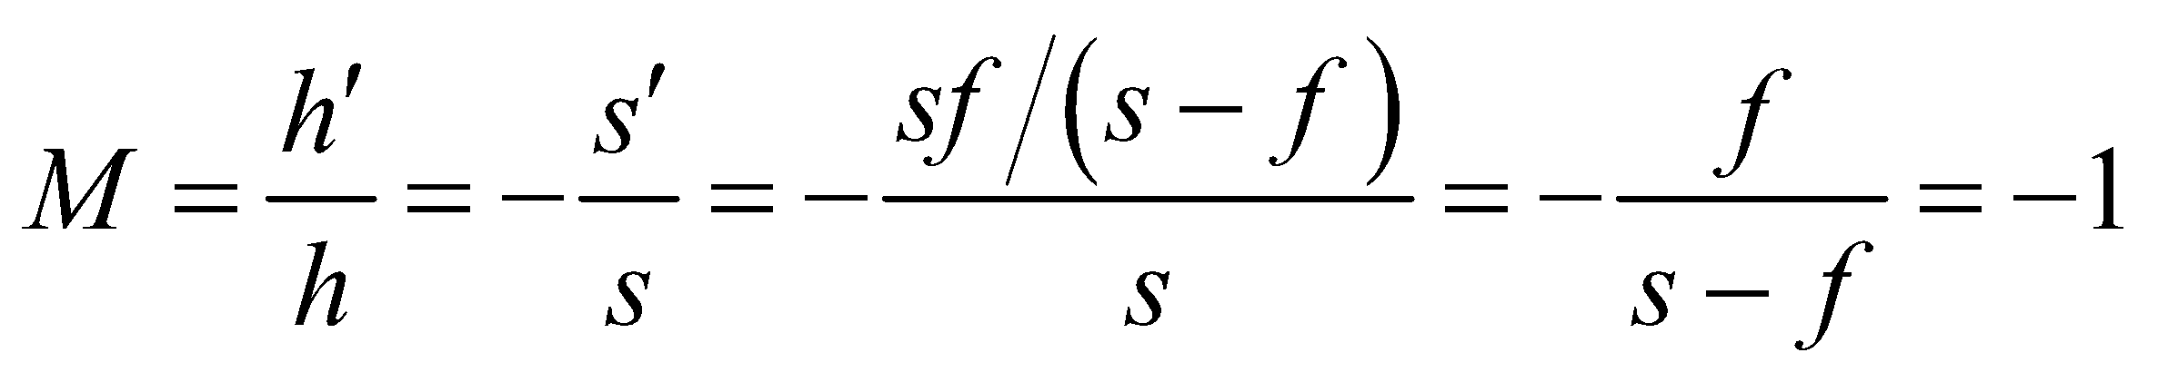

or 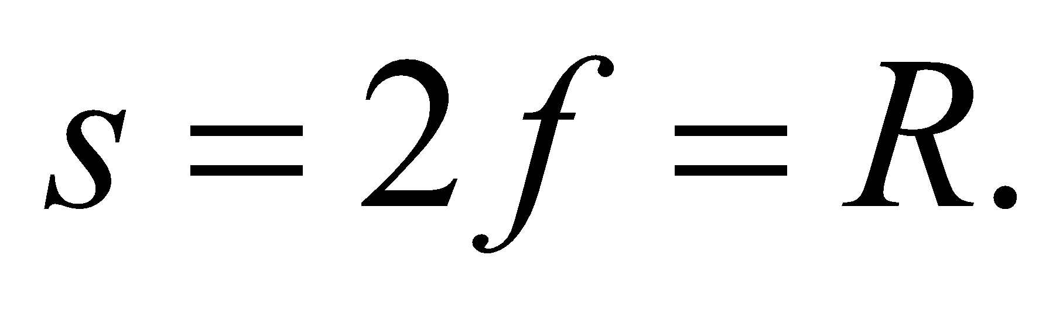 That is, put the object at the center of curvature of the mirror (or at twice its focal length).

**(b)** From Equation 31.2, we have

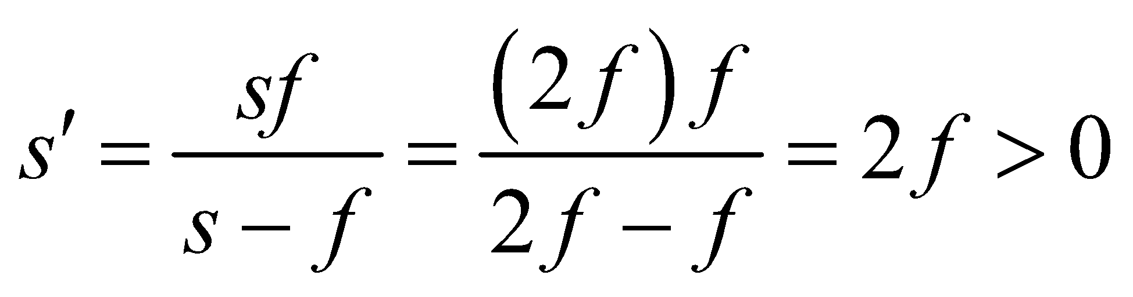

Thus, the image is real.

**Assess** For a spherical mirror, 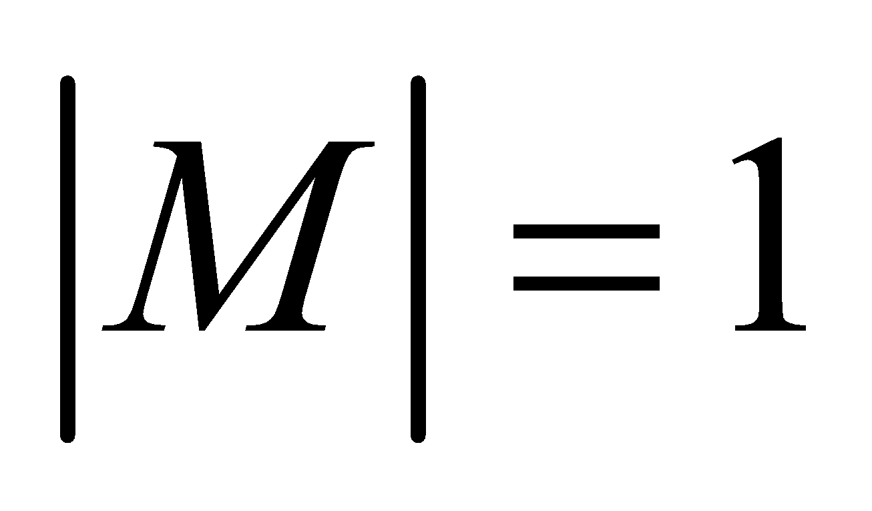 applies only to a real image, *h*′ = −*h* unless one accepts the plane mirror, which has 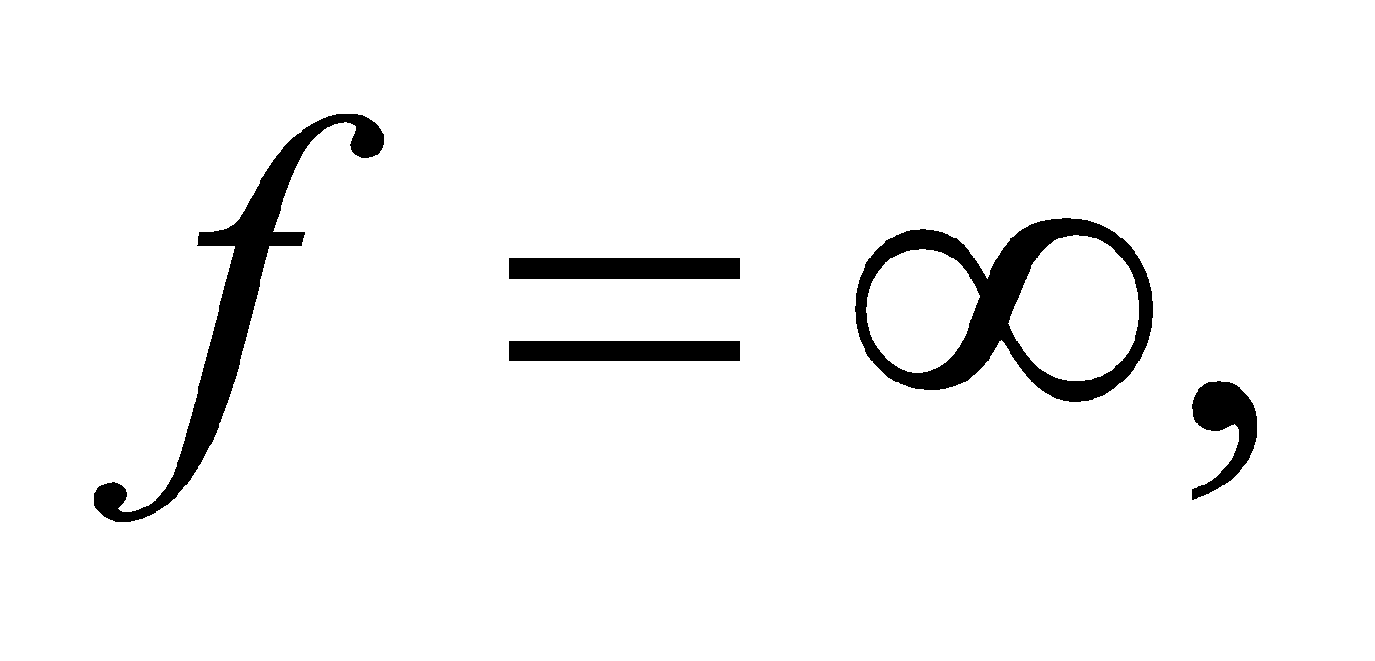 as a special case.

**Section 31.2 Images with Lenses**

**22.** **Interpret** This problem involves finding the focal length and the magnification of a convex lens.

**Develop** Apply the lens equation (Equation 31.5) and solve for the focal length *f*. The magnification may be found using Equation 31.4.

**Evaluate** **(a)** The focal length is

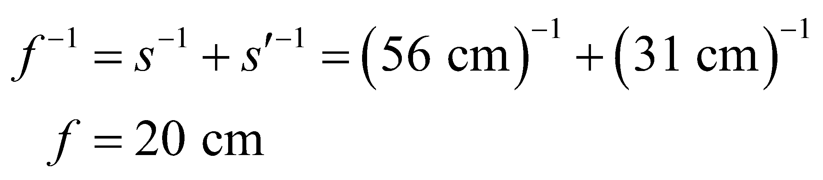

**(b)** Equation 31.4 gives a magnification of 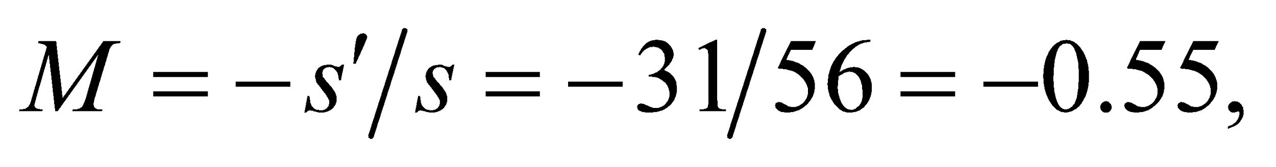 so the inverted image is reduced to approximately 55%.

**Assess** Because the magnification is negative, the image is inverted.

**23. Interpret** This is an image-formation problem involving a converging lens. We want to find the magnification as well as the orientation of the image.

**Develop** The magnification of a thin lens, for paraxial rays, is given by Equation 31.4,

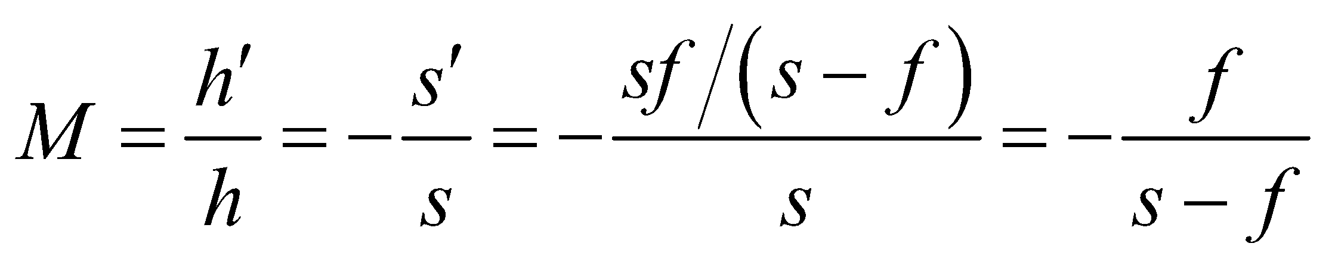

where we used the lens equation (Equation 31.5) to eliminate *s*′.

**Evaluate** If 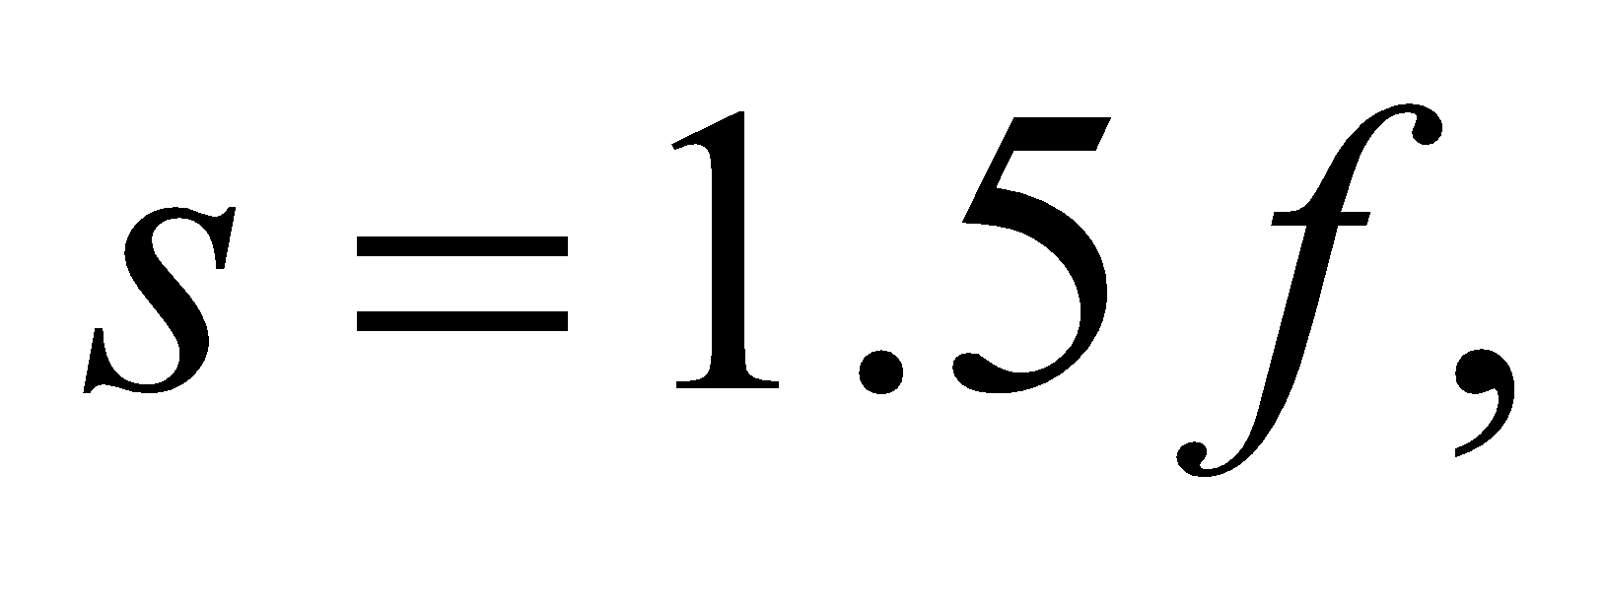 then 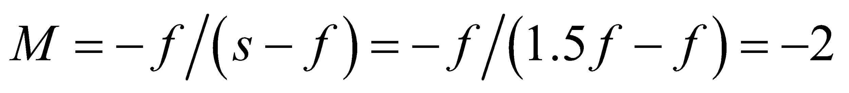. The minus sign means that the image is real and inverted.

**Assess** The lens in this problem corresponds to the second case shown in Table 31.2. With 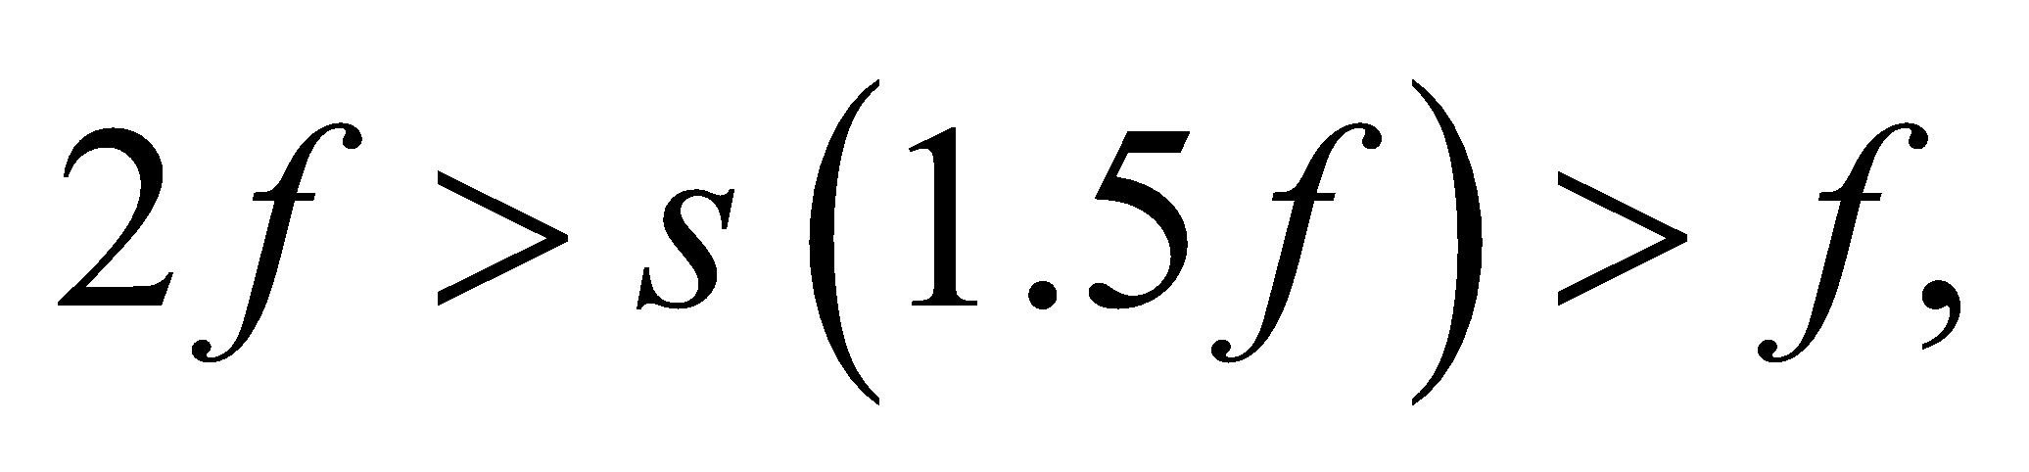 we get a real, inverted, and enlarged image.

**24.** **Interpret** We are to find the image and object distance from a lens given that they are the same height and that the image is real.

**Develop**  For a real image the same size as the object (such as in Figure 31.19), 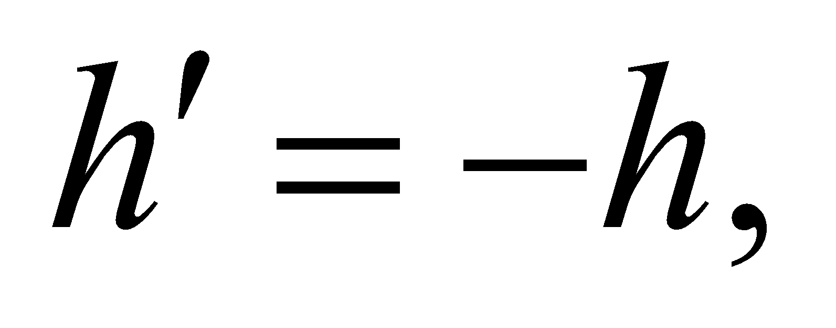 so 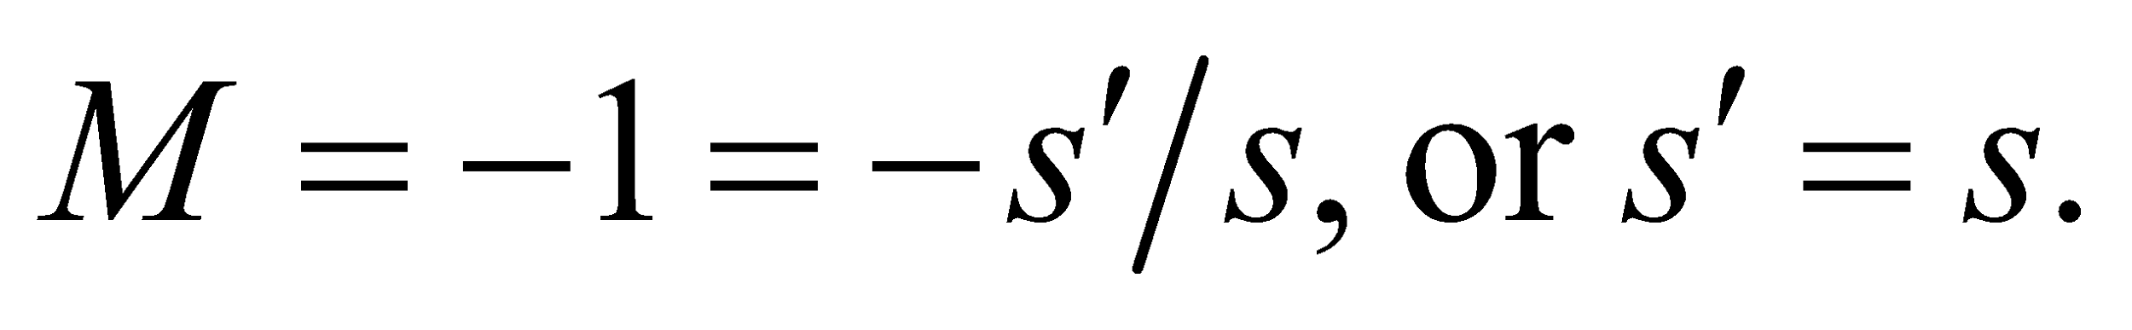 Apply the lens equation (Equation 31.5) and solve for the image (or object) distance.

**Evaluate** The object distance is

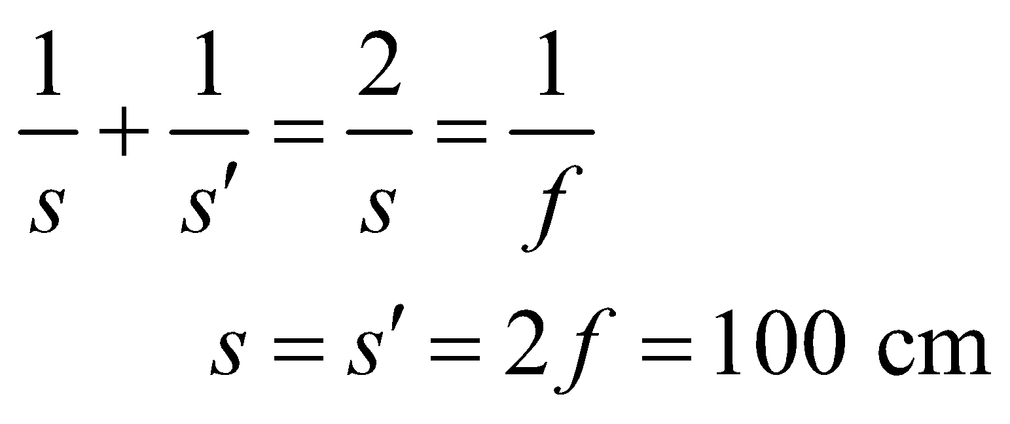

**Assess** This result is similar to that of Problem 31.21, which shows that if the object and image are equidistant from a concave mirror, the magnification is unity.

**25. Interpret** In this problem, we are asked to find the focal length of a magnifying glass that is a converging lens given the object and image distances.

**Develop** The focal length *f* is related to the object and image distances through the lens equation (Equation 31.5):

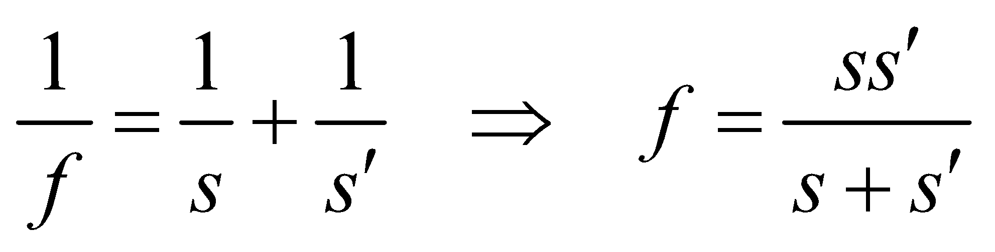

**Evaluate** Because the distances are given with respect to the lamp (i.e., the object), *s* = 25 cm and 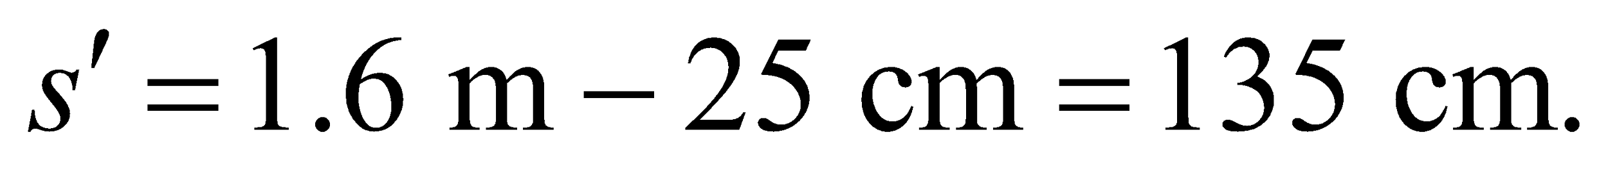 Substituting these into the lens equation, we find

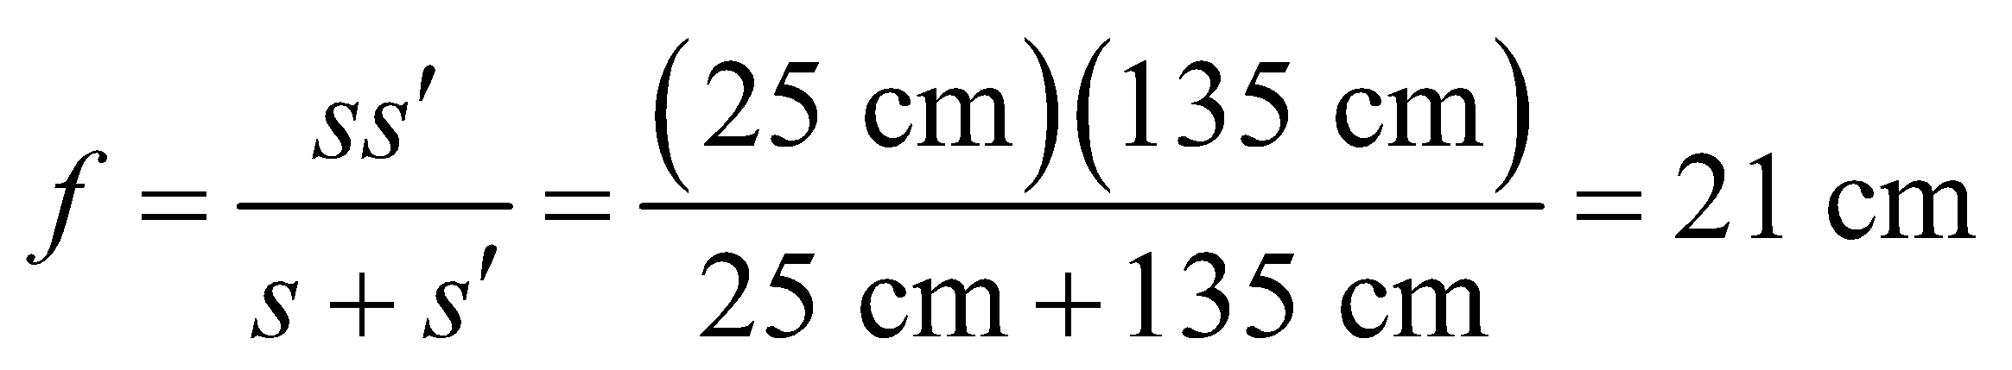

**Assess** Since 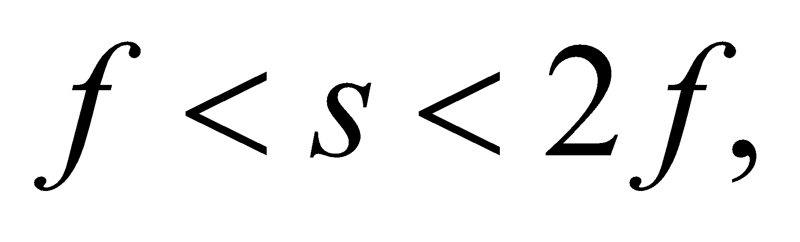 we expect the image to be real, inverted, and enlarged.

**26.** **Interpret** We are to find the object distance relative to the focal length of the given lens.

**Develop** Because the image distance is four times the object distance, use *s*′ = 4*s* into the lens equation (Equation 31.5) and solve for *s*.

**Evaluate** The object distance is

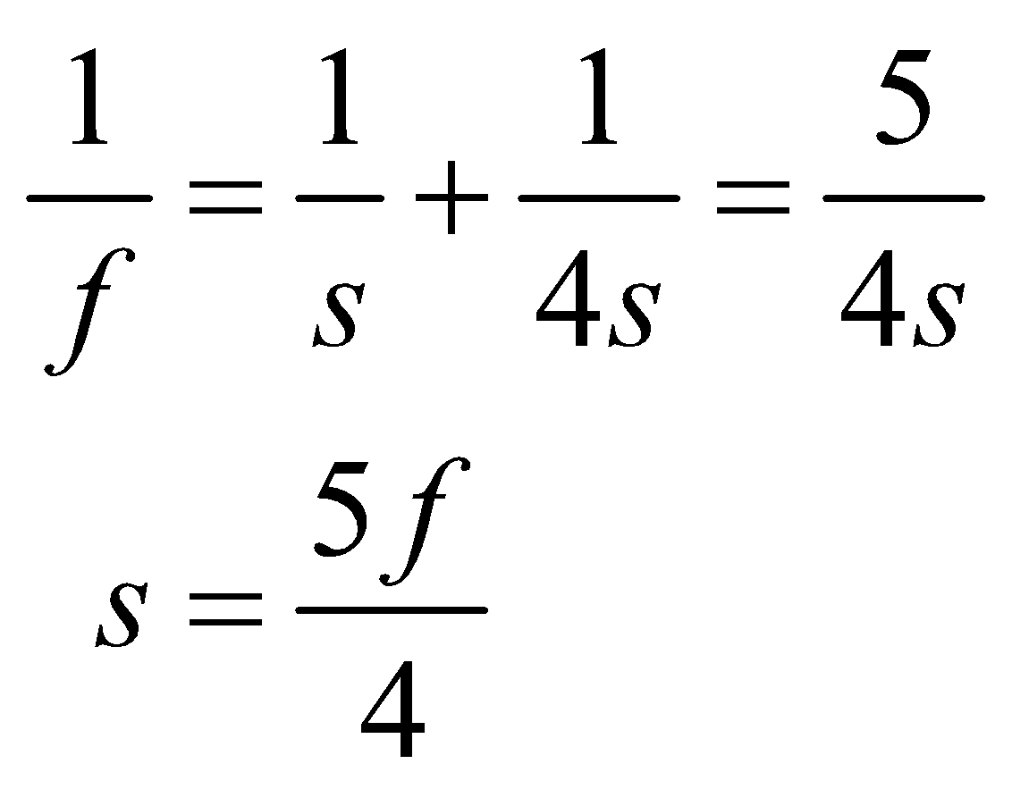

**Assess** This falls into the second category in Table 31.2; namely, that of a convex lens that produces a real, inverted, enlarged image.

**27. Interpret** We are to find the focal length of a magnifying glass given the magnification and the object distance. We shall use the lens equation and the definition of magnification to solve this problem.

**Develop** For a single lens, magnification is defined as 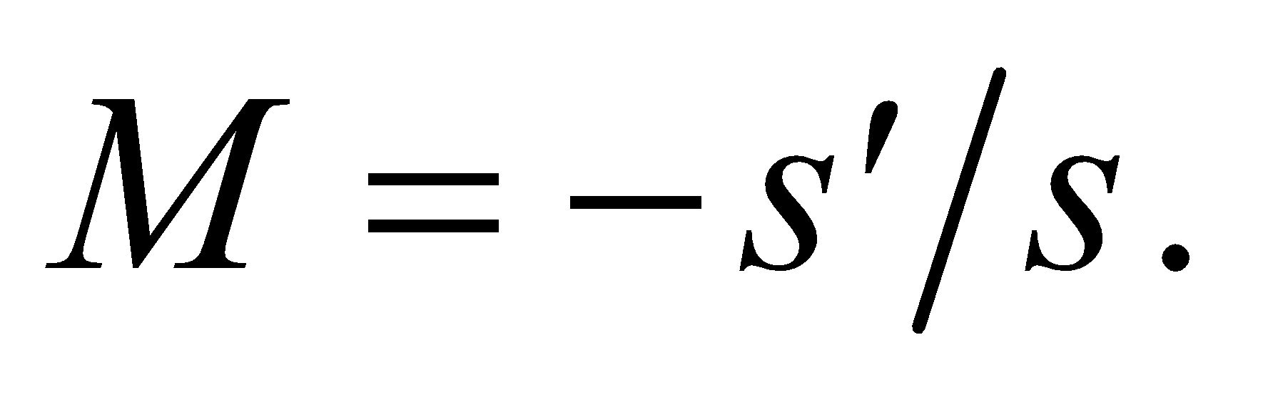 We are told that the object distance is s = 9.0 cm and that the magnification is *M* = 1.5 (i.e., 50% bigger) so we can find the image distance *s*′. The lens equation (Equation 31.5) relates the image and object distances to the focal length by 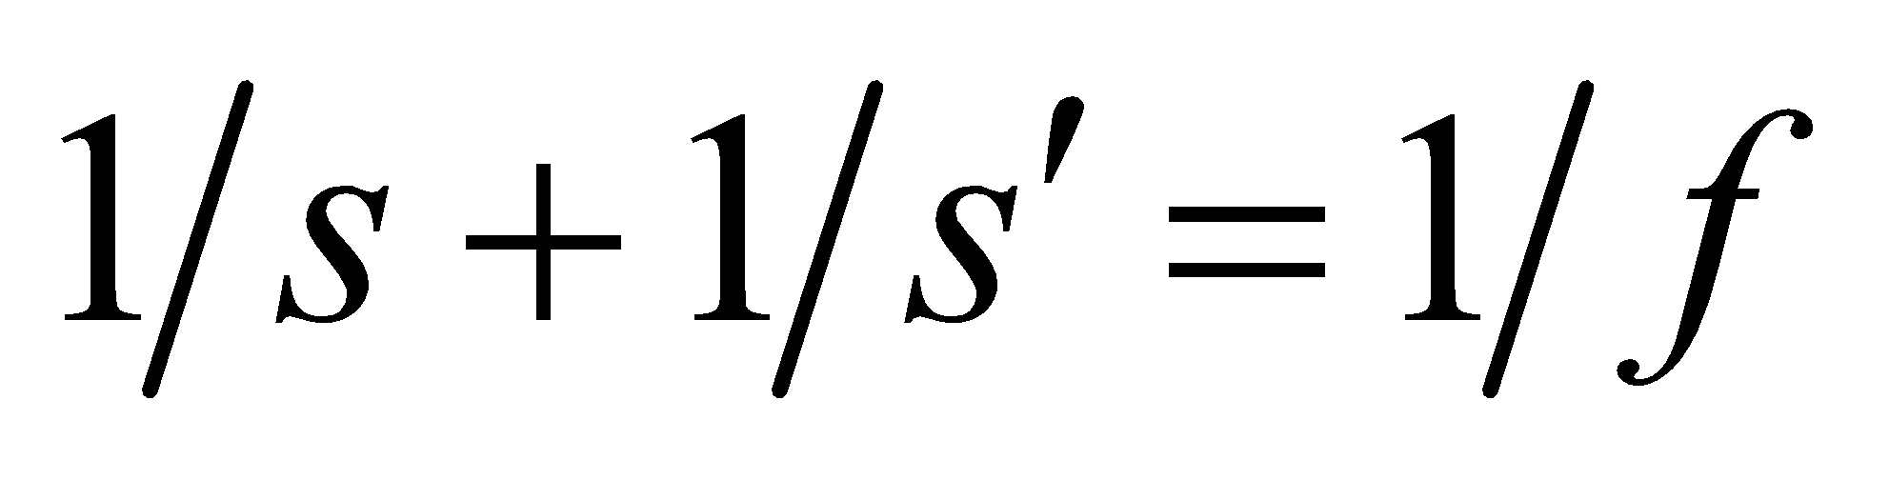, so knowing the distances we can find the focal length.

**Evaluate** Using *s*′ = −*Ms* in the lens equation and inserting the given quantities gives

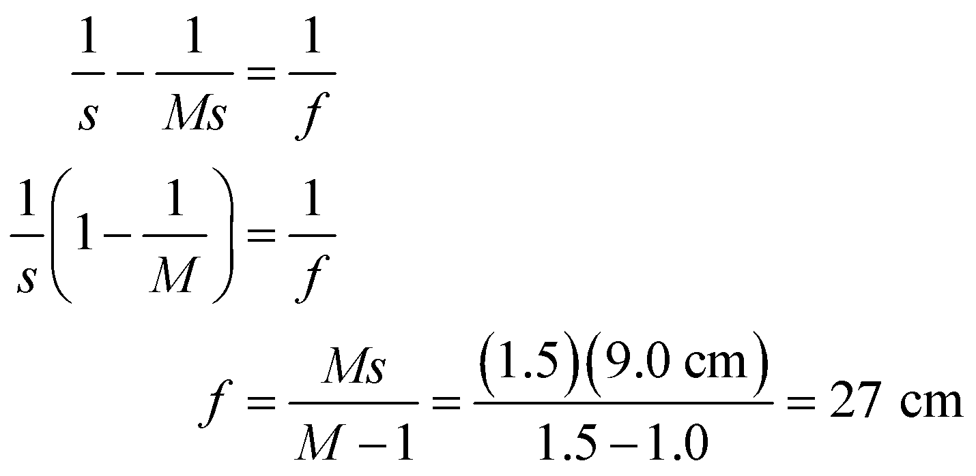

**Assess** Be careful about the signs in problems such as these. We must remember that magnification is the *negative* of the ratio of image to object distances. If we miss this detail we will get the wrong answer of = 5.4 cm.

**Section 31.3 Refraction in Lenses: The Details**

**28.** **Interpret** We are to specify the focal length of a double-convex lens with the given radii and index.

**Develop** Apply the lensmaker’s formula (Equation 31.7), with 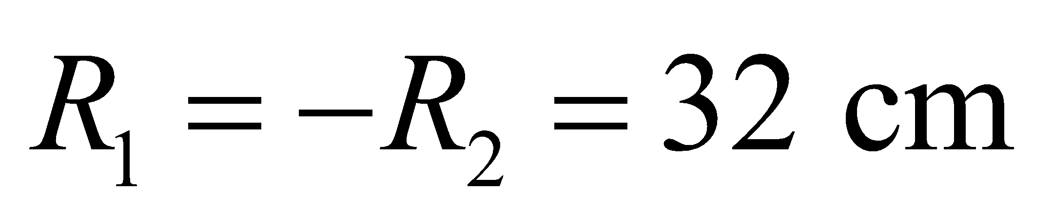 and 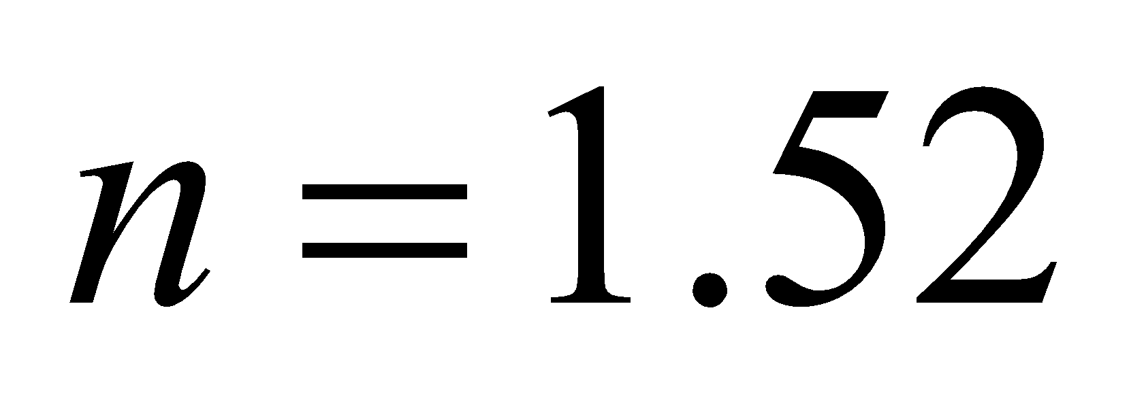.

**Evaluate** The focal length is

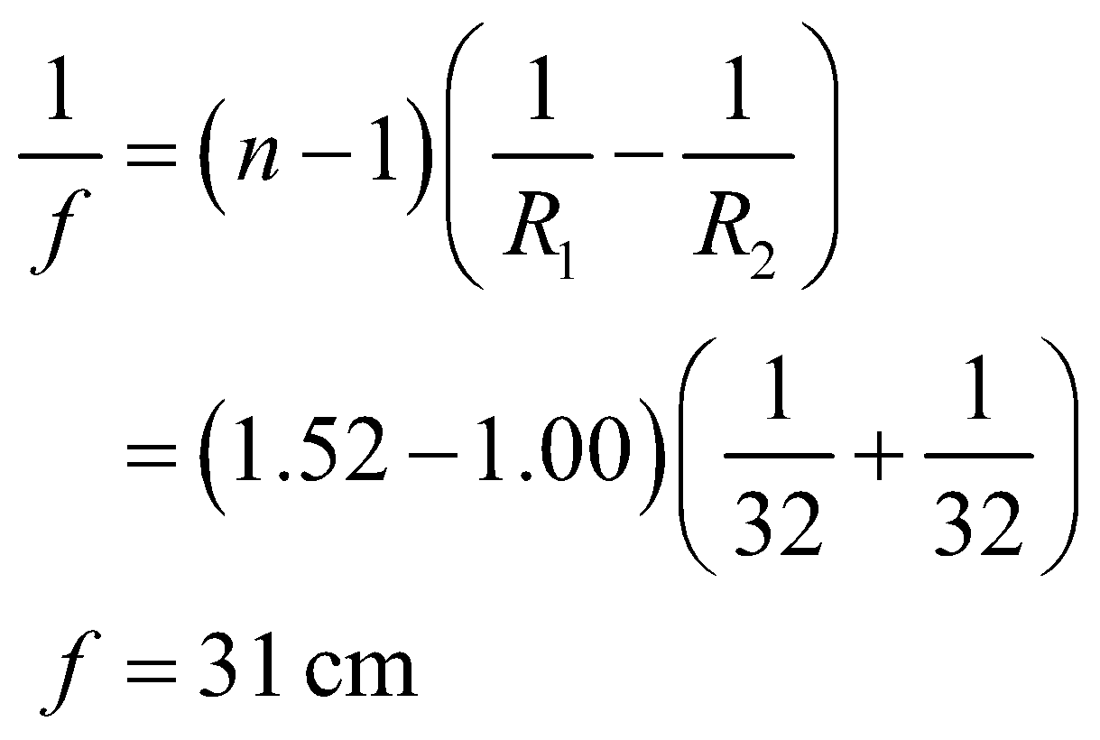

**Assess** This seems like a reasonable focal length for such a magnifying glass.

**29. Interpret** This problem involves image formation by a single refracting interface between two media. Specifically, we are to find the depth of a pool of water given the image distance of an object at the bottom of the pool.

**Develop** The image formed by a refracting interface is described by Equation 31.6,

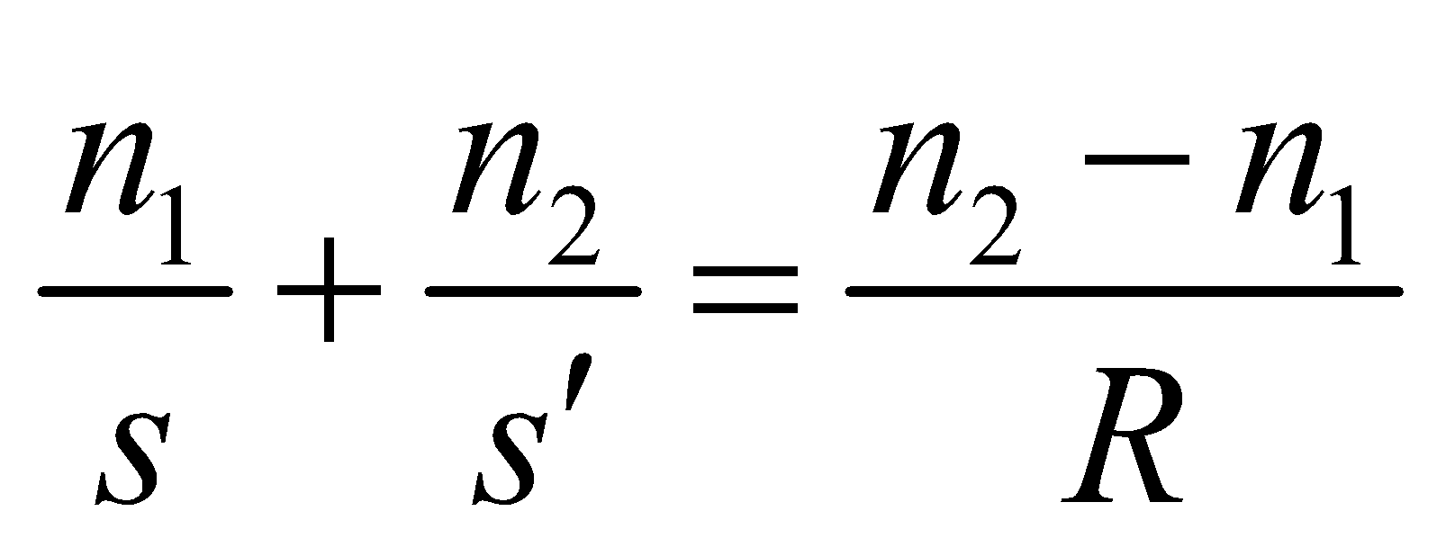

For the flat surface of the wading pool, the radius of curvature is 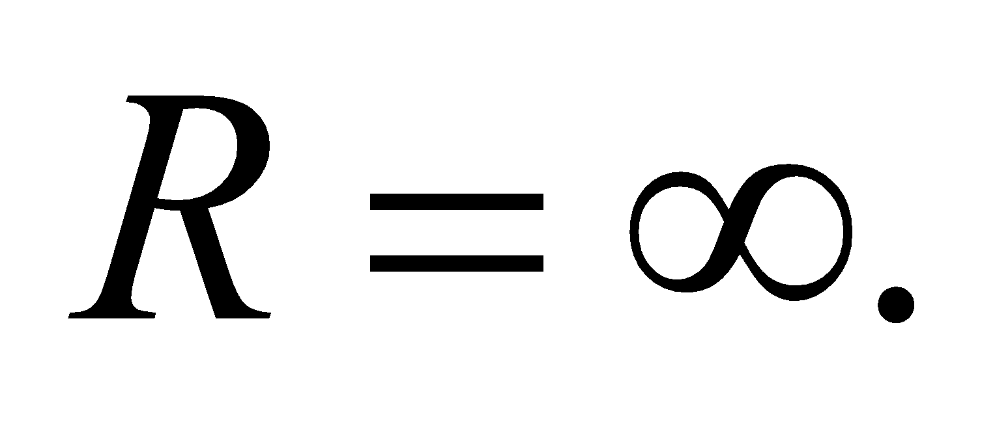 The index of refraction is 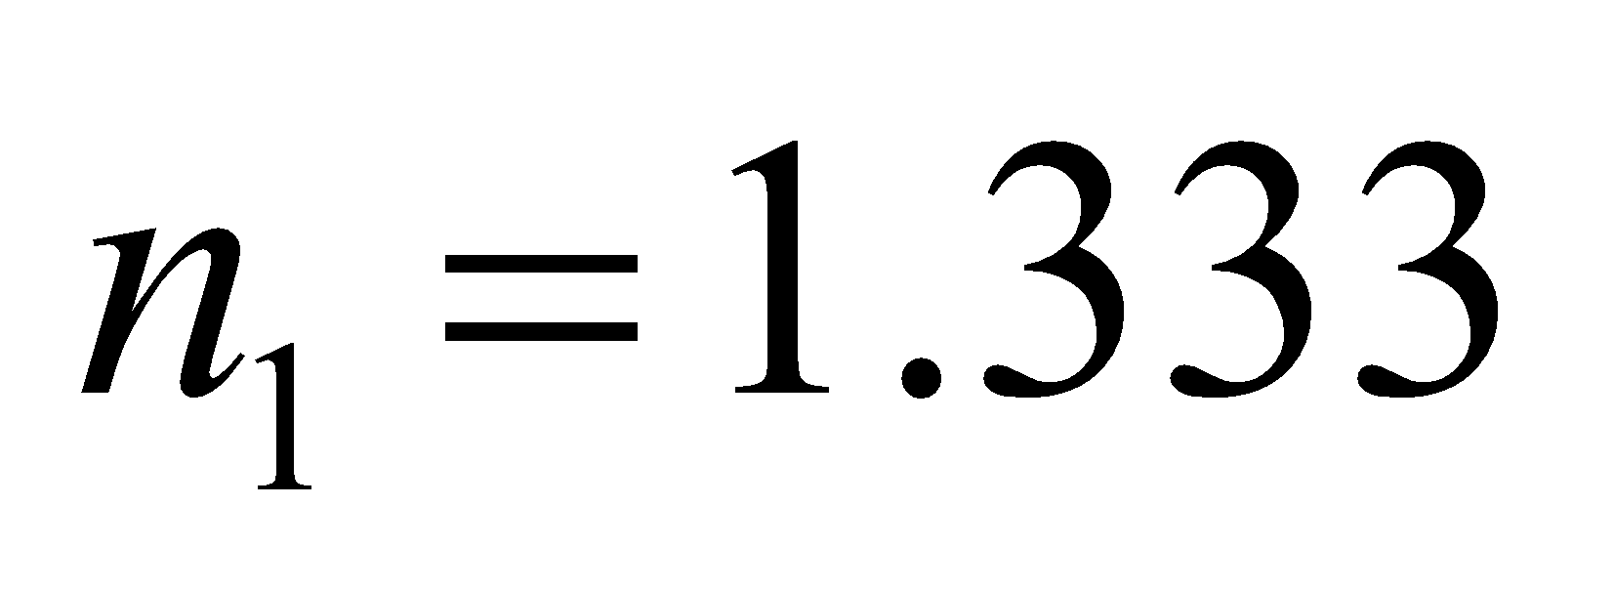 for water, *s* is the depth of the pool (your feet, the object, are on the bottom), 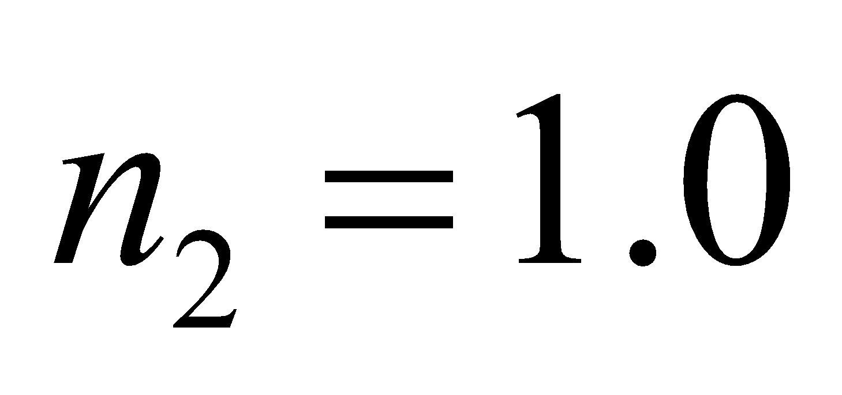 for air, and 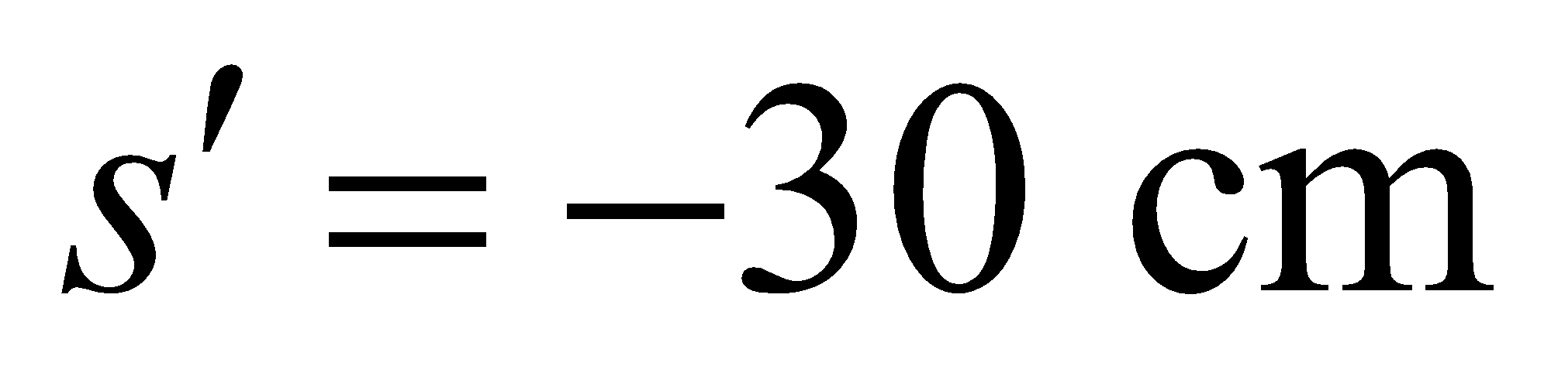 (for a virtual image at the apparent depth).

**Evaluate** Thus, the above equation gives

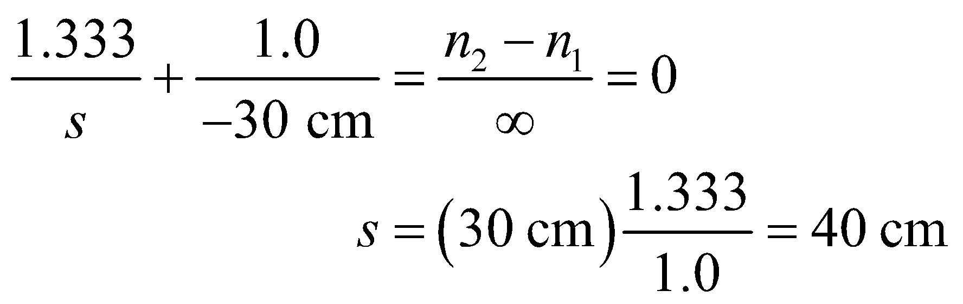

**Assess** This problem could also be solved directly from Snell’s law, without the paraxial ray approximation. Note that the image formed by a flat refracting surface is always on the same side of the surface as the object.

**30. Interpret** This problem is identical to the previous one, with the feet replaced by the actual bottom of the pool. We are to find the *actual* depth of a pool of water, given the apparent depth (i.e., the image distance). In this case, we’re looking at an object that is “inside” a “thick lens” such as in Figure 31.22, but our “lens” has an infinite radius of curvature.

**Develop**  The image distance is the apparent depth of the pool, and the object distance is the actual depth. We apply Equation 31.6,

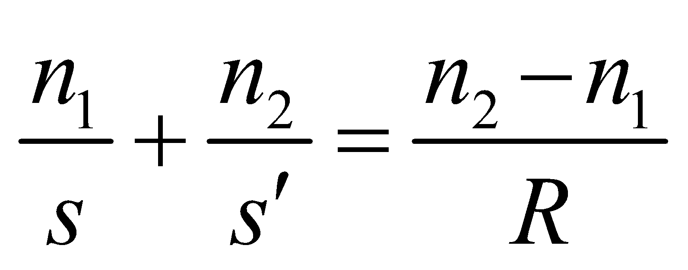

which relates the object and image distances to a single refracting surface. In this case, the refracting surface is the surface of the water, so the radius of curvature is equal to the radius of the Earth, which is approximately infinite compared to any other lengths in the problem. The index of refraction of the water is 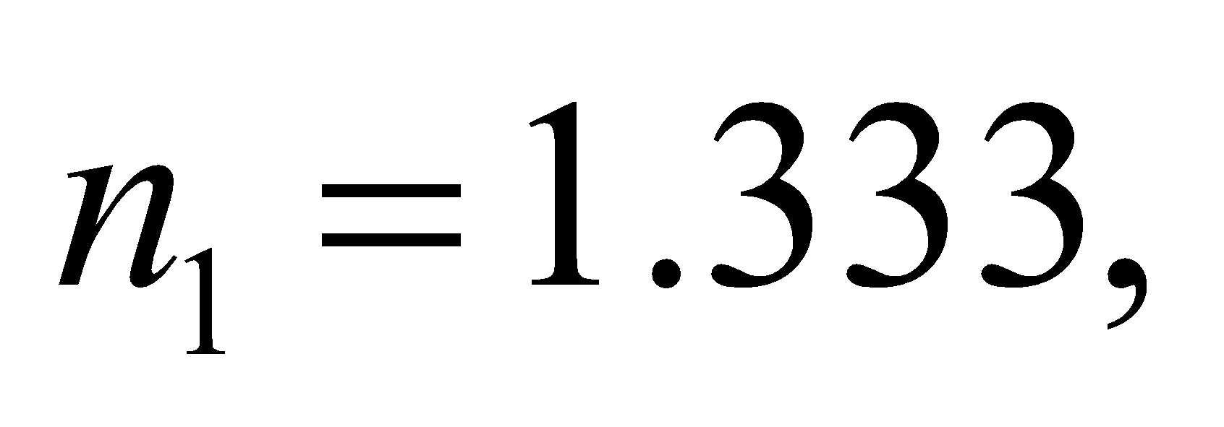 and that of air is . The image distance is 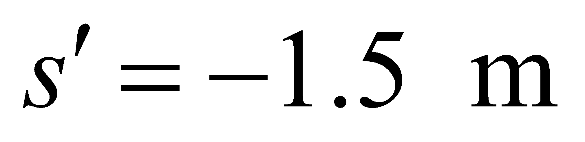(the negative sign indicates it’s a virtual image), and we wish to find the actual object distance *s*.

**Evaluate**

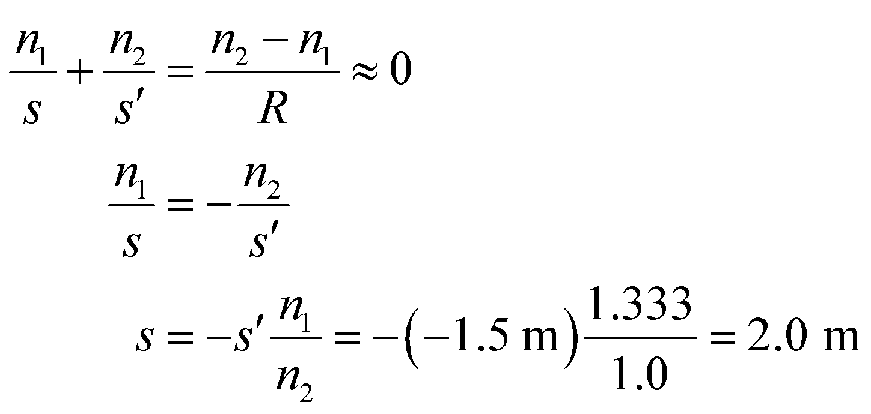

**Assess** A pool of water is always about 1/3 again deeper than it appears, due to refraction at the surface of the water.

**31.** **Interpret** This problem involves image formation by a curved refracting interface between two media.

**Develop** The image formed by a refracting interface is described by Equation 31.6,



In this case, the light from the object (the insect) starts from the water in the dew drop 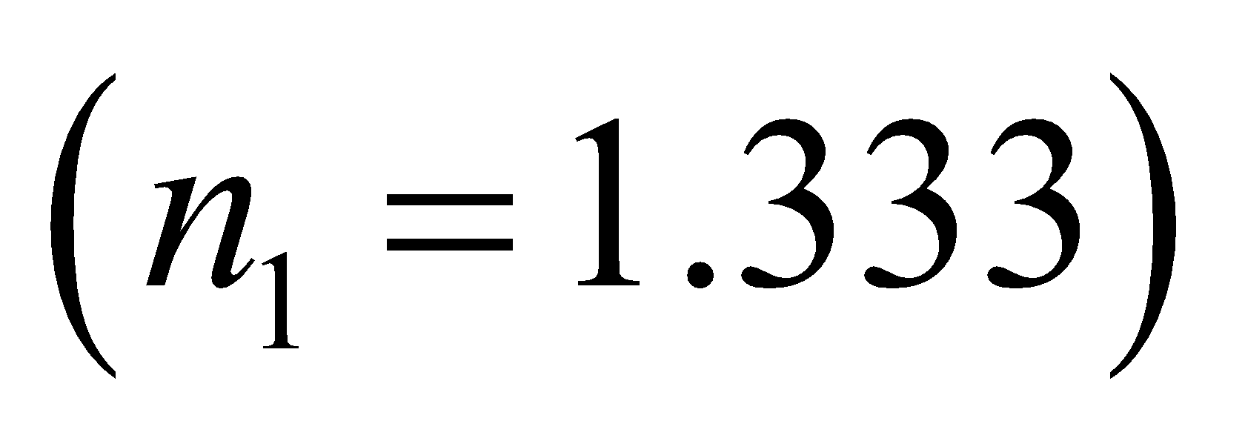 and passes into the air 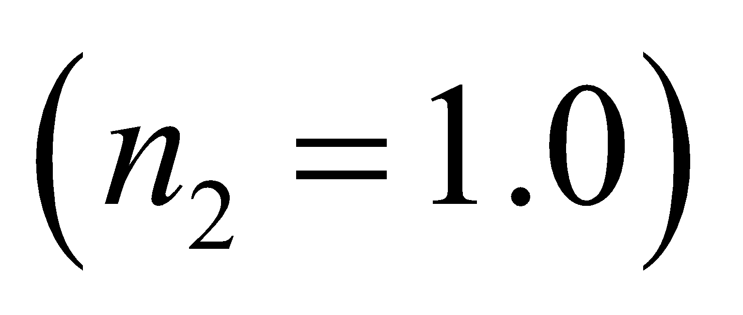 through a concave surface, so the radius is negative: 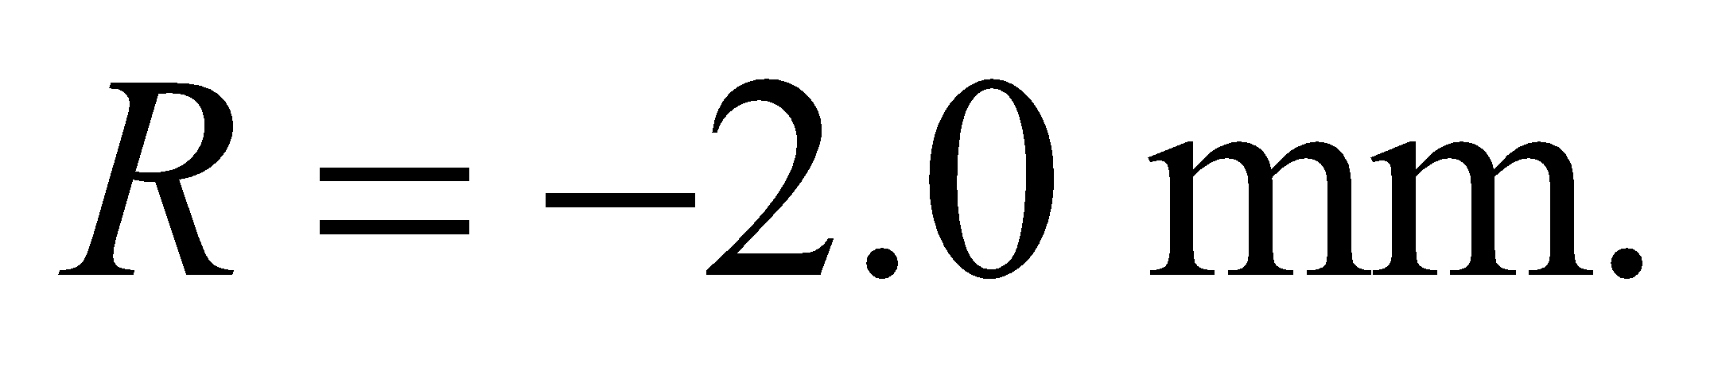 If you look at the surface that the insect is closest to, then 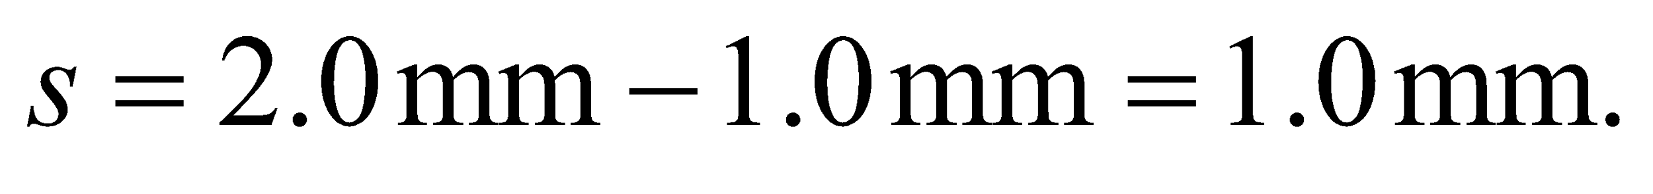

**Evaluate** Solving for the image distance gives:

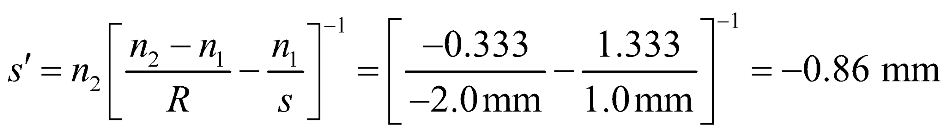

The **minus** sign implies the image is virtual. The insect appears to be 0.86 mm from the surface.

**Assess** The insect appears closer to the surface than it really is, as does the fish in Example 31.4.

**32.** **Interpret** We are given the image distance (i.e., apparent diameter) for a lens consisting of an air bubble in water and are to find the object distance (i.e., actual diameter). In this case, the image is formed inside the lens.

**Develop** Consider the sketch below, which shows the air bubble and several rays. The object, point *O* at the back edge of the bubble along the line of sight is at a distance *s* = 2|*R|* from the concave nearest surface of the bubble (radius is *R*) in air 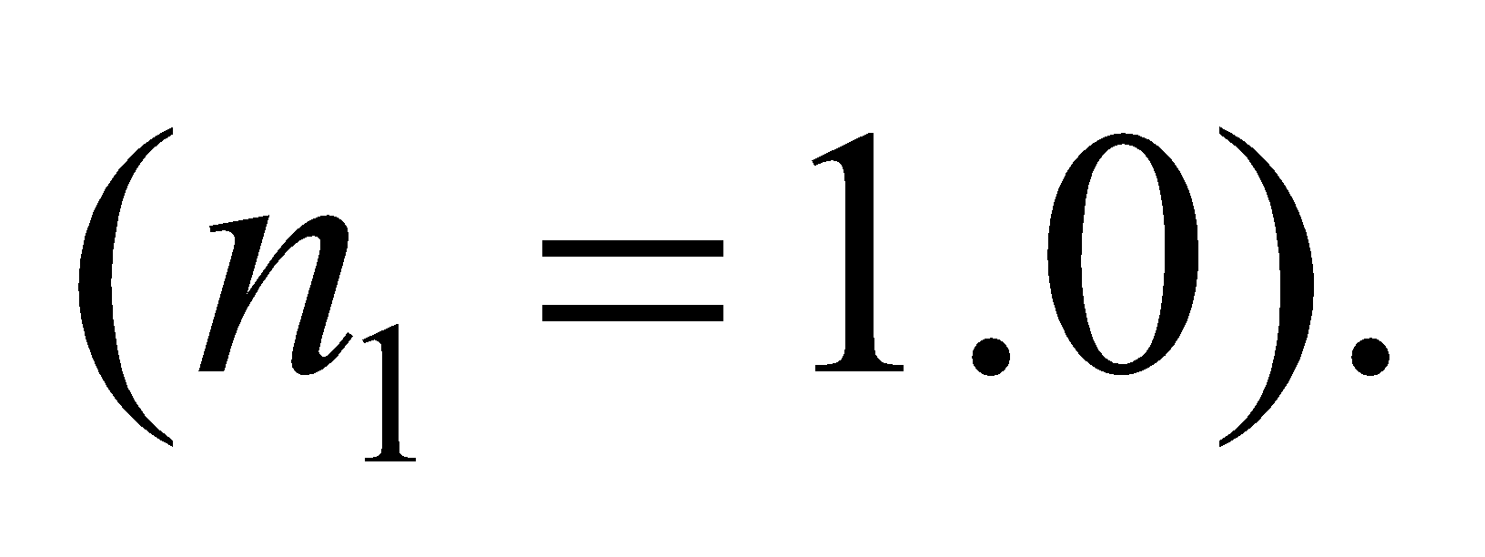 The virtual image at *I* is at the given distance, 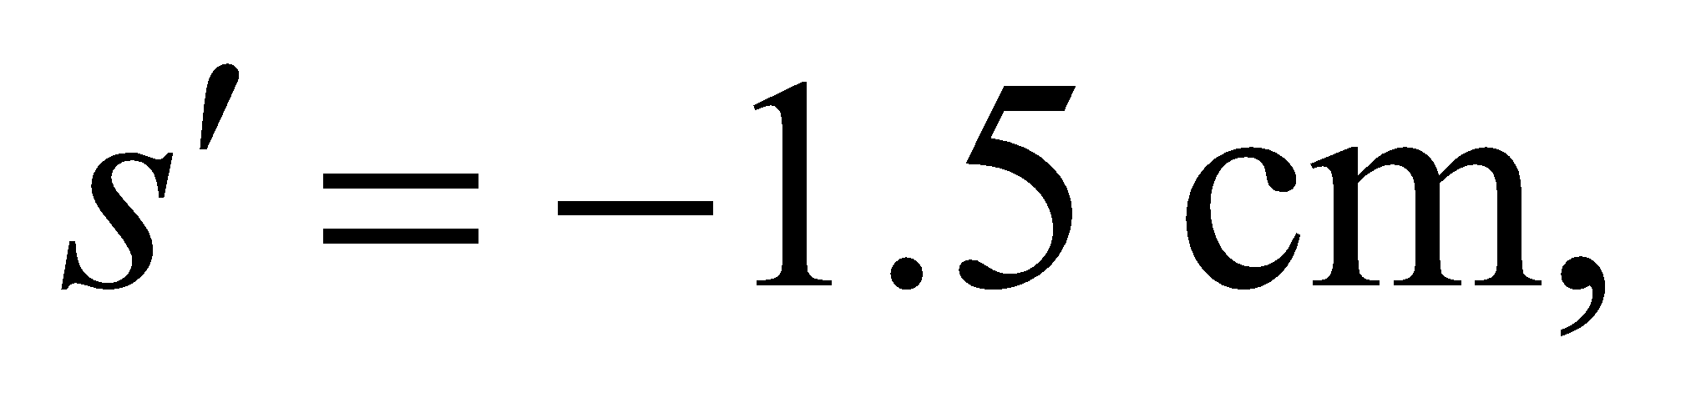 from this surface. The lens is concave toward the object, so the radius of the lens is negative (*R* = −*s*/2, see Example 31.4). Because the image is formed inside the lens, we apply Equation 31.6 and solve for the object distance *s*.



**Evaluate** Using *n*2 = 1.333 for water (from Table 30.1), the object distance *s*, which is the diameter of the bubble, is

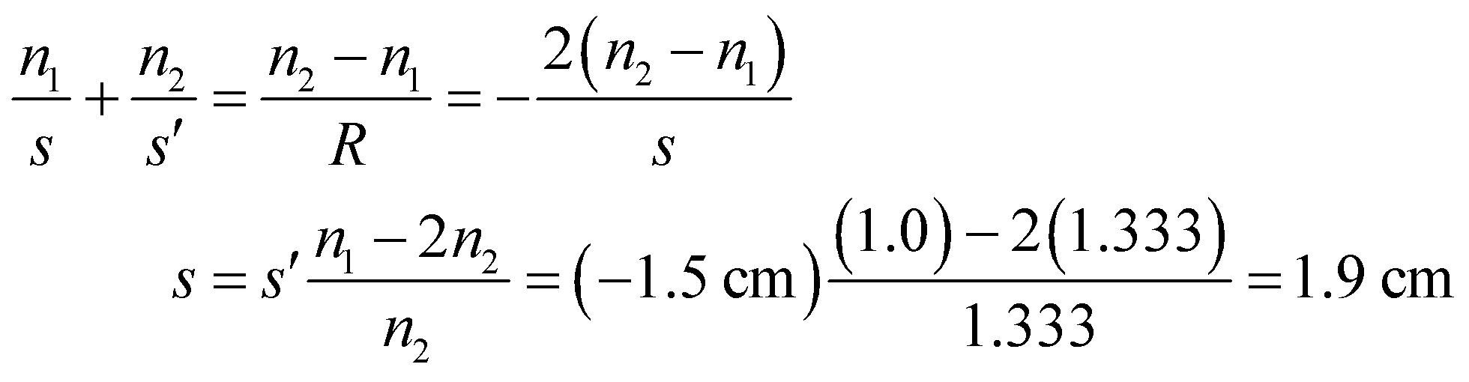

**Assess** The bubble thus appears oval, because its vertical diameter is not affected by refraction whereas its horizontal diameter is reduced by refraction.

**Section 31.4 Optical Instruments**

**33. Interpret** This problem is about the power of the lens required to correct vision. We are given the near point of the uncorrected eye and are asked to find the lens power needed to correct this (i.e., reduce the near point to the standard 25 cm).

**Develop**  The uncorrected eye has a near point of 55 cm, whereas the corrected eye has a near point of 25 cm. The lens equation (Equation 31.5) relates the focal length to the object distance *s* and the image distance *s*′:



With the focal length *f* in meters, 1/*f* is the power, in diopters. The above equation gives

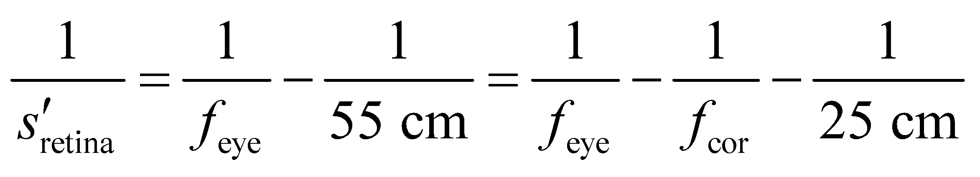

**Evaluate** The power of the lens is

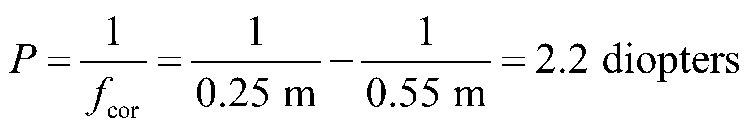

**Assess** Alternatively, Example 31.6 argues that the corrective lens should produce a virtual image of an object at 25 cm (the standard near point) at a distance of 55 cm (the uncorrected near point), so

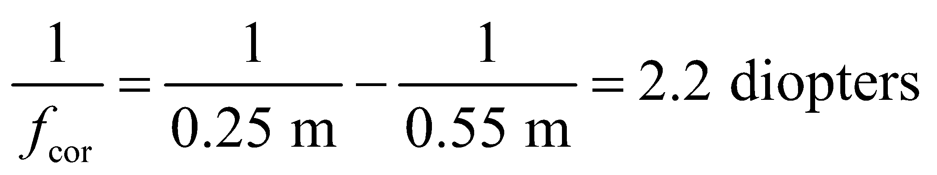

which is the same as above.

**34. Interpret** We are to determine the focal length needed to make a simple magnifier with a desired angular magnification.

**Develop** For an angular magnification of 3, apply the equation for angular magnification of a simple magnifier (Equation 31.8):

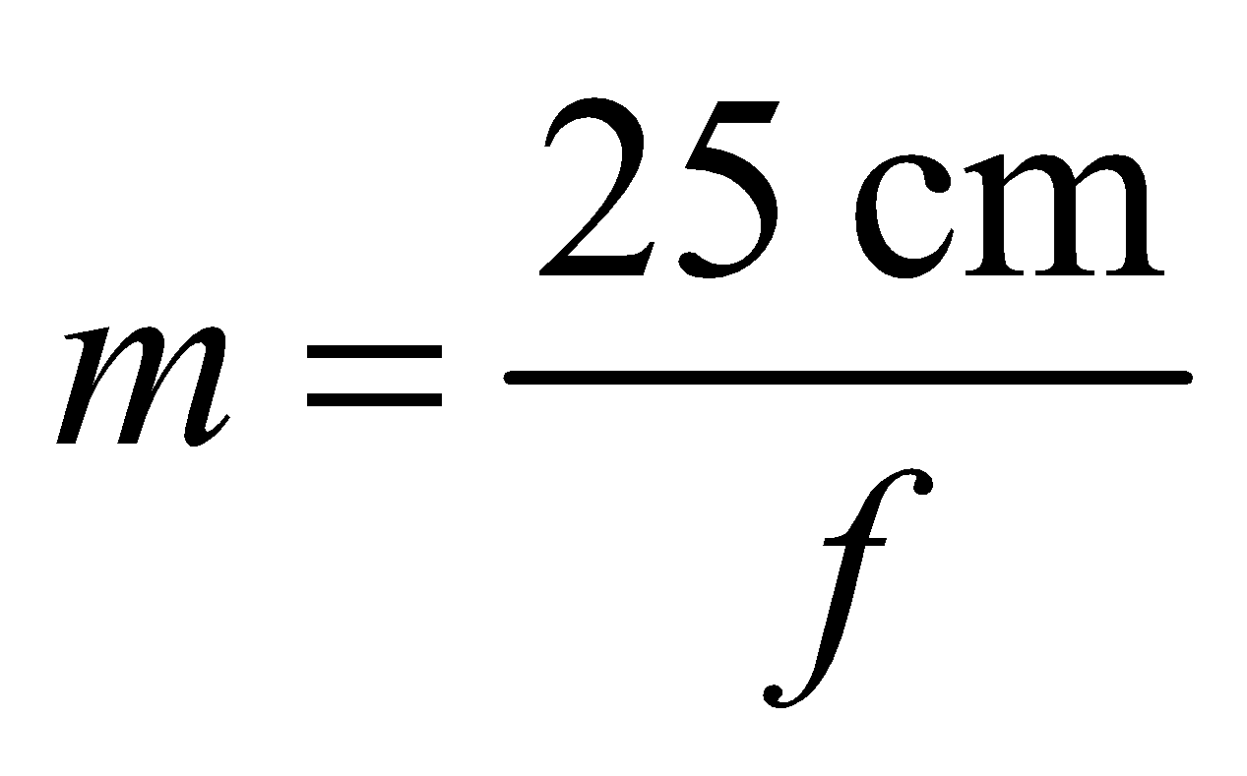

with *m* = 3 and solve for the focal length *f*.

**Evaluate** The focal length is

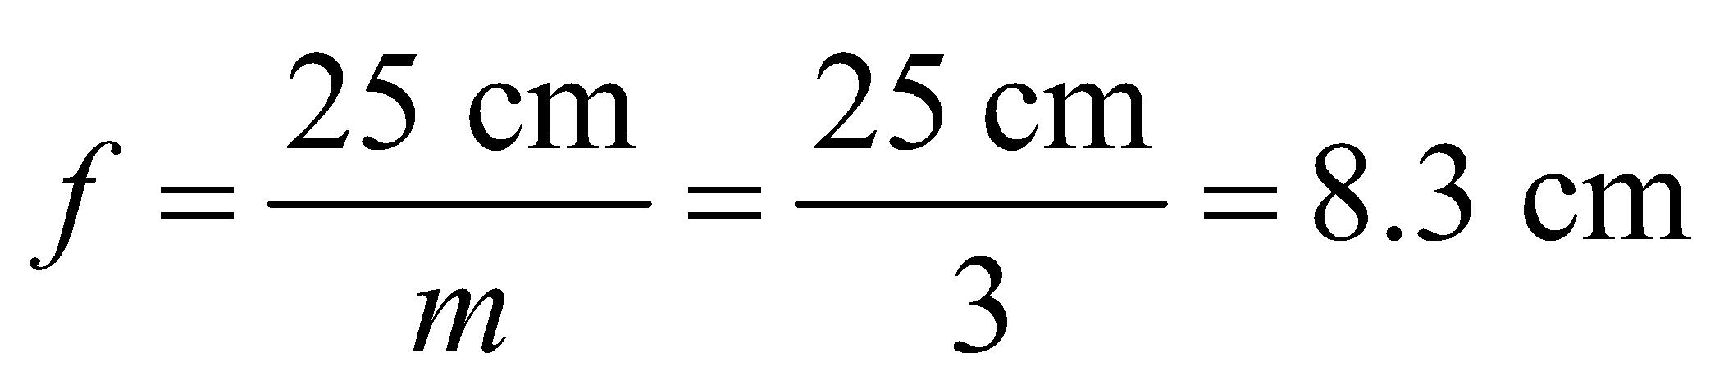

**Assess** Angular magnification makes things appear larger, even if the image is farther away.

**35. Interpret** We are to find the power of a lens that would make distant objects appear to be at a distance of 80 cm, for which we shall use the lens equation.

**Develop** The nearsighted patient described in the problem can see clearly at distances up to 80 cm. Thus, we need a lens that produces an image of distant 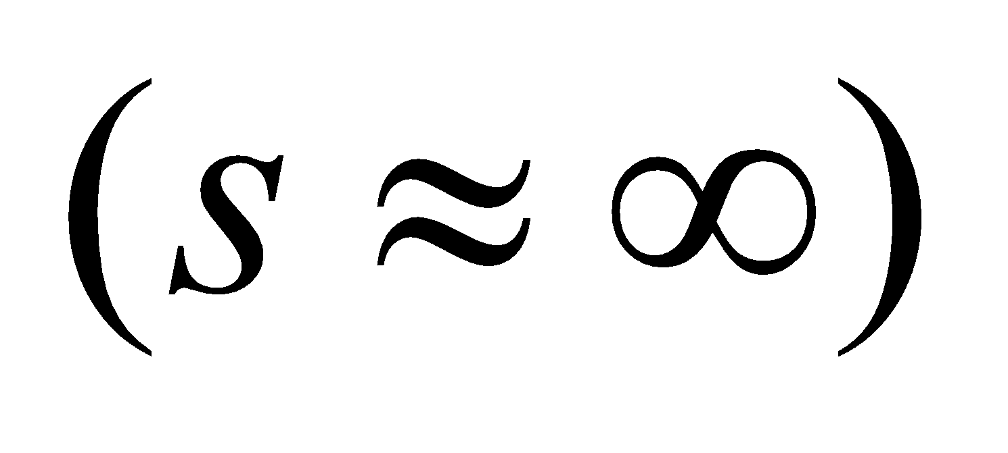 objects at this distance 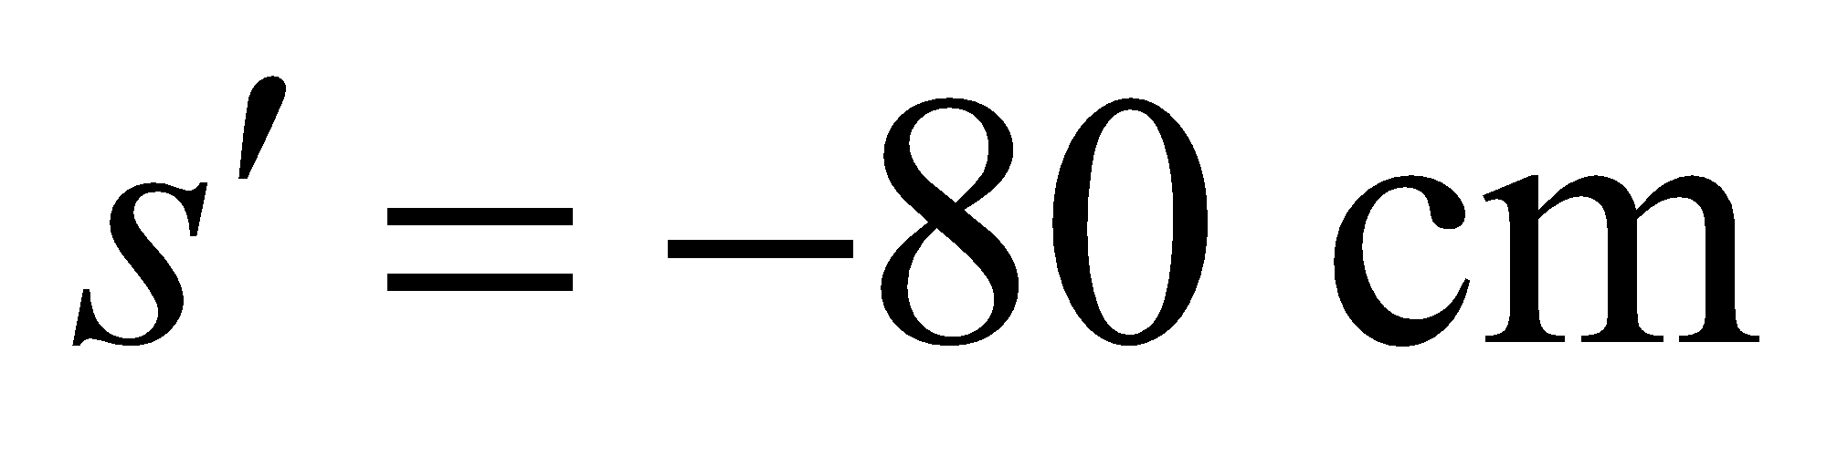, where the negative sign indicates that the image will be virtual. Apply the lens equation (Equation 31.5)



and report our answer in diopters, which is the inverse focal length in meters.

**Evaluate** The necessary lens power is

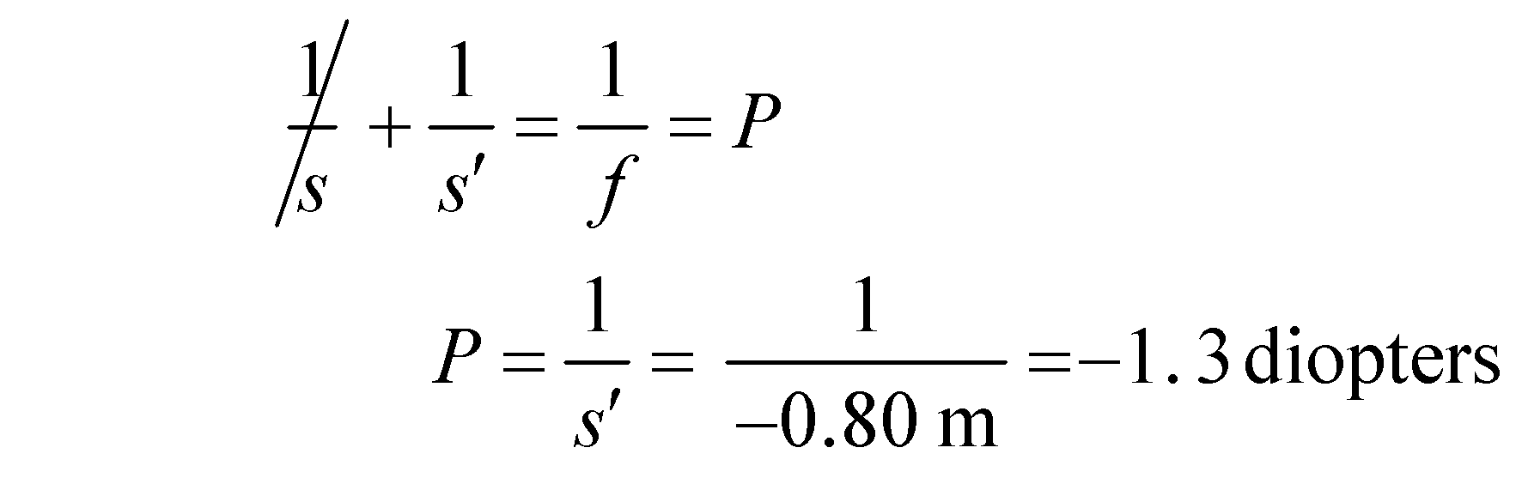

**Assess** Note the sign of *s*′ is negative, because the image is on the same side of the lens as the object.

**36.** **Interpret** We are to determine if the eye described in the problem statement is nearsighted or farsighted, and determine the corrective lens needed (i.e., the dioptric power).

**Develop**  The difference is the correction required. See Figure 31.28 to see if this is a nearsighted or farsighted person. The dioptric power (strength) of this eye is 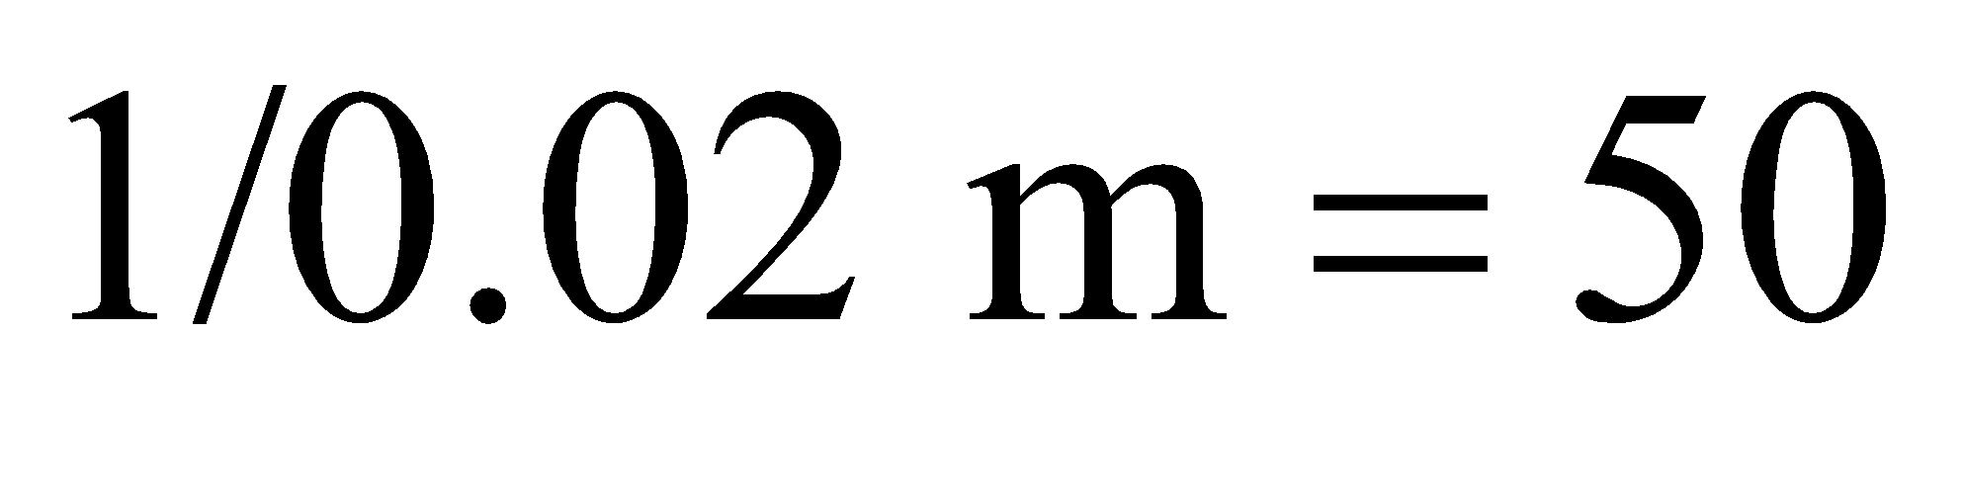 diopters, whereas a dioptric strength of 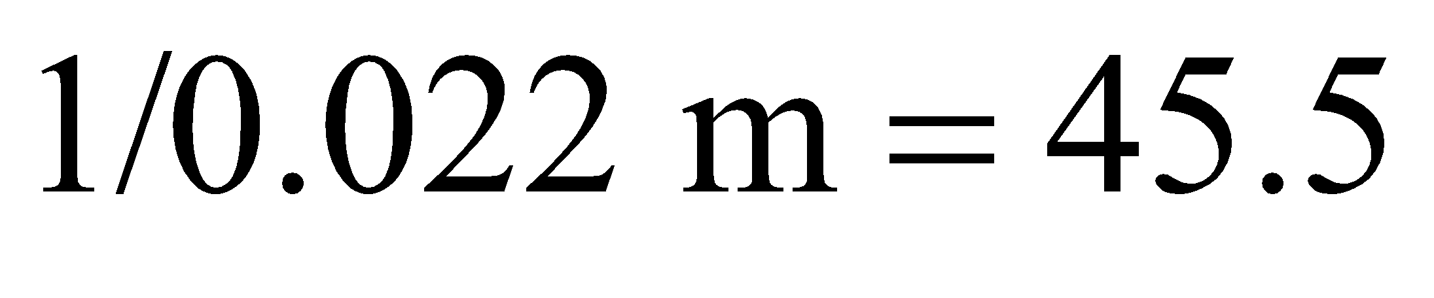 diopters is required for sharp vision.

**Evaluate** **(a)** Since this unaided eye focuses in front of the retina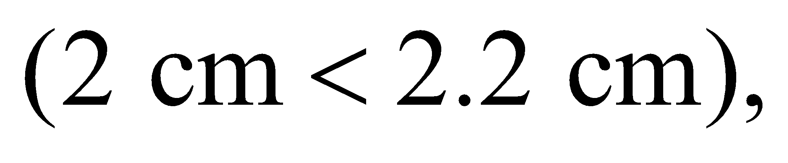it belongs to a nearsighted person.

**(b)** A correction of 45.5 − 50.0 = −4.5 diopters is necessary (see Problem 73 for the additivity of dioptric power).

**Assess** Nearsightedness is also indicated by a negative correction.

**37. Interpret** We are to find the magnification of a compound microscope, given the focal lengths of the eyepiece and objective and the distance between them.

**Develop** The magnification of a compound telescope is given by Equation 31.9:

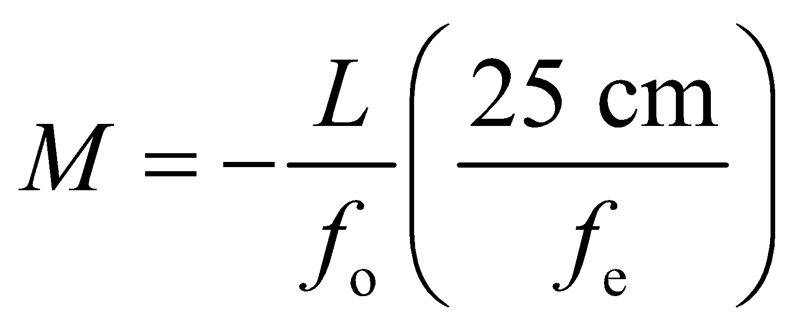

For this problem, we are given *f*o = 6.1 mm, *f*e = 1.7 cm, and *L* = 8.3 cm.

**Evaluate** Substituting the values given, we find the overall magnification of the microscope to be

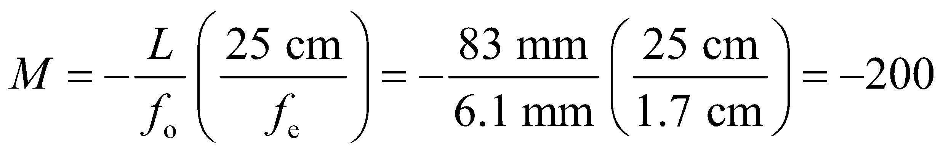

**Assess** The image is magnified 200 times. The minus sign means that the image is inverted.

**Problems**

**38. Interpret** We are to find the focal length of a concave mirror given the object and image distance, and then use that focal length to find the image distance for a new object distance.

**Develop** For part (a), apply the mirror equation (Equation 31.2) to find the focal length f. The object distance *s* = 50 cm and the image distance *s*′ = 75 cm (it is positive because the image is on the same side as the object). For part (b), use the focal length from part (a) and the new object distance (*s* = 20 cm) to find the new image distance.

**Evaluate** **(a)** The focal length is

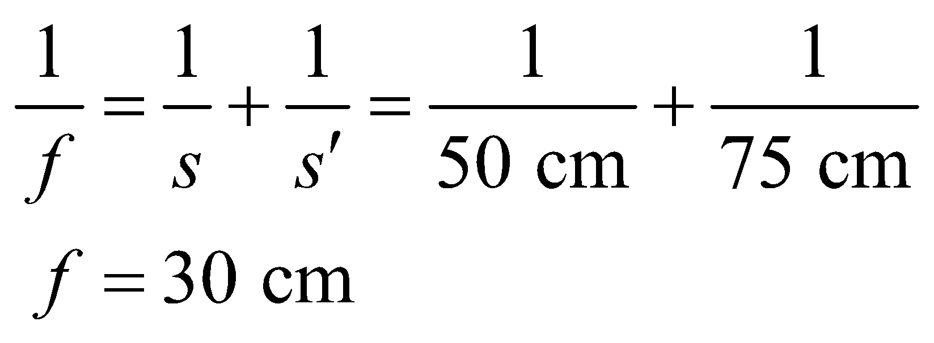

**(b)** Moving the object to *s* = 20 cm results in an image at

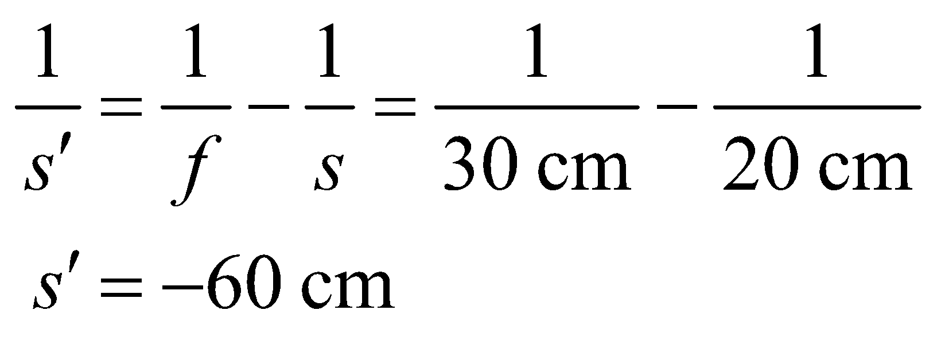

The image distance is negative, so it is a virtual image.

**Assess** These results are consistent with Table 33.1.

**39. Interpret** This is an image-formation problem involving a concave mirror. We want to know the position of the image, its height, and its orientation.

**Develop** The magnification *M*, the ratio of the image height *h*′ to object height *h*, is given by Equation 31.1:



where *s* and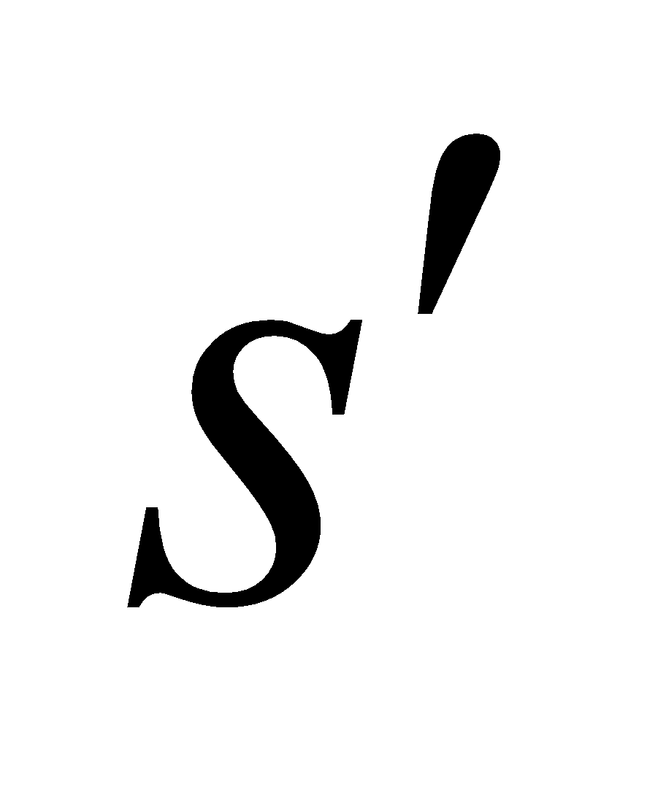are the object and image distances to the mirror, respectively. The two quantities *s* and s′ are related by the mirror equation (Equation 31.2):



where *f* is the focal length of the mirror.

**Evaluate** **(a)** The position of the image is at

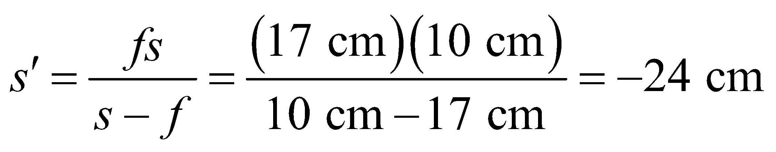

The negative sign means that the image is behind the mirror (opposite the object).

**(b)** The magnification of the image is

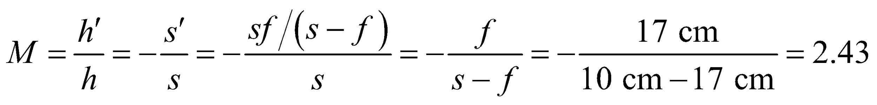

Therefore, the height of the image is 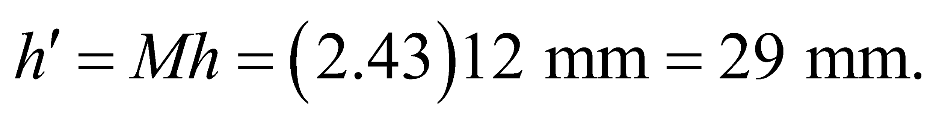

**(c)** The image is virtual 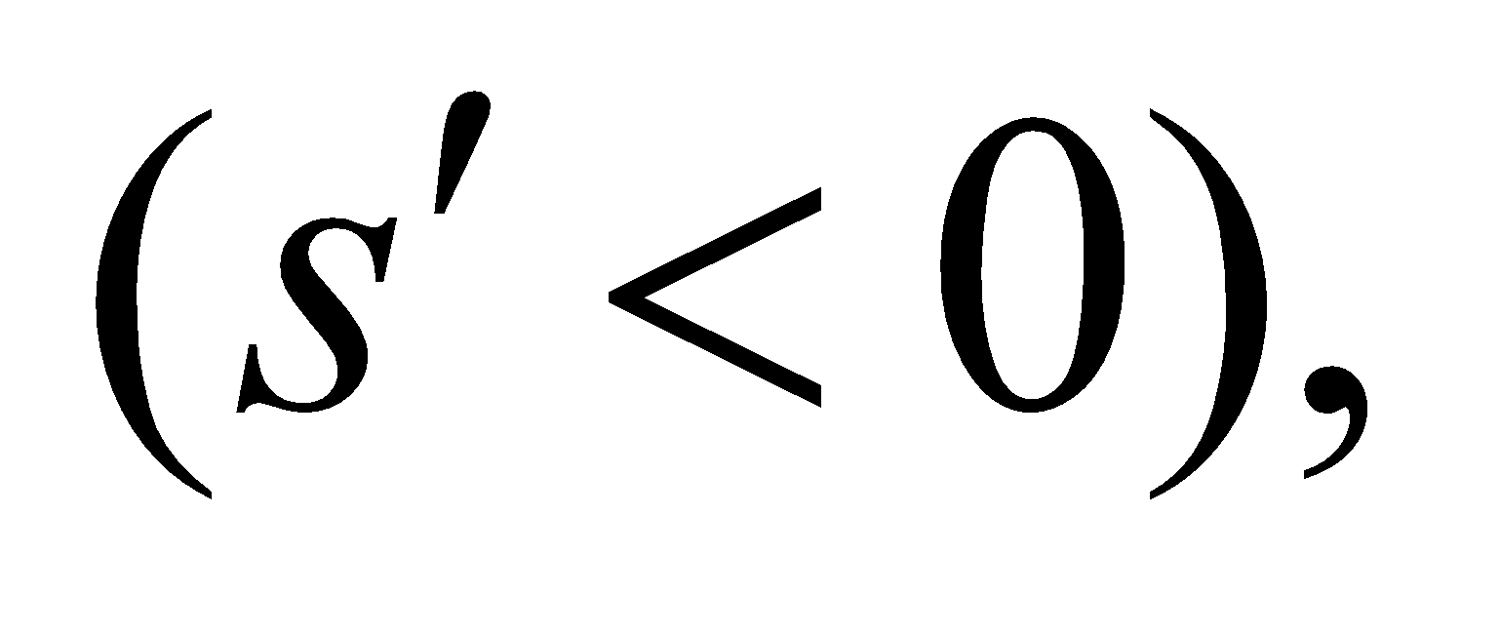upright (*M* > 0), and enlarged.

**Assess** The situation corresponds to the third case depicted in Table 31.1. The mirror is concave with 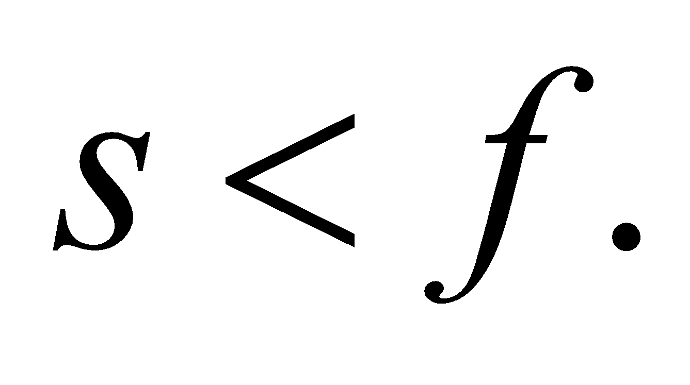

**40.** **Interpret** This problem is the same as the previous one, except that we are now dealing with a convex mirror.

**Develop** The focal length for a convex mirror is negative (for the sign conventions adopted here).

**Evaluate** **(a)** The image distance is

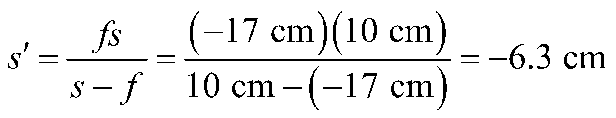

**(b)** The magnification of the image is

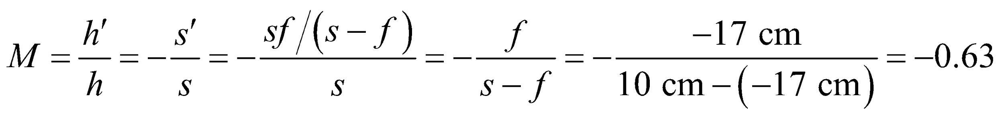

Therefore, the height of the image is 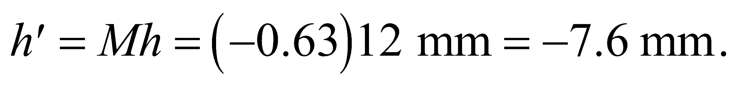

**(c)** The image is virtual  inverted (*M* < 0), and reduced.

**Assess** Changing the mirror from concave to convex changes the results, as expected.

**41. Interpret** This problem is about image formation in a concave mirror. We want to know the position of the object, given its magnification and the focal length of the mirror.

**Develop** Using Equations 31.1 and 31.2, the magnification of the image can be written as

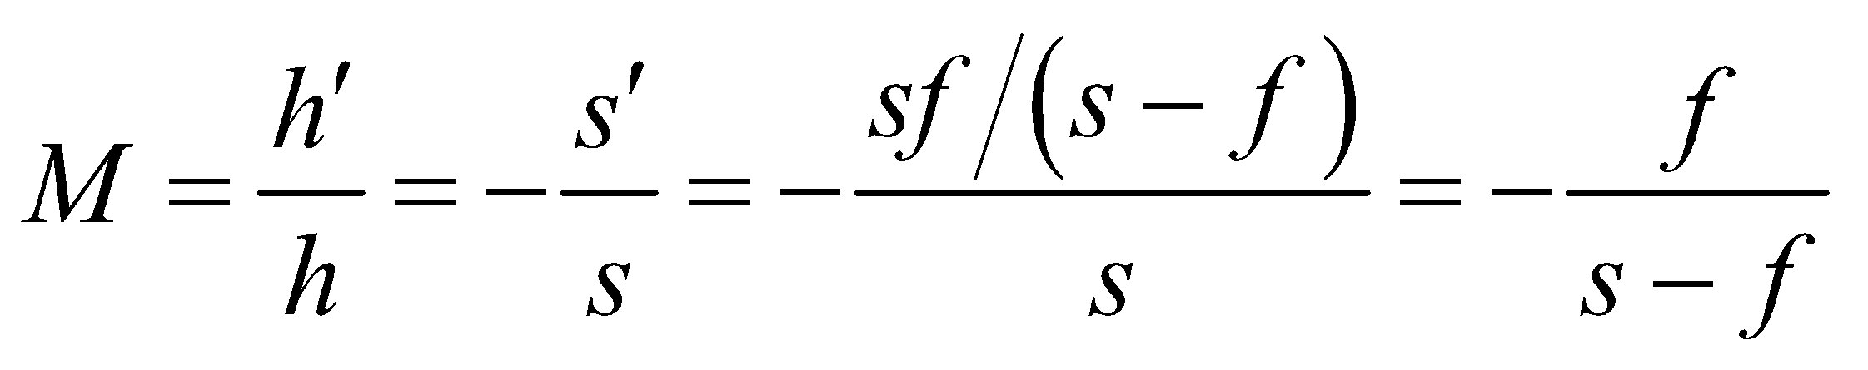

The fact that the image is upright tells us that *M* > 0. This equation allows us to solve for *s*, the position of the object.

**Evaluate** With *M* = +3 and *f* = 27 cm, we get

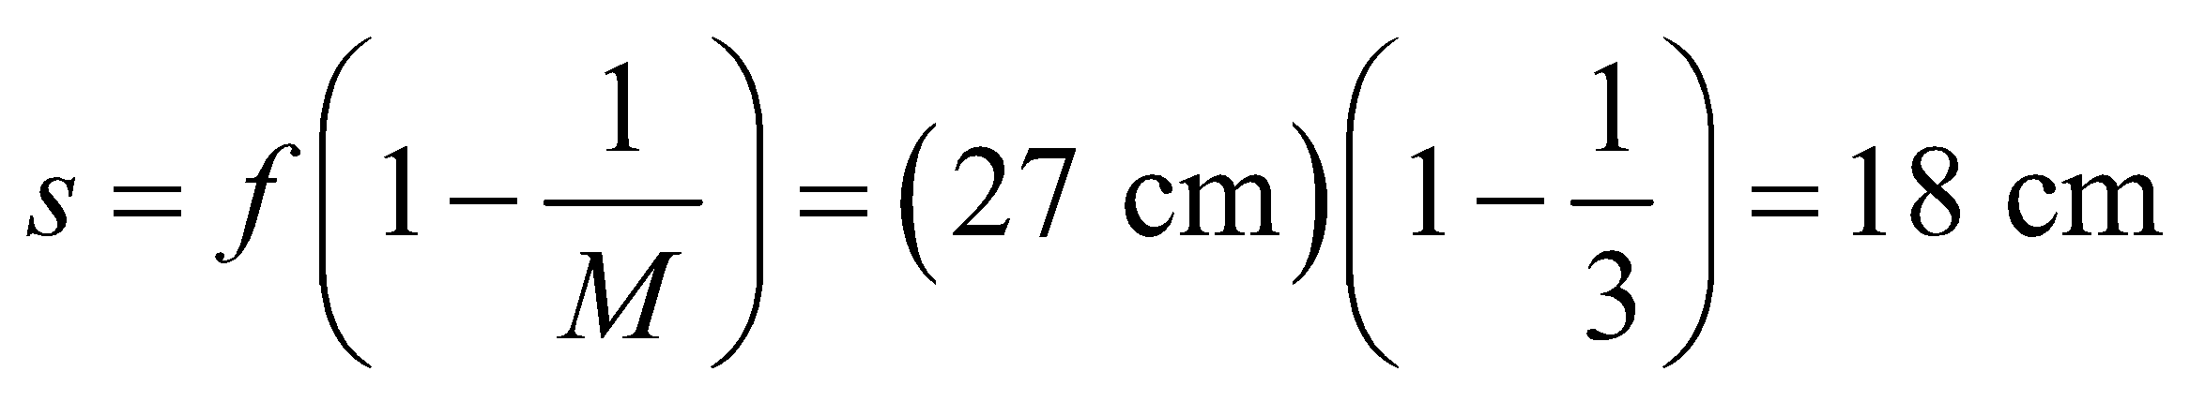

The object is in front of the mirror.

**Assess** The image distance is 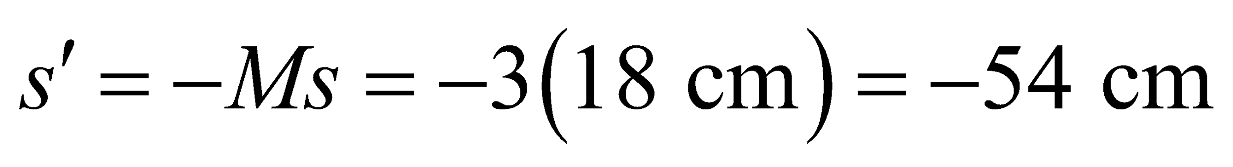. The situation corresponds to the third case depicted in Table 31.1. The mirror is concave with *s* < *f* and the image is virtual, upright, and enlarged.

**42.** **Interpret** You're designing a mirror that will produce an enlarged image of an object placed in front of it. You need to calculate the mirror's radius.

**Develop** The radius of a curved mirror is related to the focus by 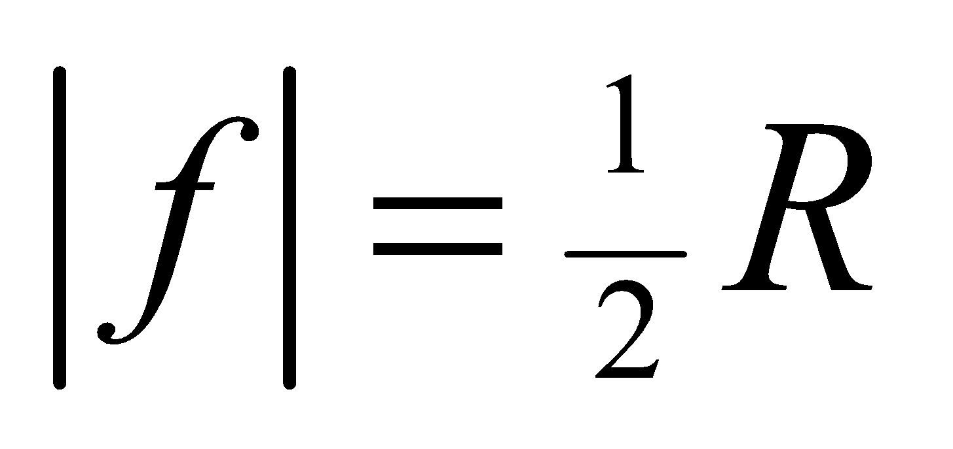 (Equation 31.3). Because the mirror is concave, the radius is positive. The magnification of the mirror is just the ratio of image and object distances from the mirror: 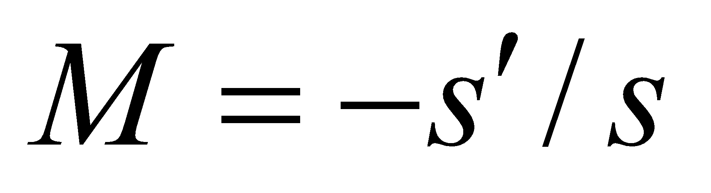 (Equation 31.1). You can solve for the radius by plugging these expressions into the mirror equation, 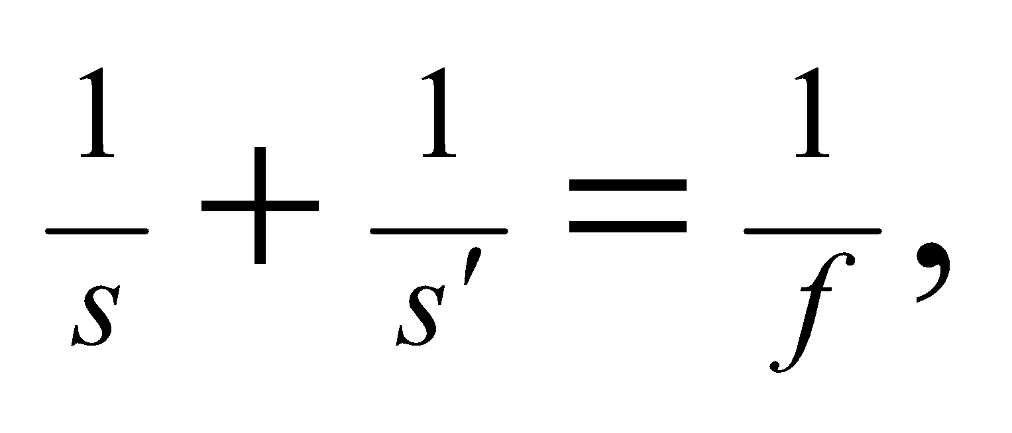

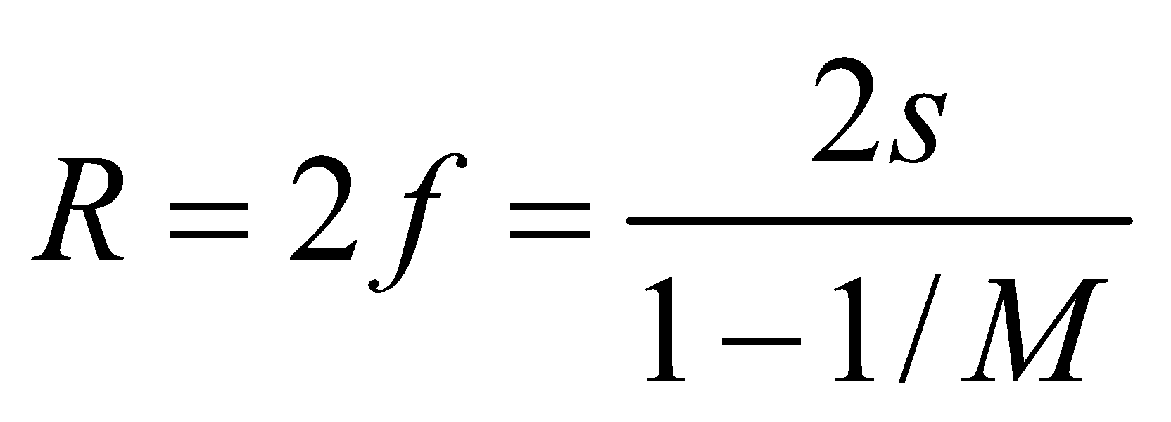

**Evaluate:** Using the values given, you find

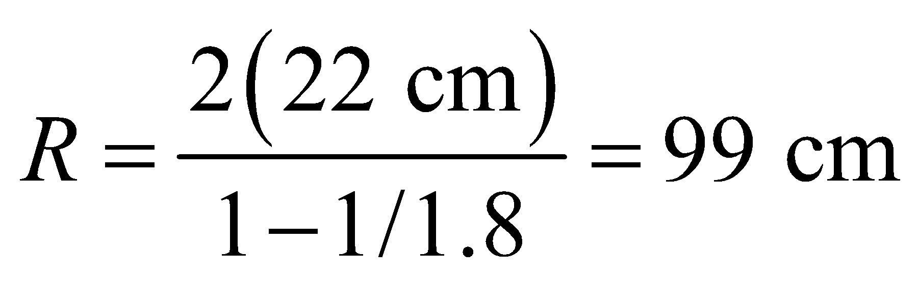

**Assess** The image is supposed to be virtual, so we can check that the distance  is negative:

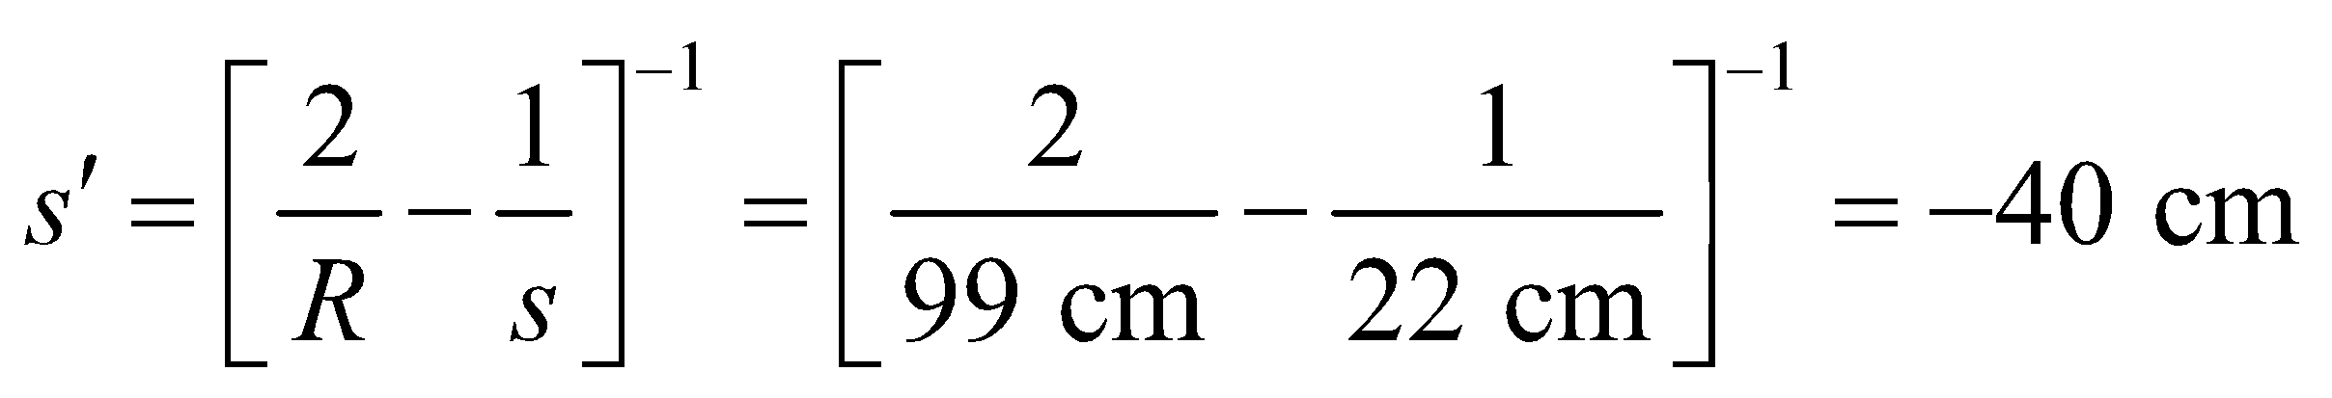

So the mirror radius is in accordance.

**43. Interpret** This problem is about the image formed by a telescope. The main mirror of a telescope is concave, since only a concave mirror can collect light from a distant object and form a real image.

**Develop** Inspection of Figure 31.6*a* (partially redrawn below) shows that the angular size of the object and image are equal

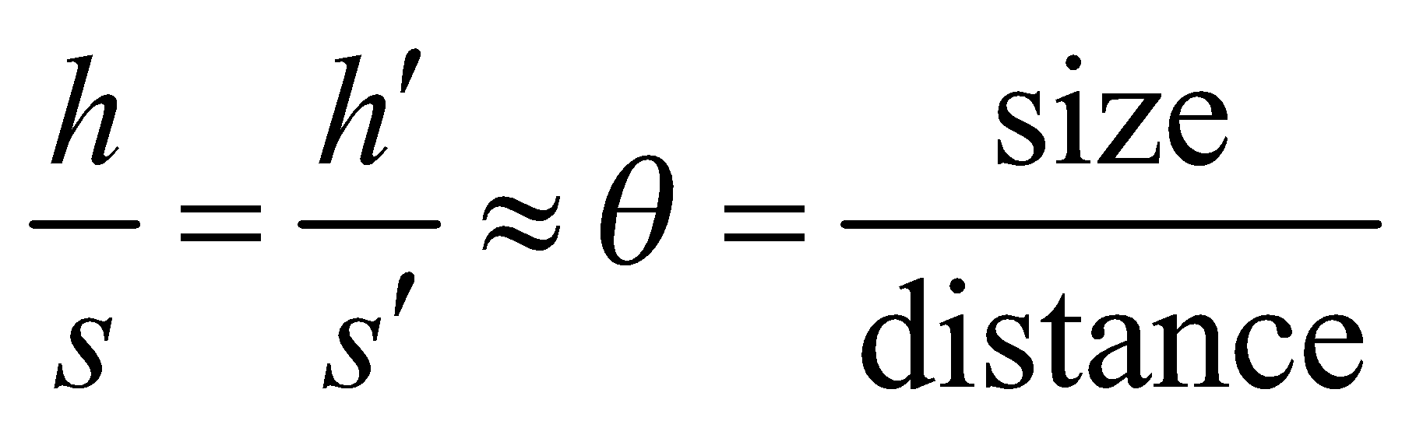

Since the object distance is astronomical,

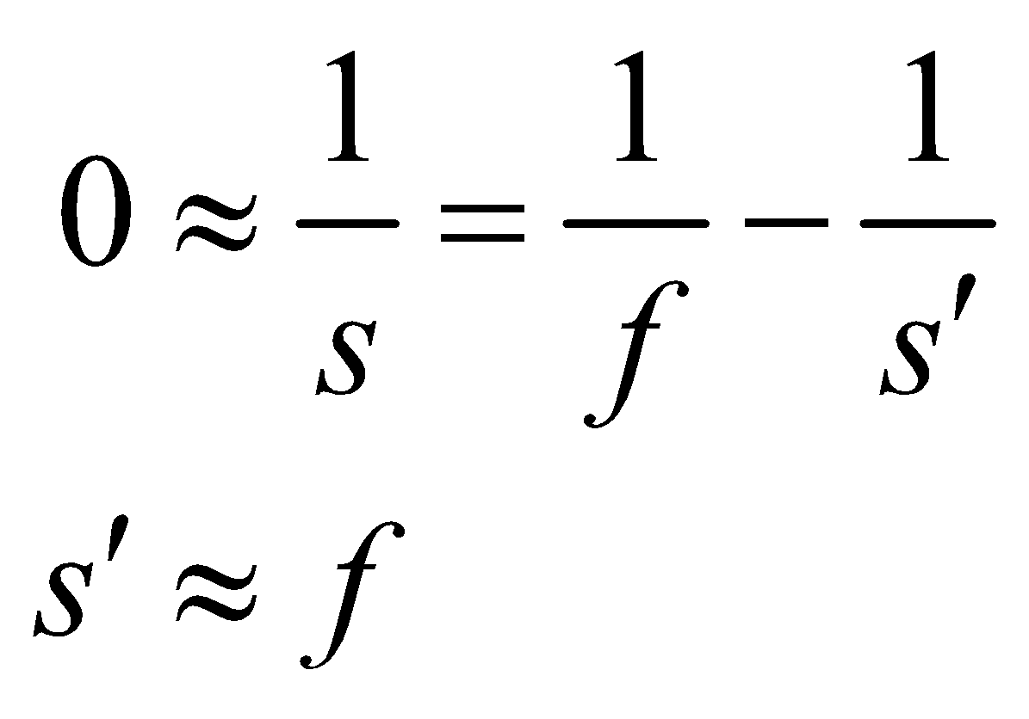

That is, the image distance is approximately equal to the focal length. It follows from the law of reflection that the angular size of the object and image are the same, as seen from the mirror.

**Evaluate** Combining the two equations above, the image size is

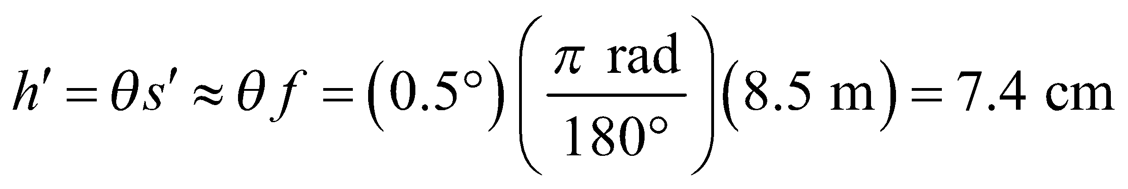

**Assess** The situation corresponds to the first case shown in Table 31.1. From the ray diagram, we see that the image is real, inverted, and reduced in size. Since *s*′ > 0, the image is in front of the mirror.



**44.** **Interpret** We are to find two object distances that give a magnification of 1.5 for a concave mirror, given the focal length of the mirror.

**Develop** Equation 31.3 gives the magnification of the mirror:



For this problem, we require 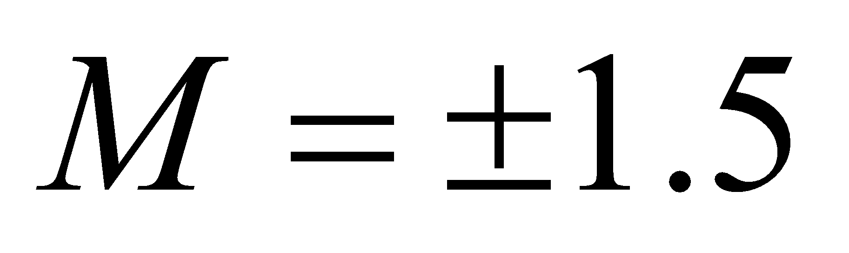 (for a virtual or real image). Use 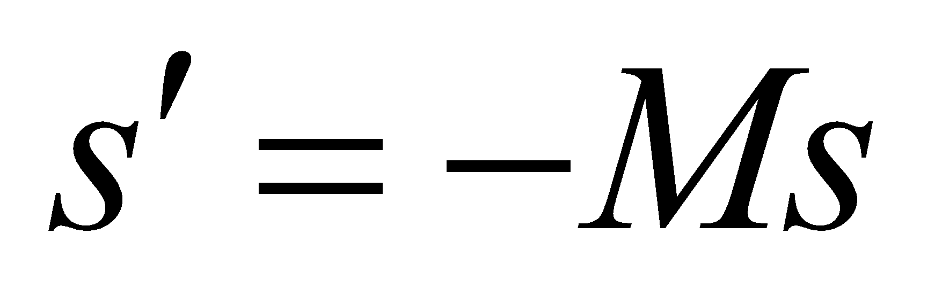 to remove the image distance *s*′ from the mirror equation (Equation 31.2), then solve for the two possible object distances.

**Evaluate** The object distances are

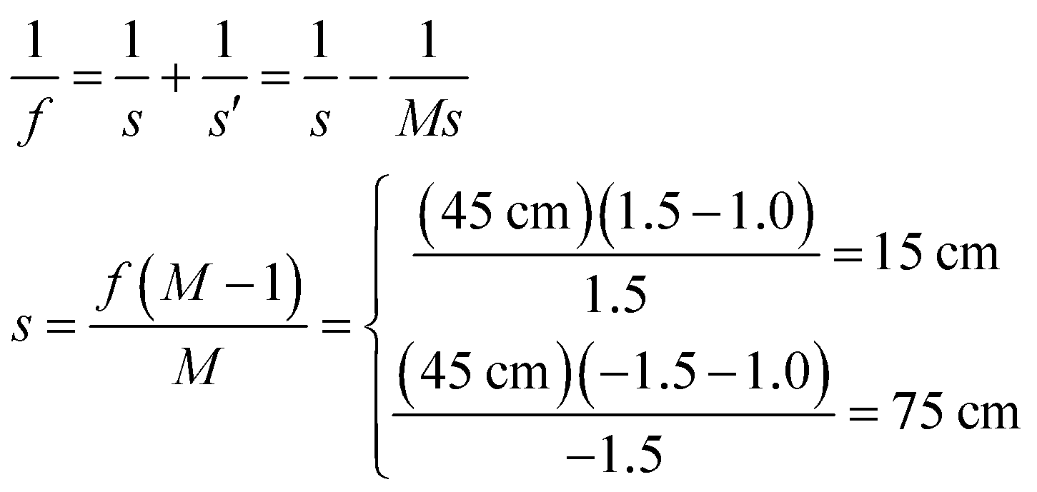

**Assess** The upper result corresponds to the upright image and the lower result corresponds to the inverted image.

**45.** **Interpret** The problem asks us where to place an LCD display in front of a lens in order to project it on a distant screen.

**Develop** The lens is convex, so the focus is positive: 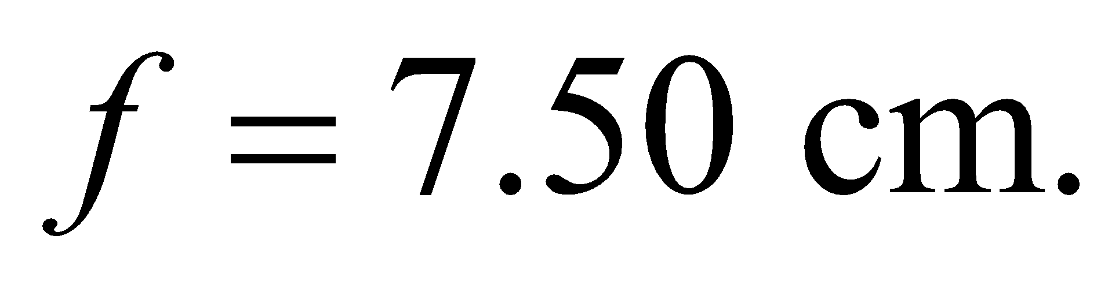 Given the distance to the screen 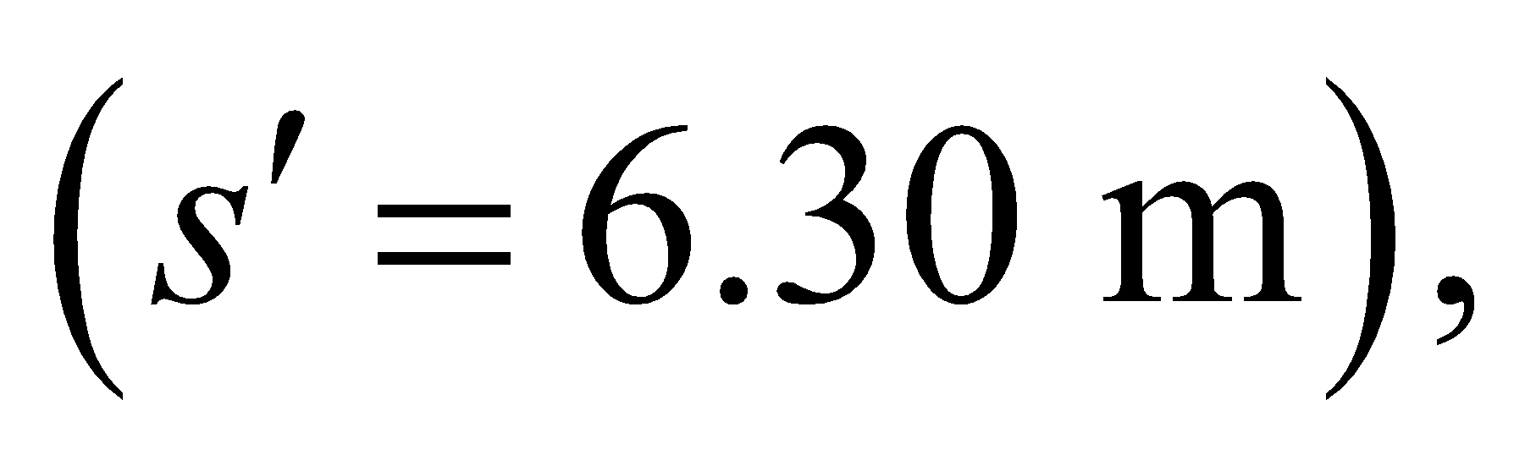we can use the lens equation, to find out how far from the lens the display should be put.

**Evaluate** Plugging in the values, we calculate

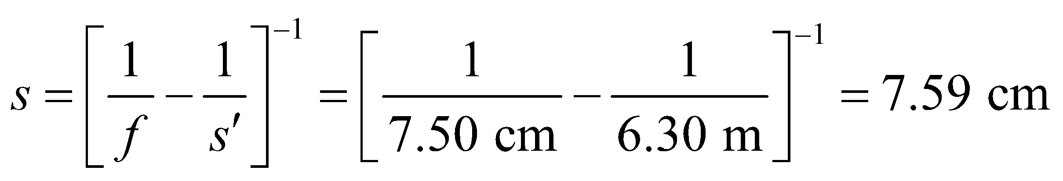

**Assess** The object distance satisfies: 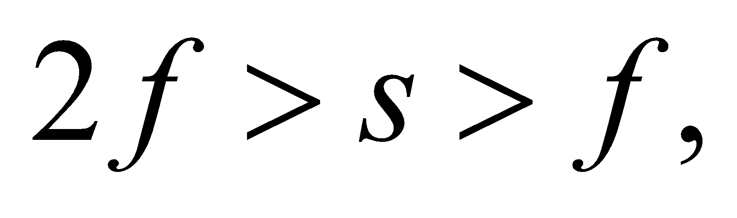 which means the image is real, inverted and enlarged (see Table 31.2). Therefore, the display will need to be upside down in order to have the projected image right-side up.

**46.** **Interpret** We are to find the focal length of a concave mirror given its image distance and the magnification.

**Develop** Apply the mirror equation (Equation 31.2) where the object distance is s = 15 cm. The image distance *s*′ may be found from the magnification (Equation 31.1):

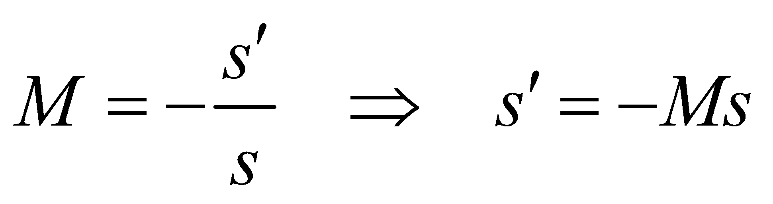

Insert this into the mirror equation and solve for the focal length *f*.

**Evaluate** The focal length is

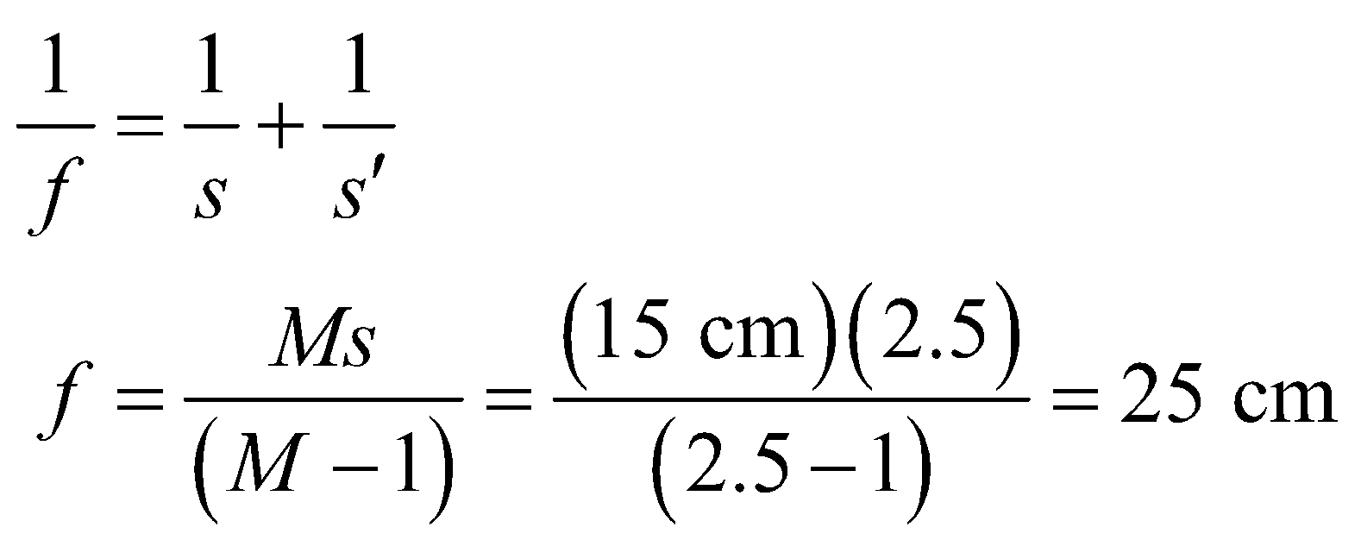

**Assess** From the magnification equation above, we see that the image is virtual, because it is on the opposite side of the mirror compared to the object distance *s*.

**47. Interpret** This problem involves finding the object distance necessary for the given converging lens to form an image with the desired magnification.

**Develop** The magnification of a thin lens, for paraxial rays, is given by Equation 31.4,

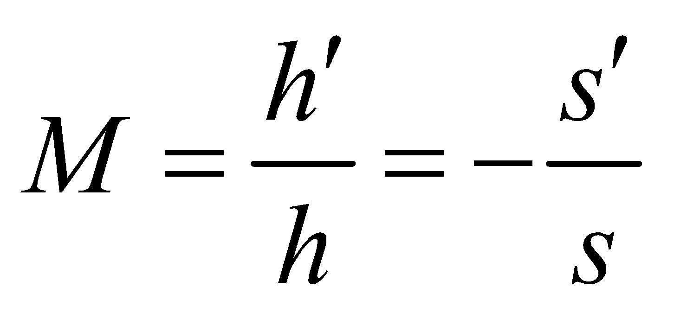

Combining this with the lens equation (Equation 31.5) to eliminate the image distance s′ gives

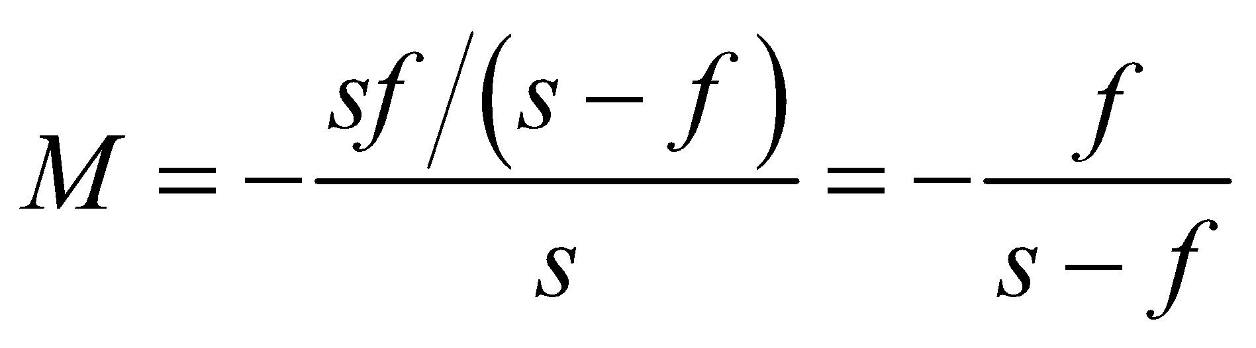

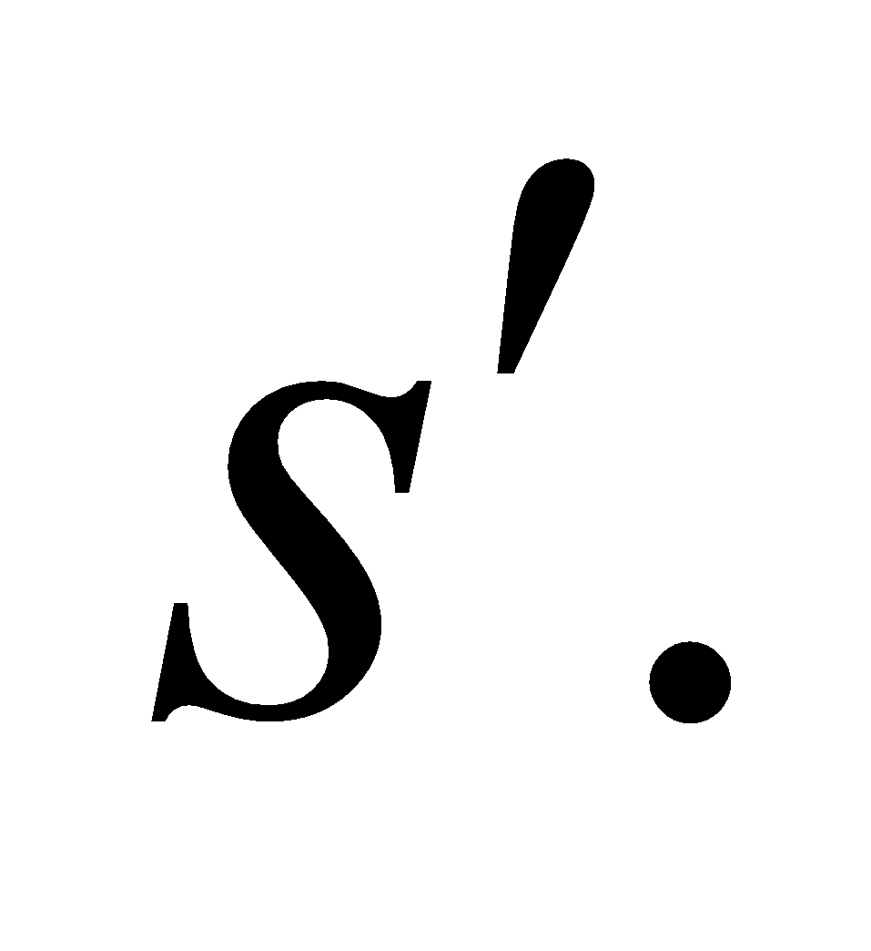 Solve this equation for the object distance *s*.

**Evaluate** When a virtual, upright image is formed by a converging lens, the magnification is positive; M = 1.6. Therefore,

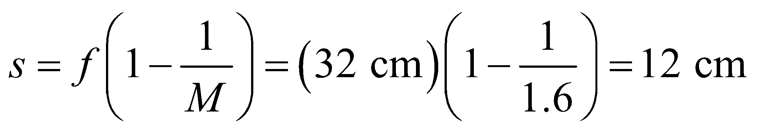

**Assess** The image formation in this problem corresponds to the third case shown in Table 31.2. With *s* < *f*, we get a virtual, upright, and enlarged image. Note that a diverging lens always produces a reduced image.

**48.** **Interpret** We are to find the image distance and the magnification by ray tracing, and then confirm our result using the lens equation (Equation 31.5).

**Develop** A reproduction of a full-scale, ray tracing diagram might appear as below. Note the four rays have been traced: (1) a ray from the tip of the arrow parallel to the lens axis that goes through the focal point on the opposite side, (2) a ray from the tip of the arrow through the center that continues undeviated, (3) a ray from the bottom of the arrow parallel to the lens axis that goes through the focal point on the opposite side, and (4) a ray from the bottom of the arrow that goes undeviated through the center of the lens. The image is then drawn between the intersection of the rays from the top and bottom of the object. The ray tracing may be confirmed by using the lens equation to find the image distance and the magnification equation (Equation 31.4) to find the magnification.



**Evaluate** The focal length is

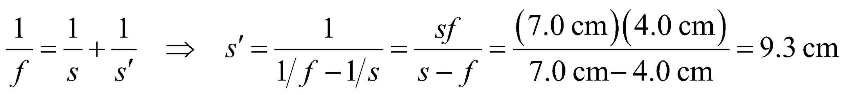

and the magnification is

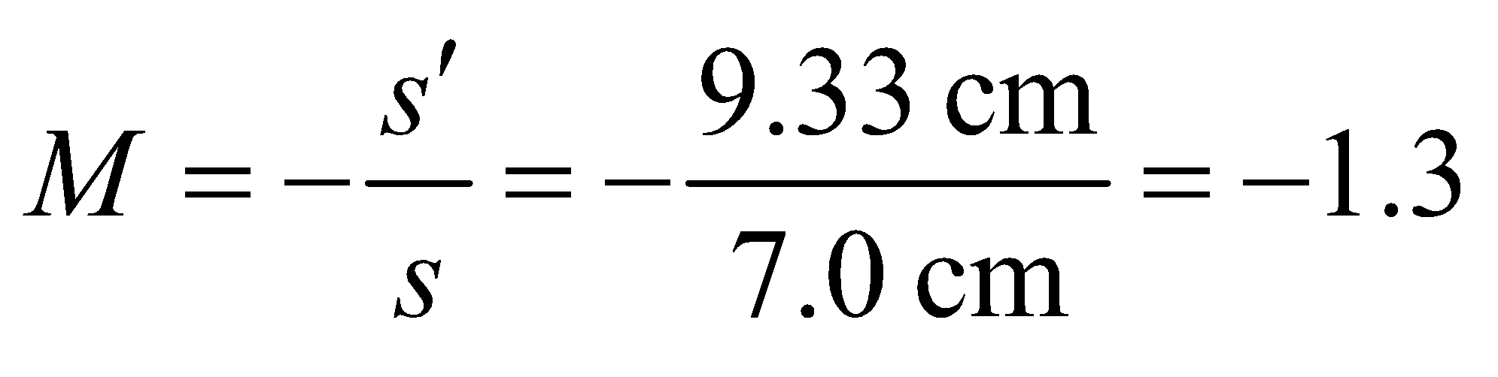

These parameters may be verified by making measurements on the figure above.

**Assess** The magnification is negative, which indicates an inverted image. This is confirmed in the drawing. In addition, the image distance is positive, indicating a real image; again, verified in the drawing.

**49. Interpret** This problem is finding the image distance and the image type (i.e., inverted, not inverted, reduced, extended, real, virtual) formed by a converging lens with the given focal distance.

**Develop** Using the lens equation (Equation 31.5) and Equation 31.4 for the magnification of a thin converging (positive *f*) lens, we obtain



so 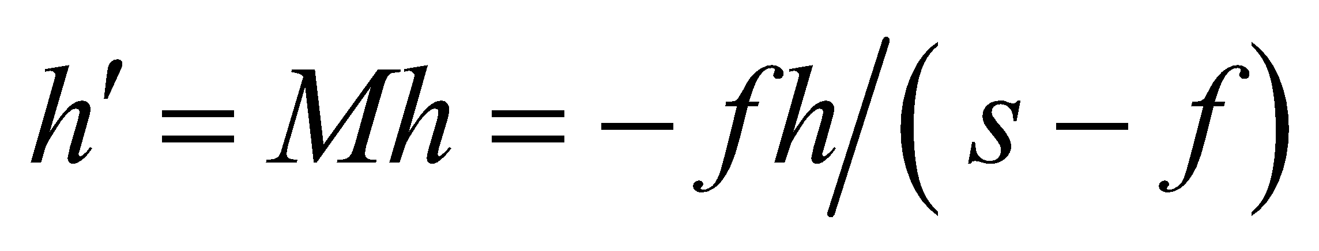 where h′ is the image height.

**Evaluate** **(a)** If *f* = 35 cm and *s* = *f* + 10 cm = 45 cm, then

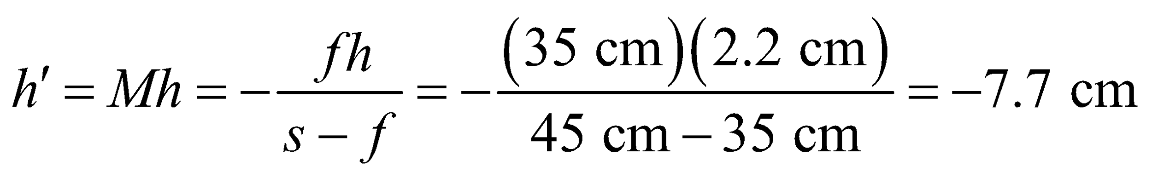

The image distance is

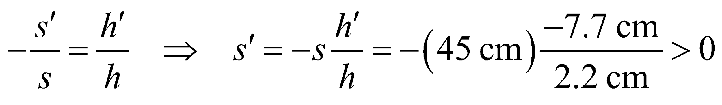

The negative image height signifies an inverted image and the positive image distance signifies a real image. In addition, the image is enlarged compared to the object.

**(b)** If *s* = *f* − 10 cm = 25 cm, then

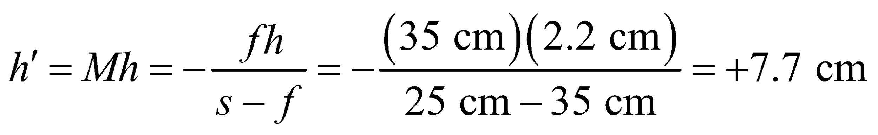

The image distance is

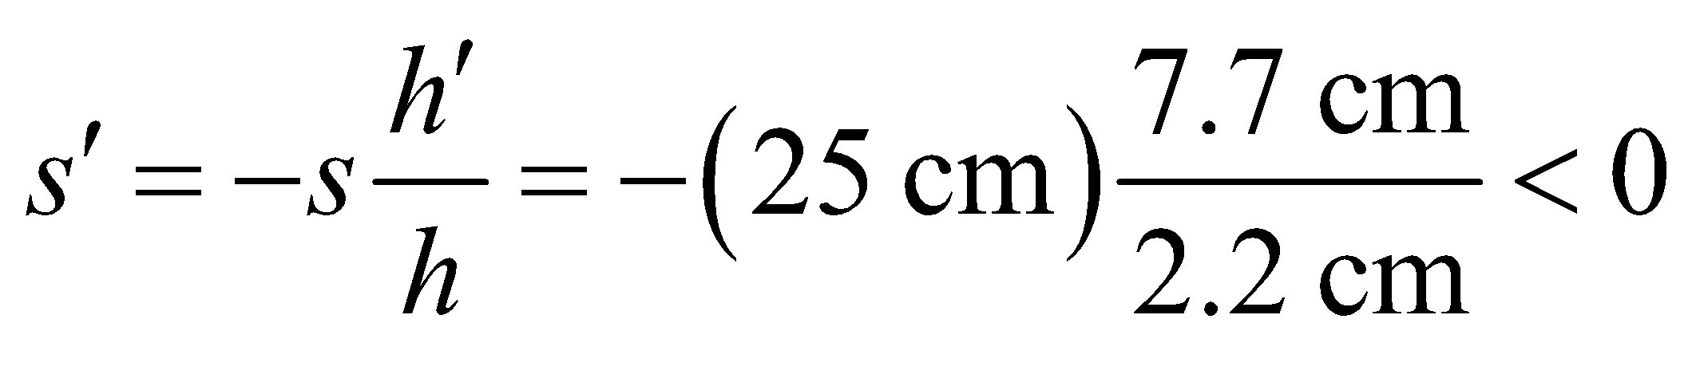

The positive image height signifies an upright image and the negative image distance signifies a virtual image. In addition, the image is enlarged compared to the object.

**Assess** The image formed in **(a)** corresponds to the second case shown in Table 31.2. With 2*f* > *s* > *f*, we get a real, inverted, and enlarged image. The situation in **(b)** corresponds to the third case shown in Table 31.2. With *s* < *f*, we get a virtual, upright, and enlarged image.

**50.** **Interpret** We are to find the distance between the object and image for a converging lens with the given focal lengths and for two different object distances.

**Develop** The distance between the object and image is 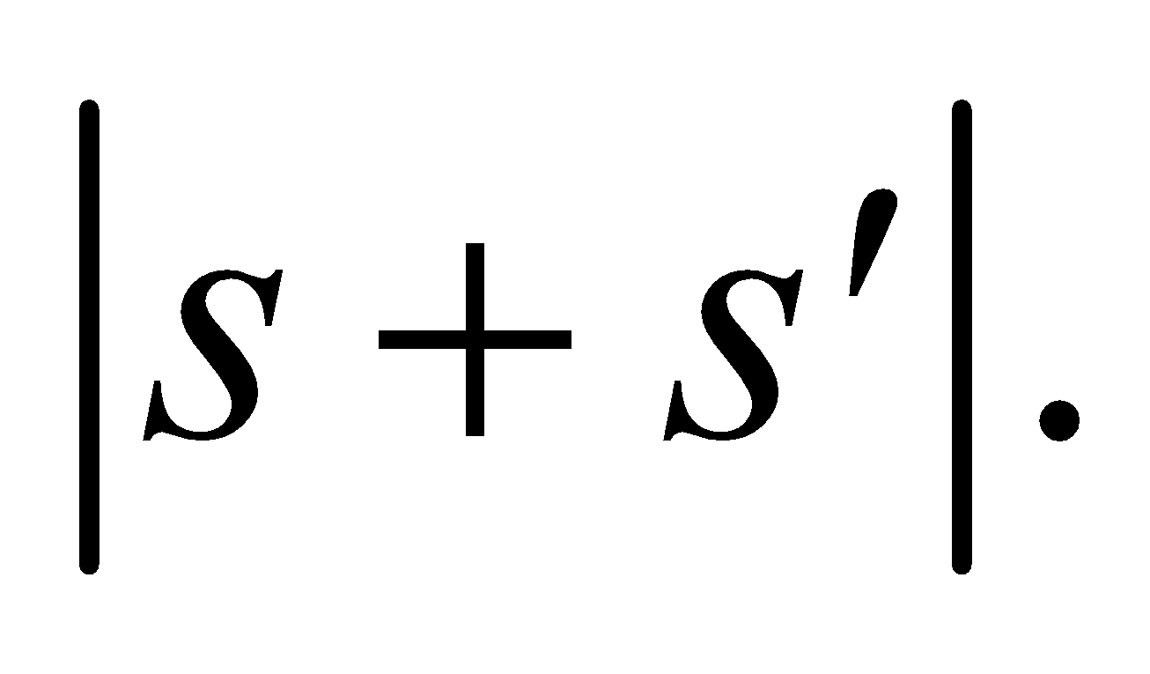 Using the lens equation to eliminate *s*′ gives

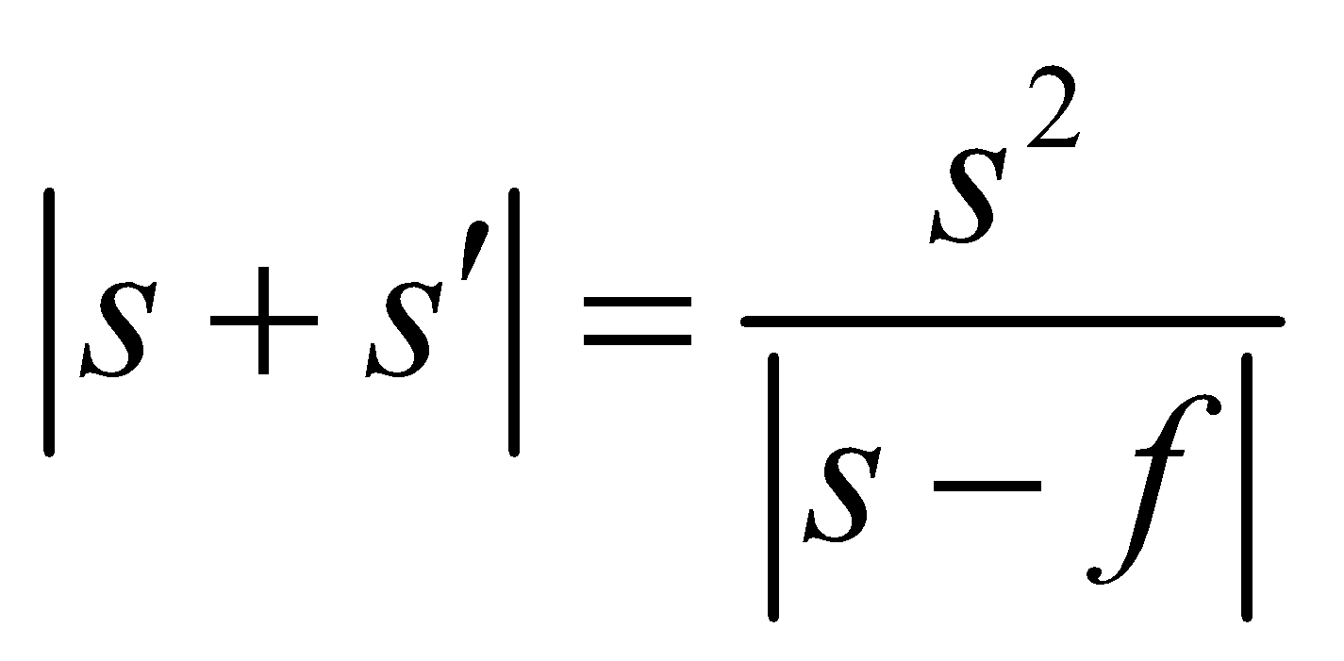

**Evaluate** **(a)** For *s* = 40 cm,

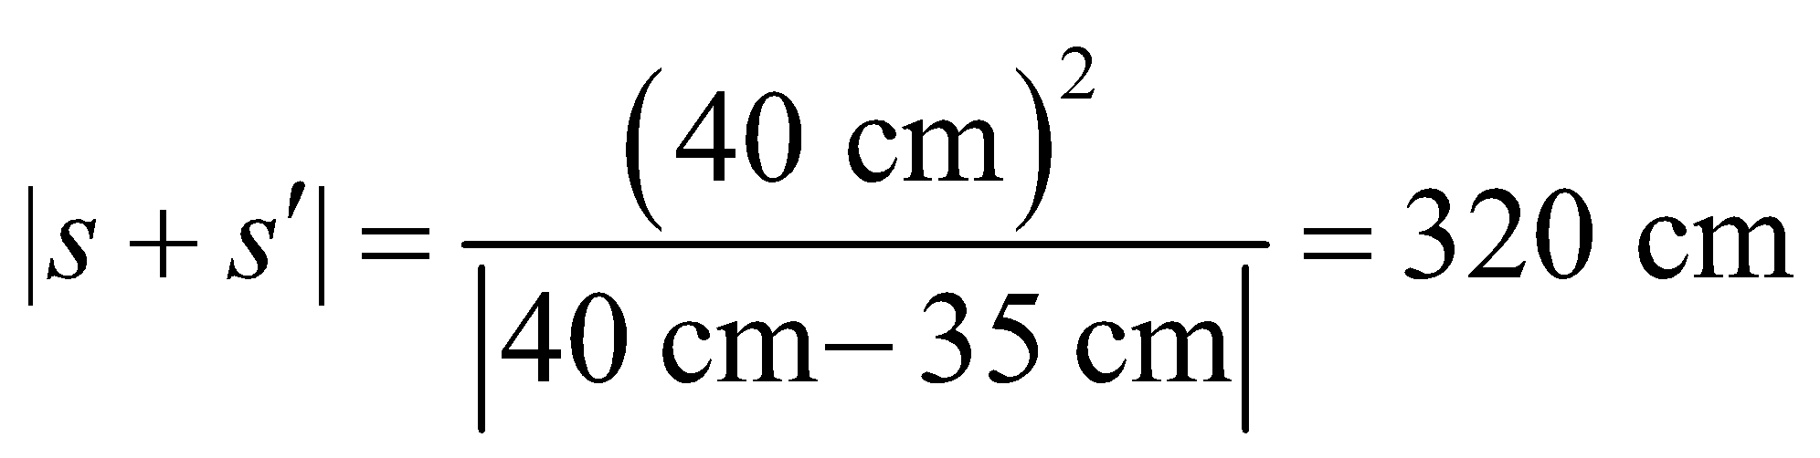

**(b)** For *s* = 30 cm,

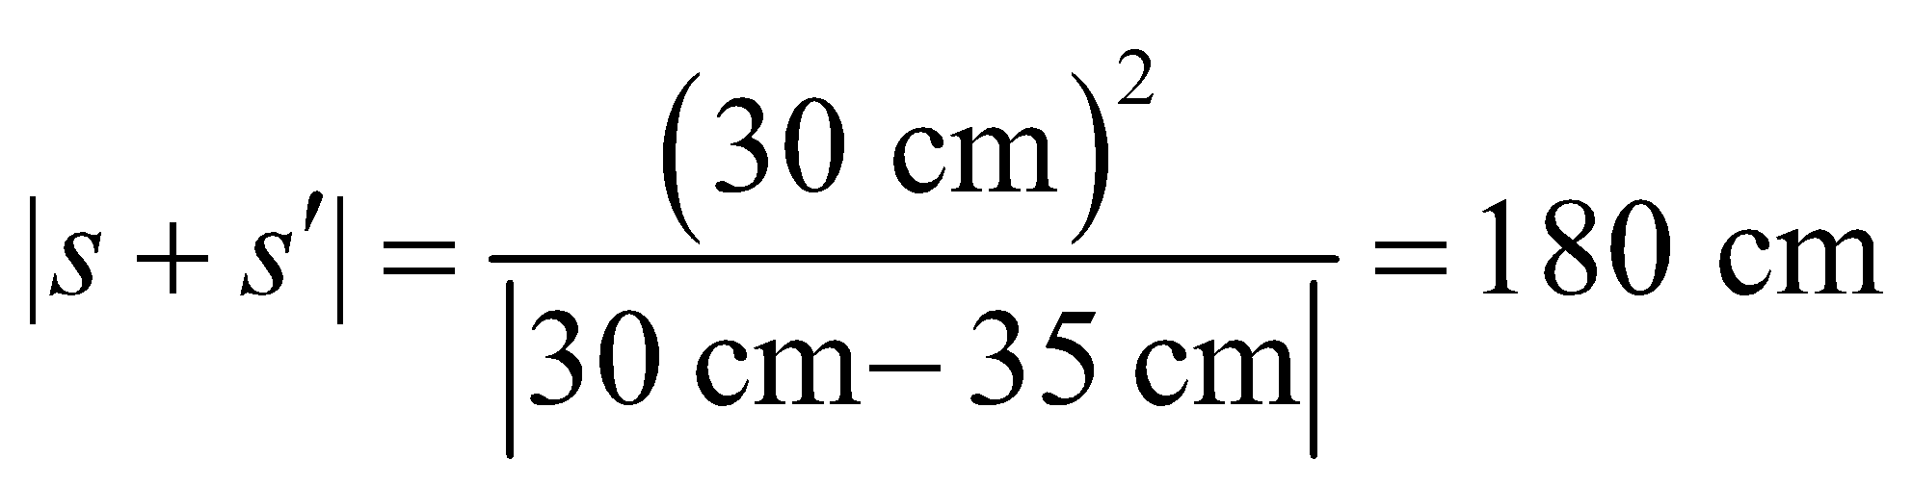

**Assess** The object-image distance is reduced when the object distance is reduced.

**51. Interpret** This problem involves finding the image formed by a convex lens. We are given the focal length of the lens, the distance between the object and the image, and are asked to locate the lens.

**Develop** Since *s* and *s*′ are both positive for a real image, and the distance 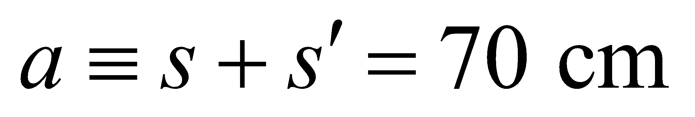 is fixed, and the lens equation (Equation 31.5) can be rewritten as

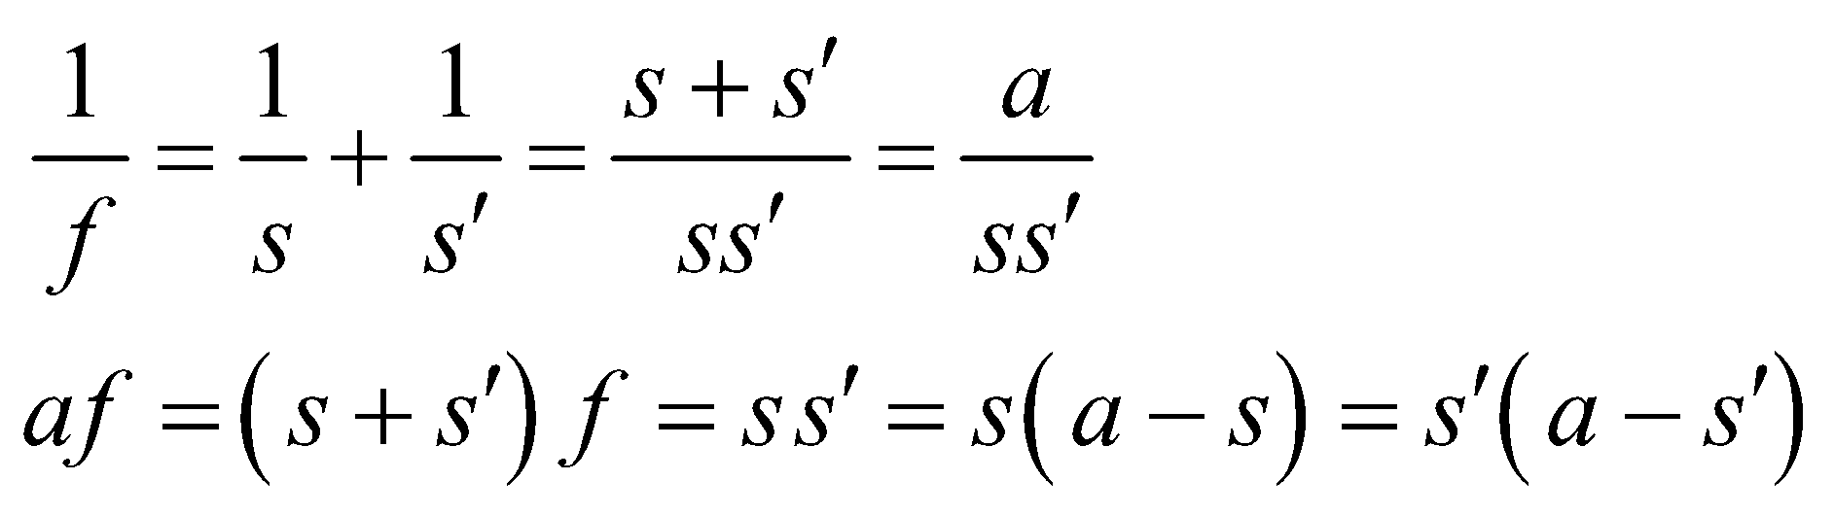

Solving the quadratic equation yields the two desired positions.

**Evaluate** The solutions for the object distance *s* (or the image distance *s*′) are

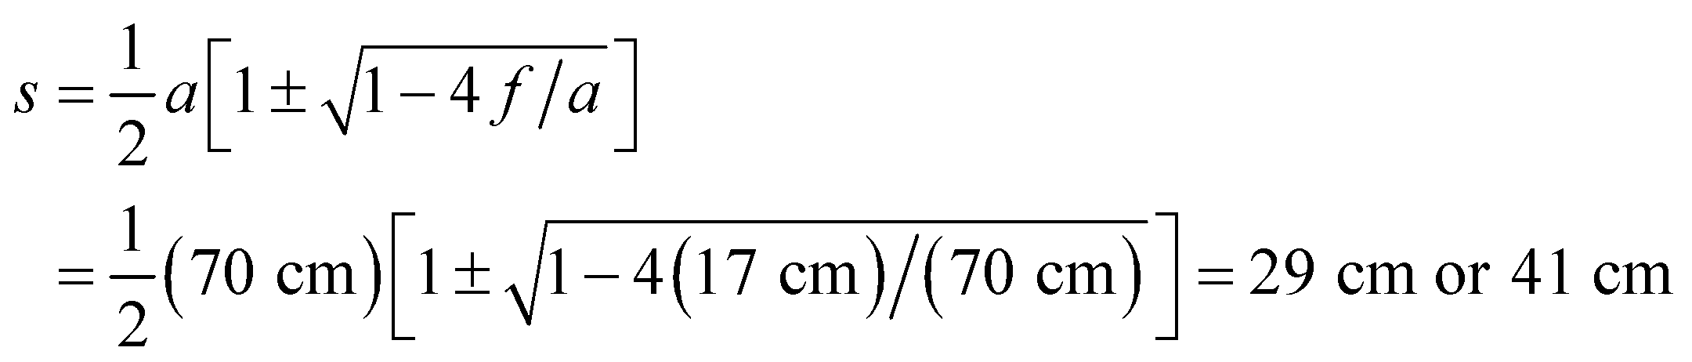

which are the desired lens locations.

**Assess**  Note that this situation has a real solution only if 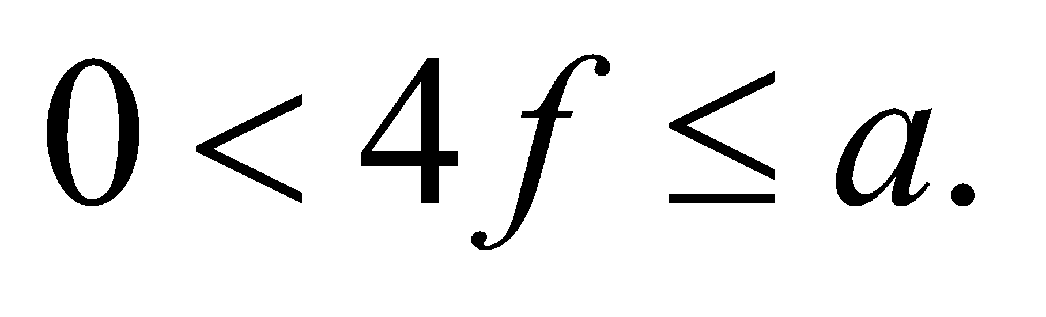 Both *s* and *s*′ are positive, as required for a real image.

**52.** **Interpret** We are to characterize the image formed by a diverging lens when an object is positioned at two focal lengths from the lens.

**Develop** Review Figure 31.20 to determine the type of image produced by a diverging lens. For part (b), apply Equation 31.4 in the form

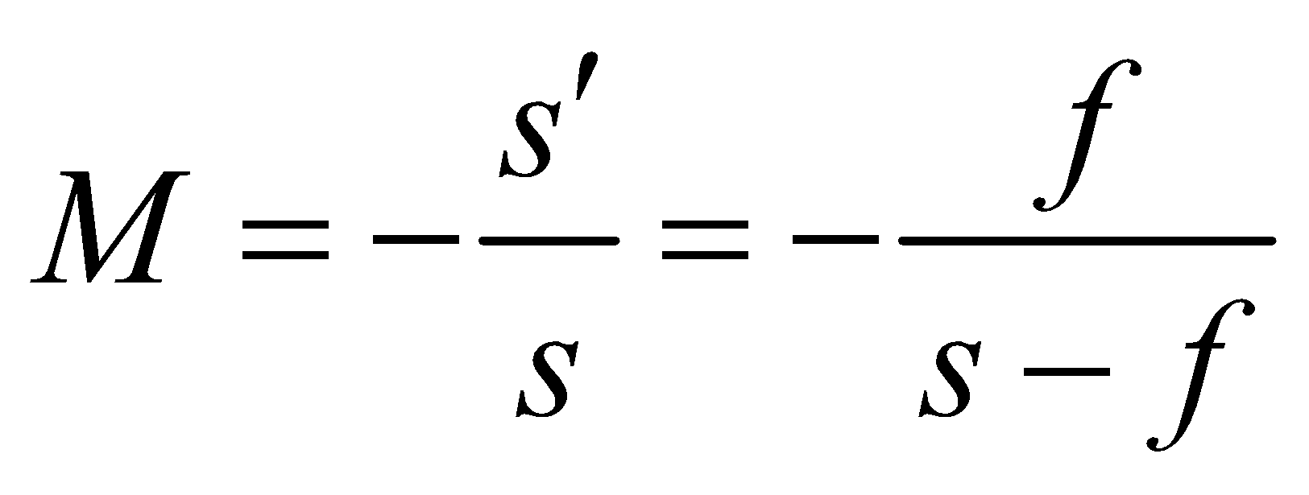

and recall that *f* < 0 for a diverging lens. Finally, to locate the image, use the lens equation (Equation 31.5).

**Evaluate** **(a)** According to Figure 31.20, a single diverging lens will always produce a virtual image.

**(b)** Because *f* < 0, 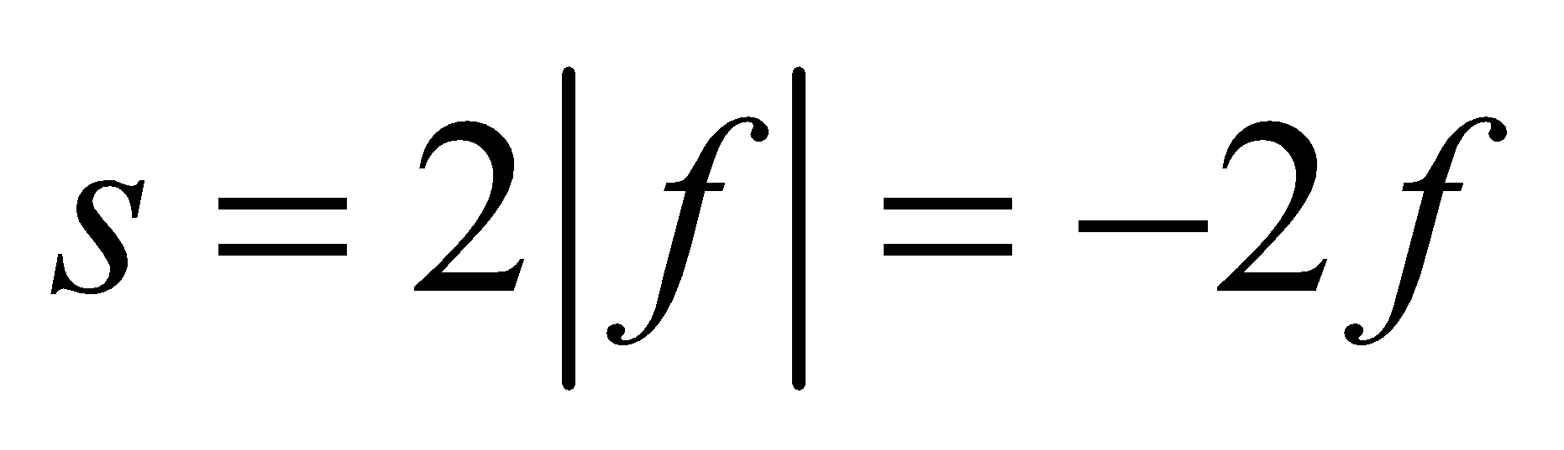 in this problem. Thus,

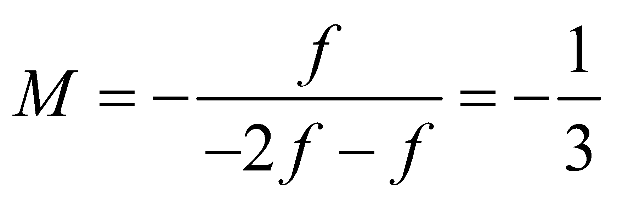

**(c)** The image distance *s*′ is

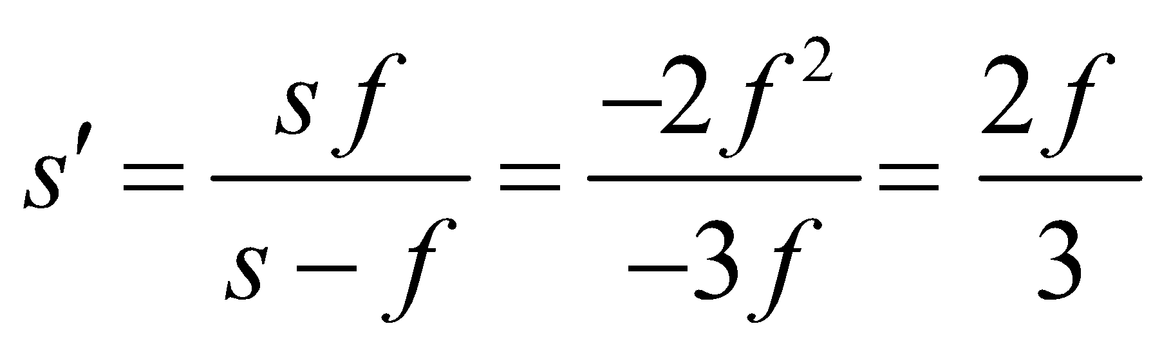

which is negative (on the same side of the lens as the object).

**Assess** Because the object distance is greater than the focal length, the image distance is less than the focal length, as we found in this problem.

**53. Interpret** We are to find the object distance needed to produce an upright image with the given magnification for the given converging lens.

**Develop** Using the lens equation (Equation 31.5) and Equation 31.4 for the magnification for a thin converging (positive *f*) lens, we obtain



so 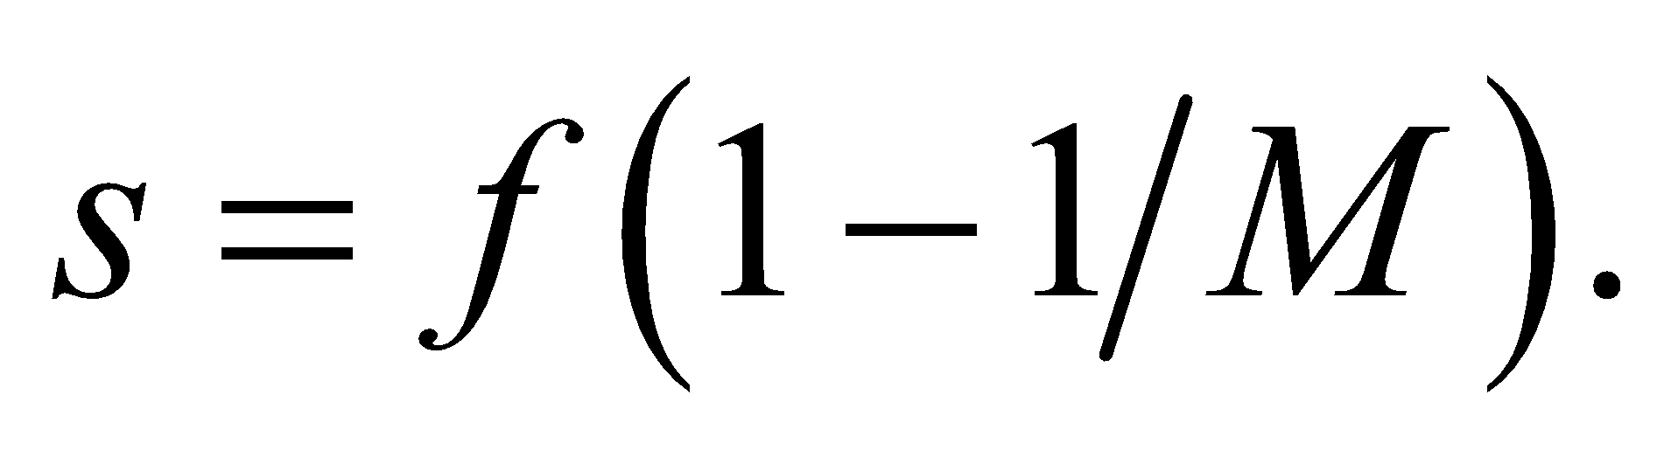 Because the image is upright, the magnification is positive: *M* = 1.8.

**Evaluate** From the above equation, we get

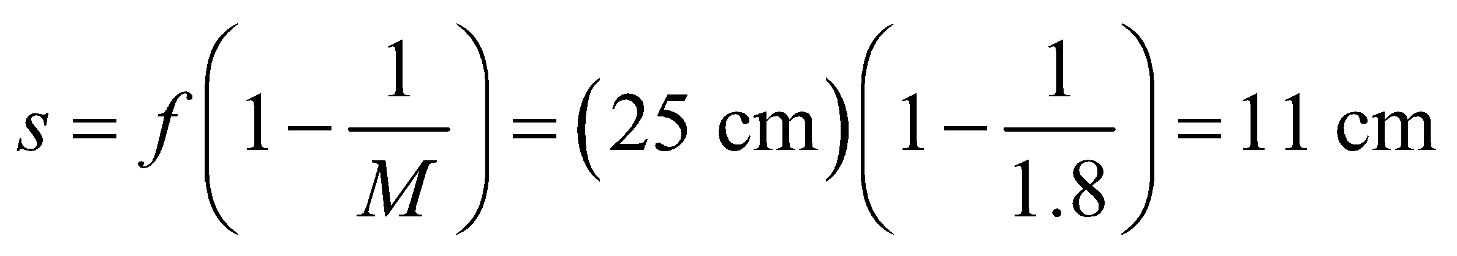

**Assess** Since *s* < *f*, the situation corresponds to the third case shown in Table 31.2. The image is virtual, upright, and enlarged.

**54.** **Interpret** We are to find the possible object distances and magnification for the given lens, with the criteria that the object-image distance is 2.4 m.

**Develop** If the distance between the object and the real image is *L* = *s* + *s*′ (all positive), the lens equation 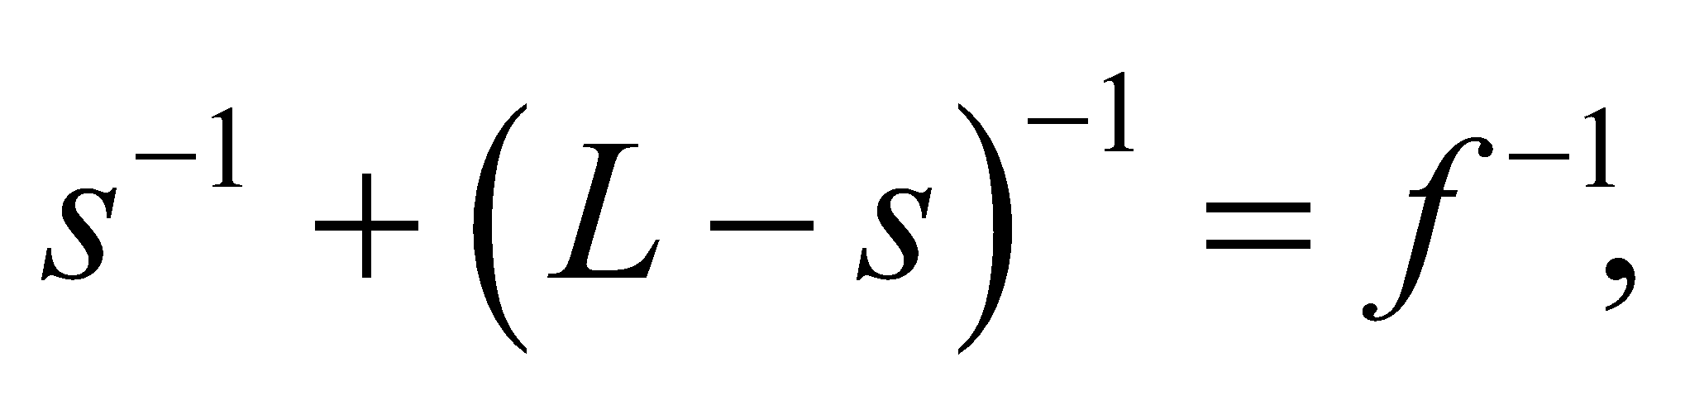 can be rewritten as 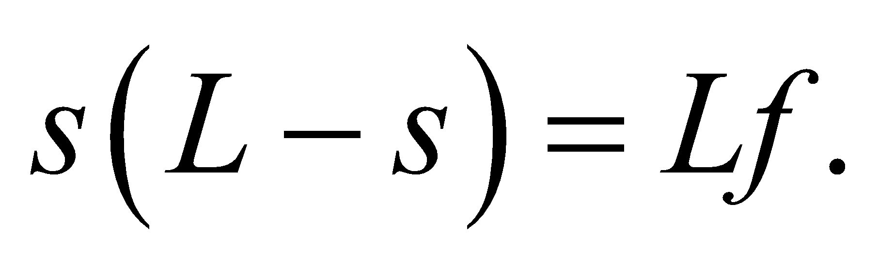 This quadratic in *s* has solutions 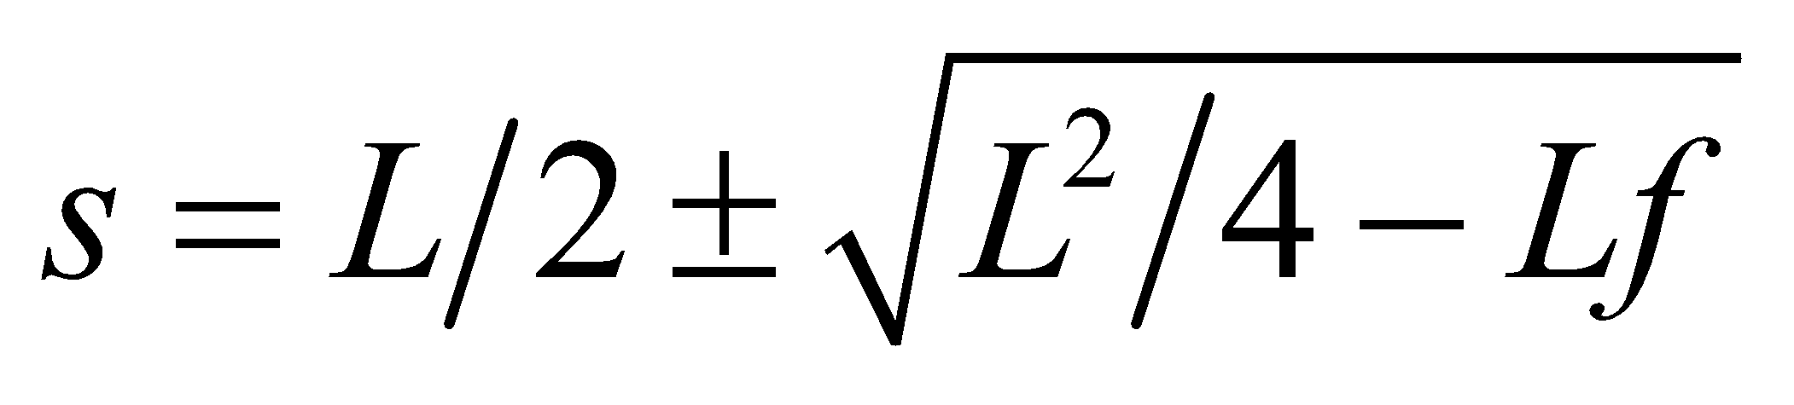. The corresponding magnifications are 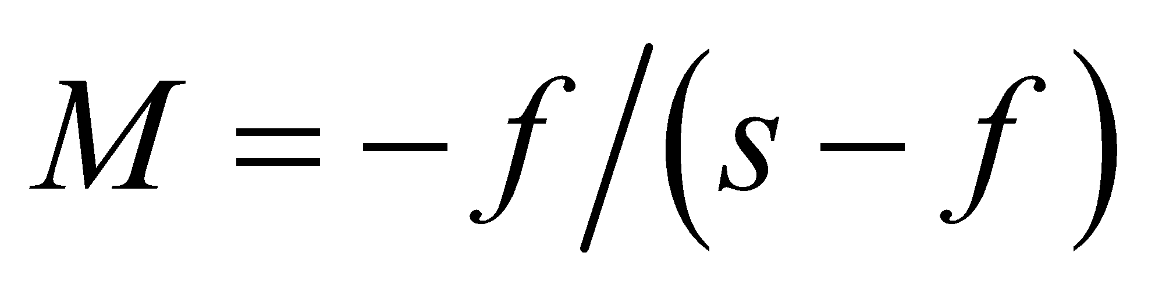.

**Evaluate** **(a)** The solutions to the quadratic in *L* are



**(b)** The respective magnifications are

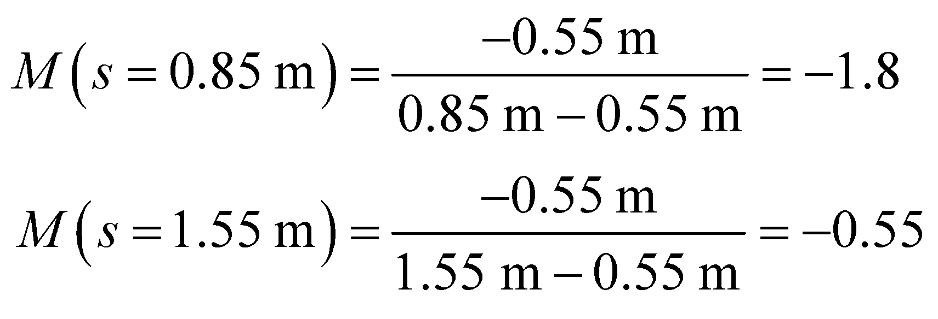

**Assess** Since the image and object distances satisfy the same quadratic, 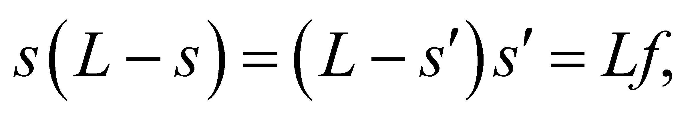 their numerical values are conjugates. Compare with the solution to Problem 31.51.

**55. Interpret** This problem involves image formation by a refracting plano-convex lens.

**Develop** The focal length of the lens is given by the lens maker’s formula in Equation 31.7,

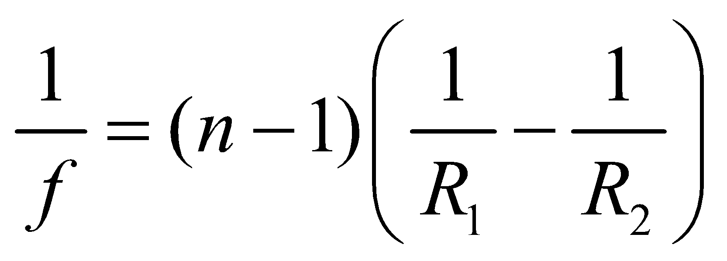

With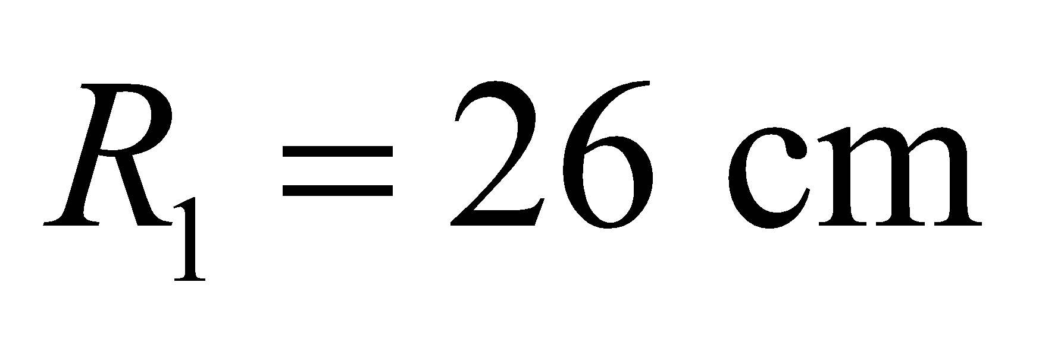and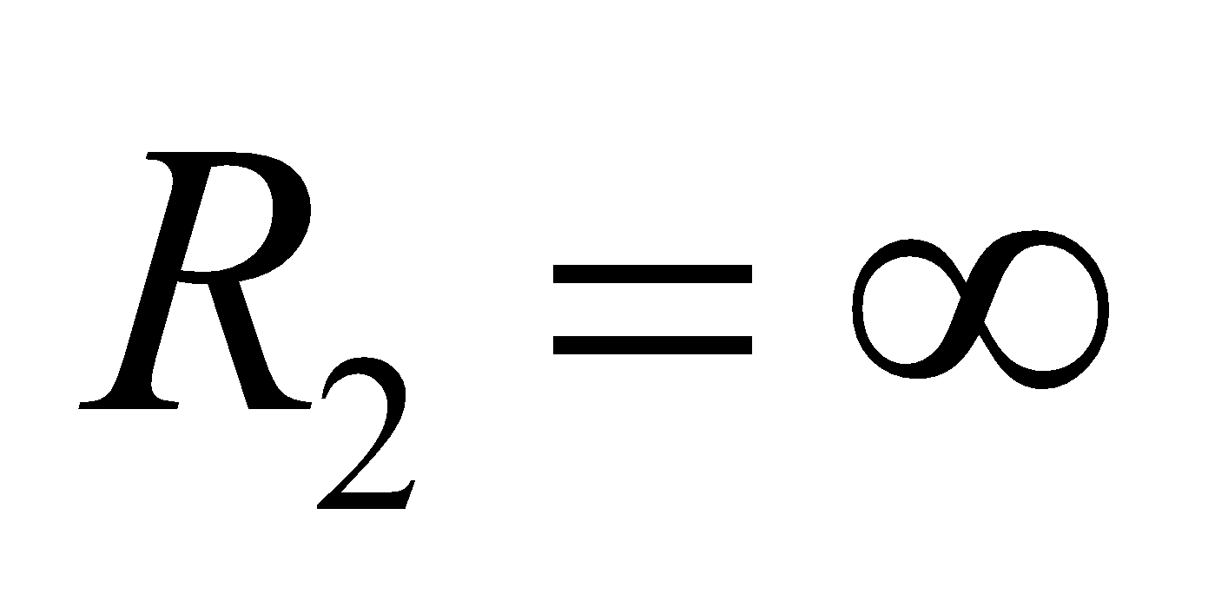(or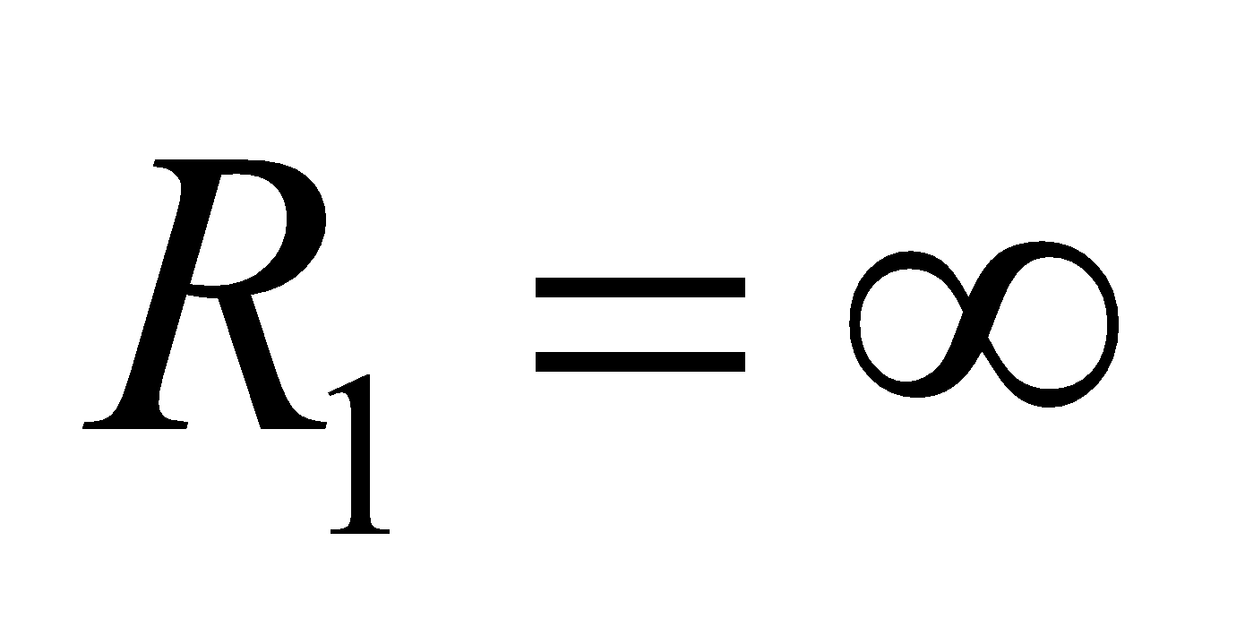and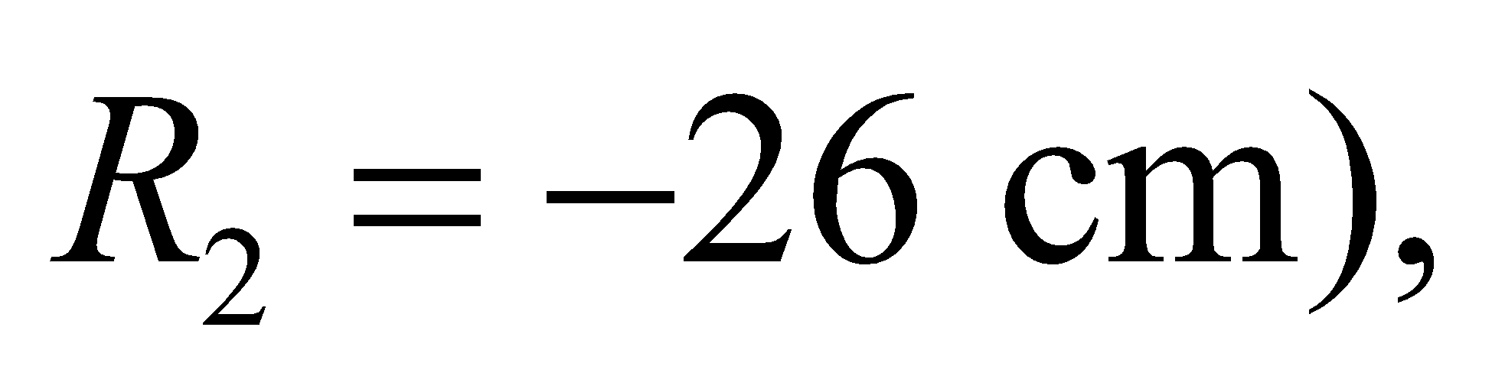the focal length is

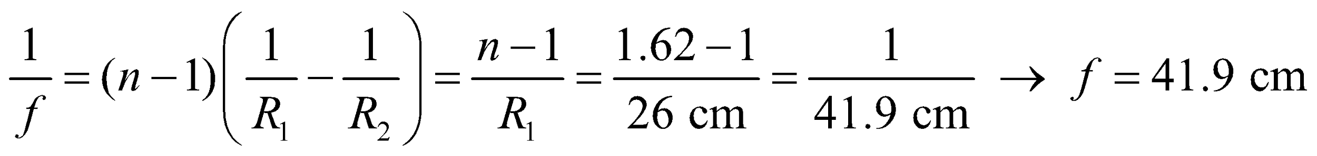

**Evaluate** An object at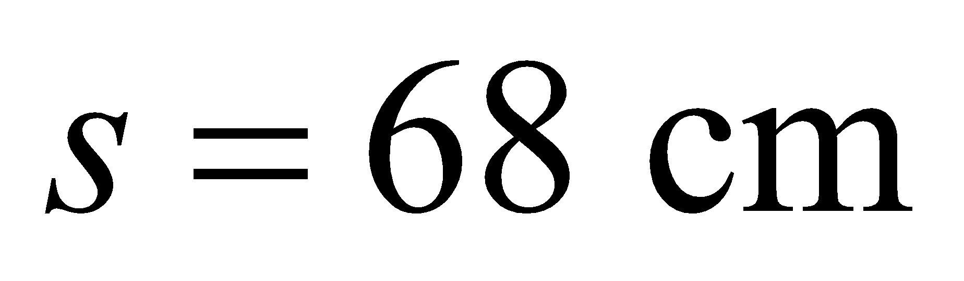has its image at

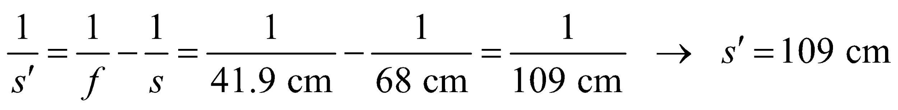

This is a real, inverted image, on the opposite side of the lens from the object.

**Assess** The image formed corresponds to the second case shown in Table 31.2. With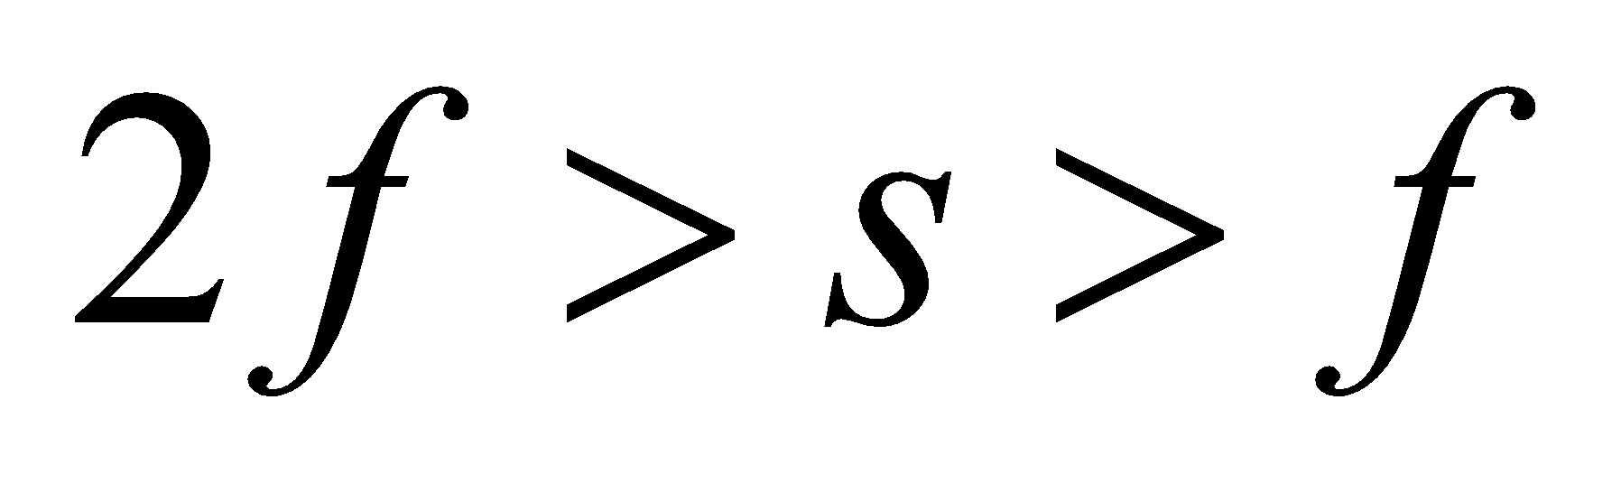and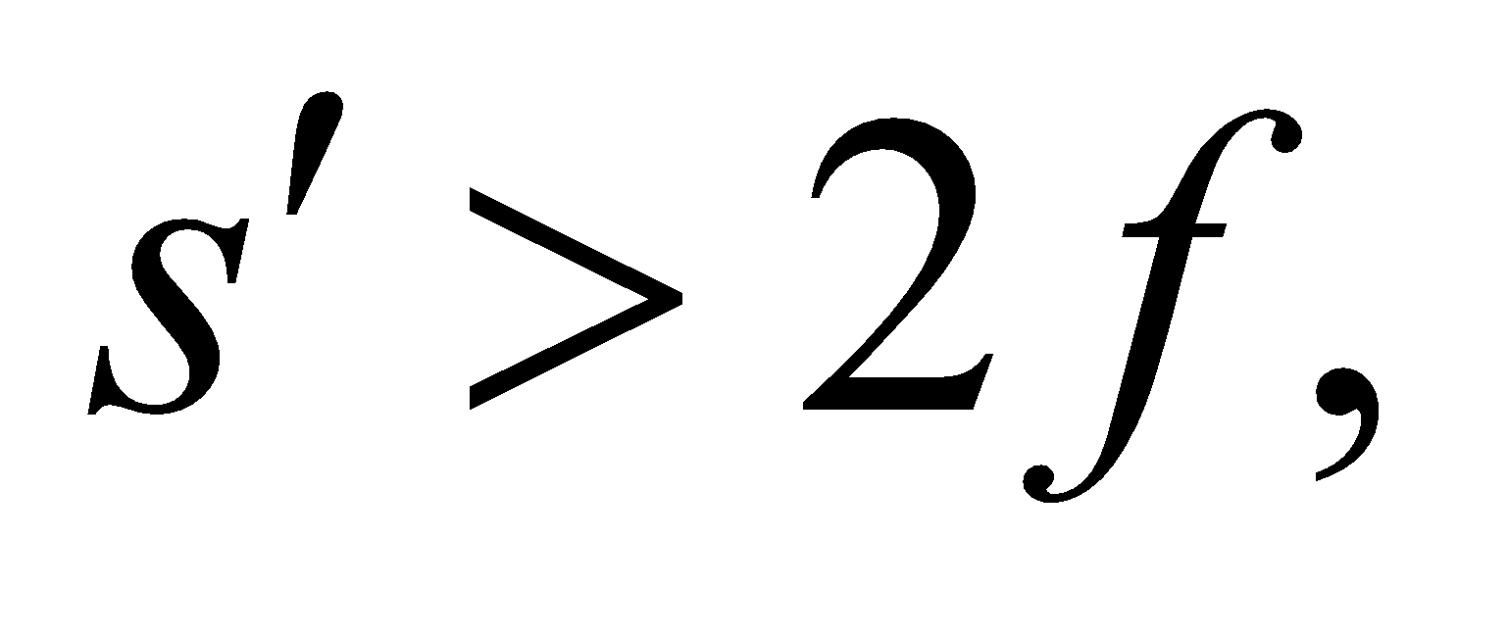  
we get a real, inverted, and enlarged image.

**56.** **Interpret** Using Equation 31.6, we are to show that an object at the center of a transparent sphere will appear to be one radius from the sphere’s surface.

**Develop** Solving forin Equation 31.6 gives us

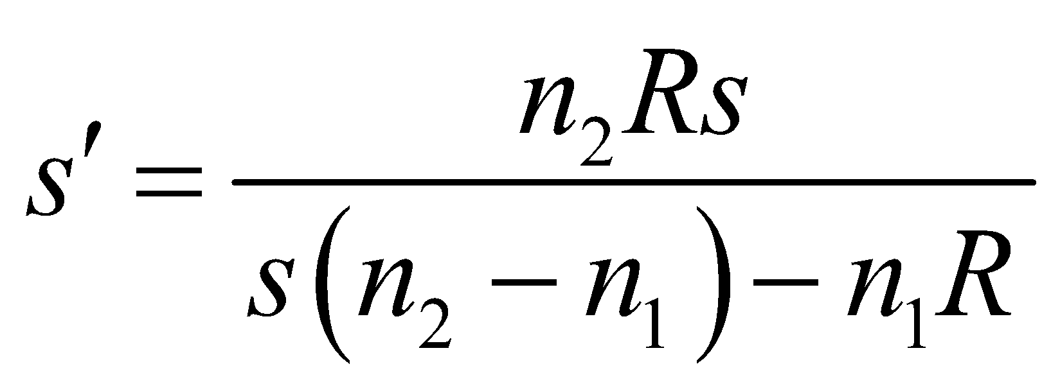

If the object is at the center of a glass sphere, then *s* = |*R*| (note that *R* < 0 because the sphere is concave toward the object). In addition *n*2 = 1 because we are viewing the object from outside the sphere (i.e., outside the lens).

**Evaluate** **(a)** Inserting the values for s and n2 into the expression above gives

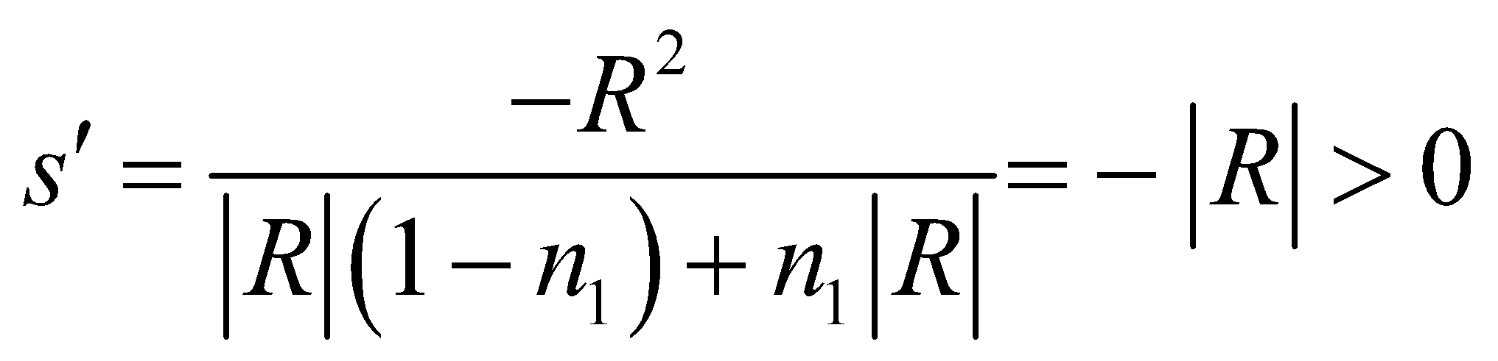

This represents a virtual image, on the same side of the surface as the object, a distance |*R*| from the surface. In other words, it’s at the center, coincident with the object.

**Assess** This result is to be expected because all the rays from an object at the center of curvature strike the surface normally and are not refracted (see the diagram below).



**57. Interpret** As seen in Example 31.4, this problem involves image formation by the water in the aquarium, which forms a two-dimensional concave refracting spherical surface. The “lens” is concave toward the object, so the radius is negative.

**Develop** The image formed by a refracting interface is described by Equation 31.6,



The equation can be used to solve for the apparent distance *s*′.

**Evaluate** With *R* = −35 cm ,for water, *s* = 70 cm − 15 cm = 55 cm (distance from the near wall), and  for air, the expression above gives an image distance of

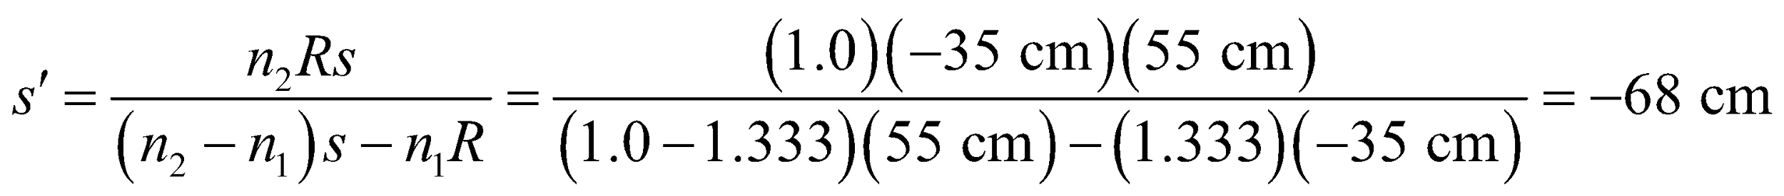

A negative image distance means that the image is virtual.

**Assess** In this case, the object is closer to the refracting surface than its image (see sketch below and compare with Figure 31.23*b*).



**58.** **Interpret** This problem involves refraction at the curved interface between water and air. The object (your nose) is 15 cm from the refracting surface and we are to find the image distance.

**Develop** Apply Equation 31.6 with *n*1 = 1.00 (the object is in air), *n*2 = 1.333 (water), *s* = 15 cm, and the surface is concave toward the object so *R* = −35 cm.

**Evaluate** Solving Equation 31.6 for the image distance *s*′ gives

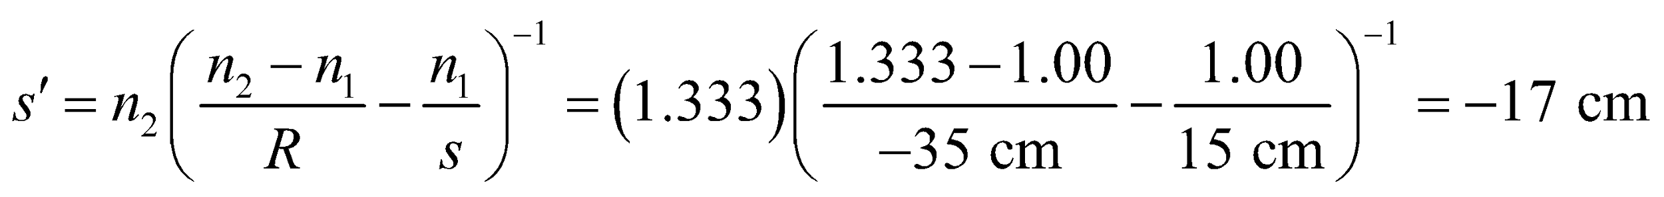

The distance is negative because it’s a virtual image, so the actual distance perceived by the fish is 17 cm.

**Assess** Thus, if the fish were to try to bite your nose, its aim would be 2 cm too long.

**59. Interpret** This problem involves image formation by a refracting crystal ball. We are interested in the index of refraction of the ball and are given the object and image distance of the center speck (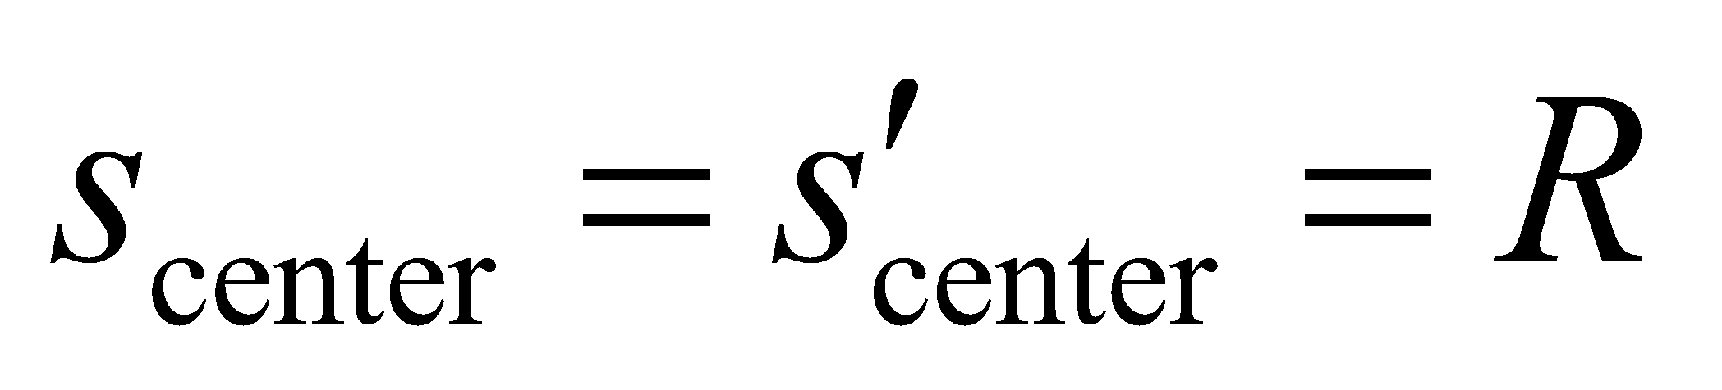, see Problem 31.56) and the image and object distance of the outer speck.

**Develop** The image distance of the outer speck is 1/3 of the distance to the center of the ball, so 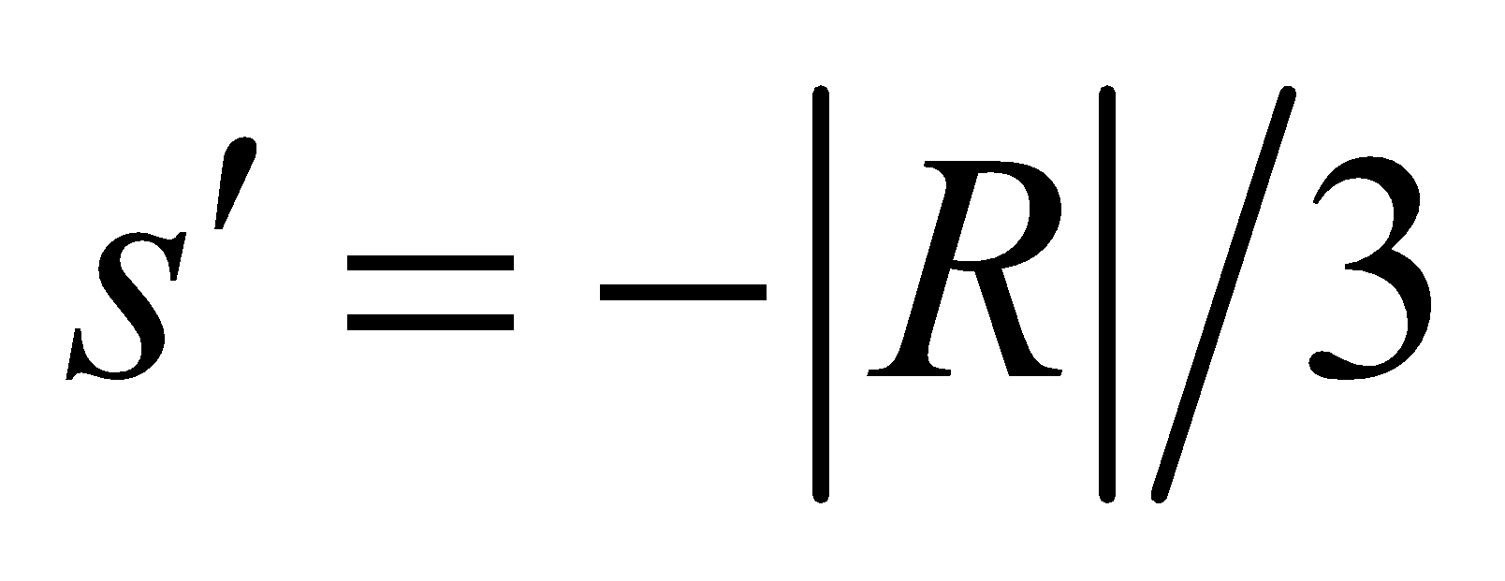. The object distance of the outer speck is given as 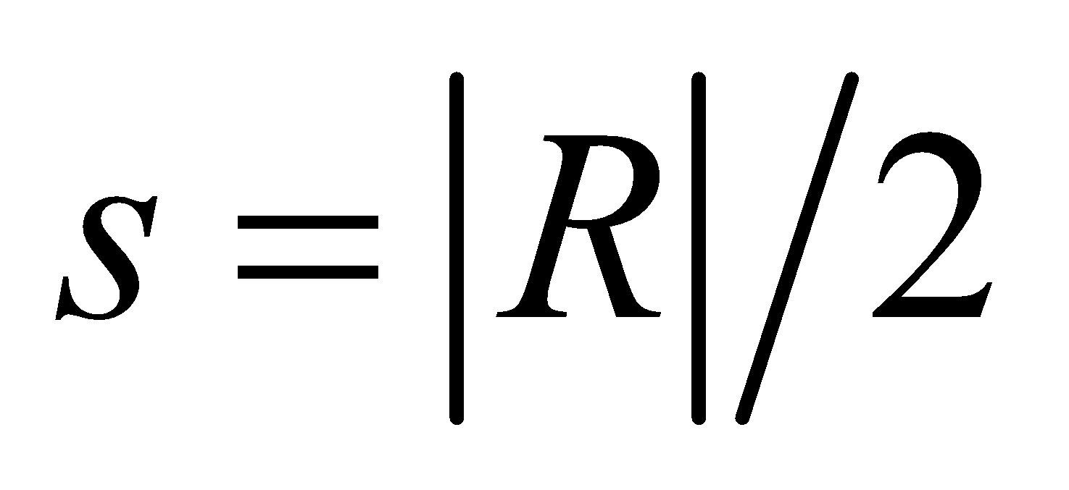. We can then solve for Equation 31.6



for *n*1, which is the index of the material containing the object (i.e., the ball).

**Evaluate** Equation 31.6 (with *n*1 for the ball’s material, *n*2 = 1.00 for air, and 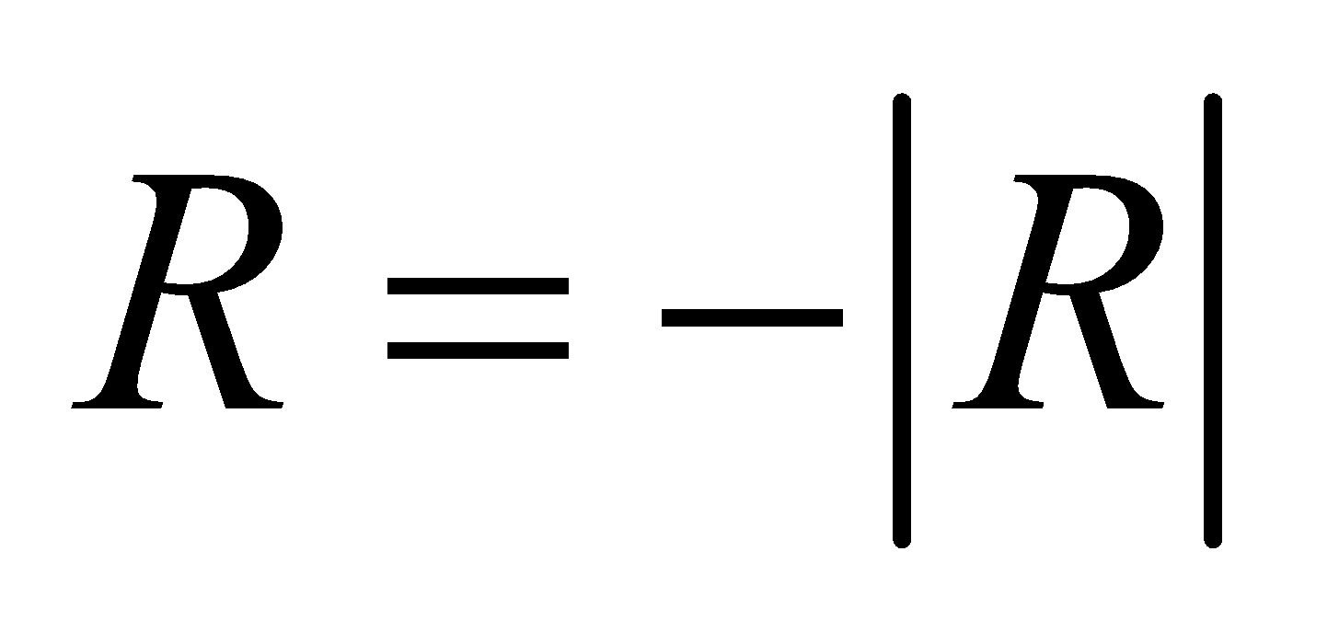 for a concave surface toward the object) gives

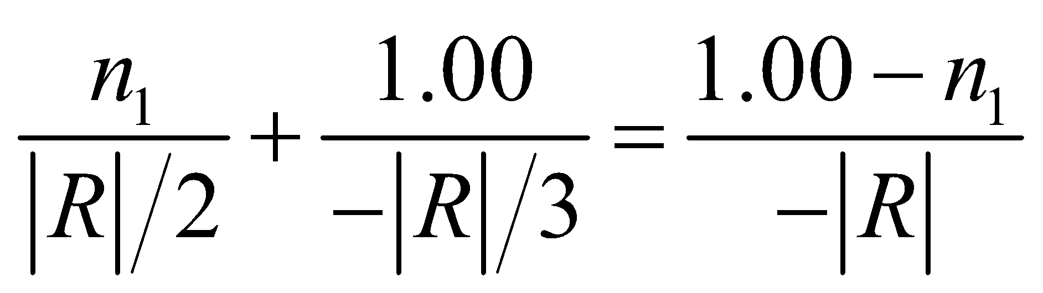

This simplifies to 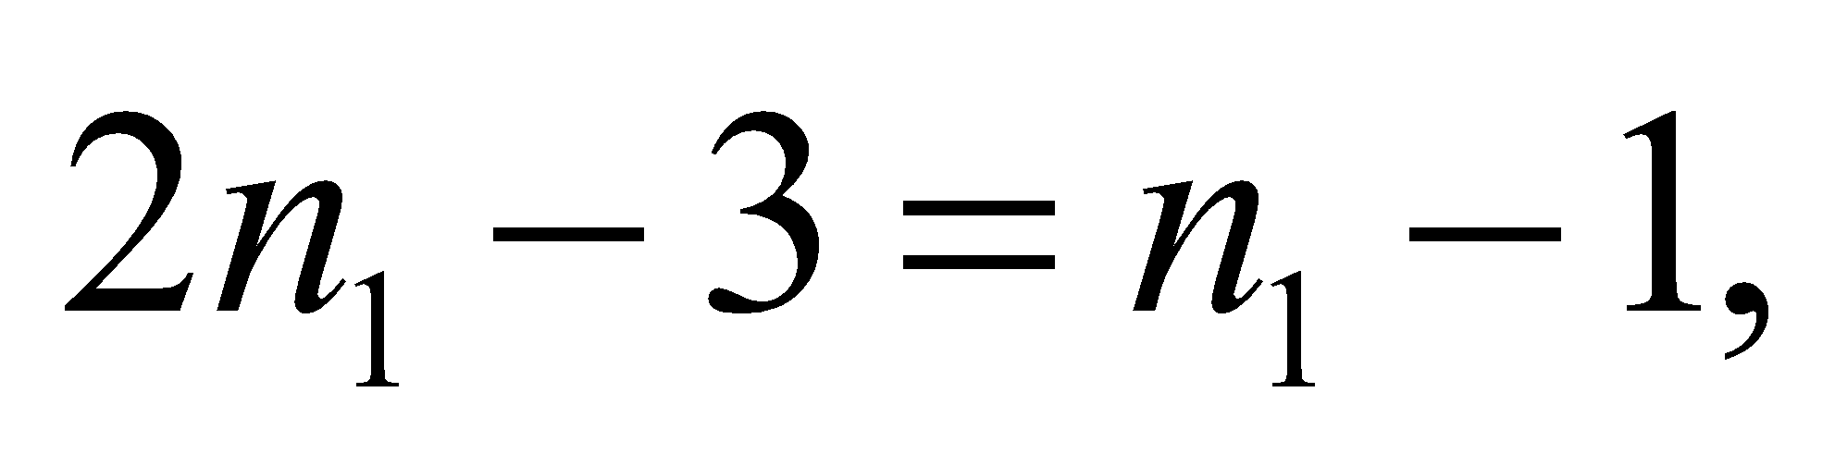 or 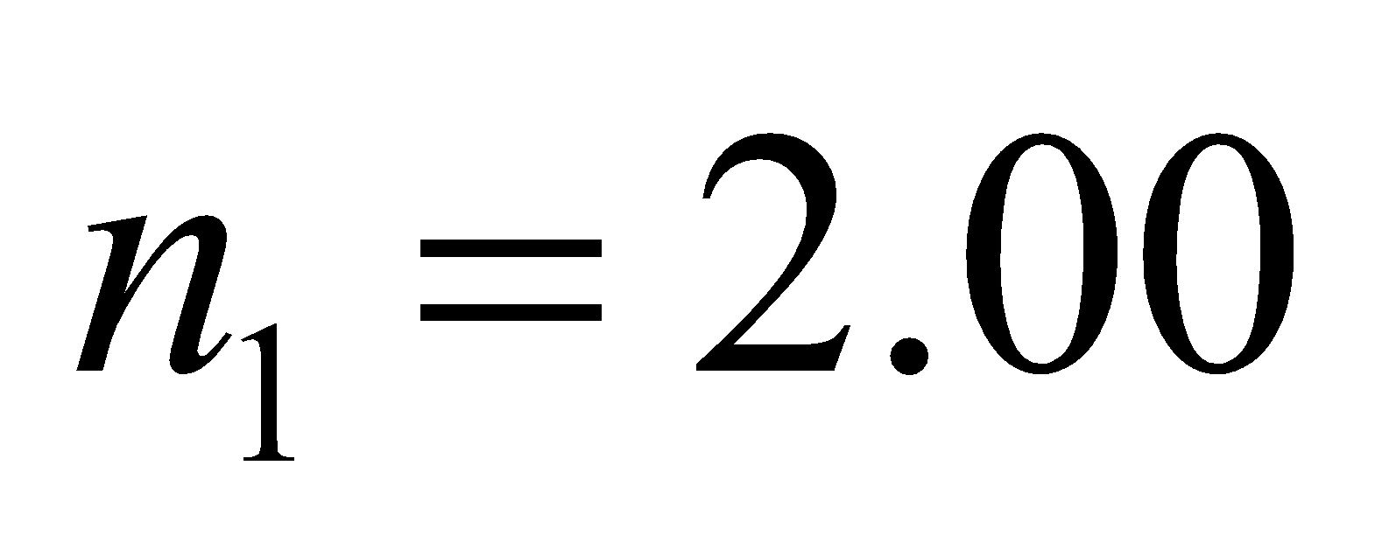.

**Assess** The index of refraction of crystal indeed is about 2.0.

**60.** **Interpret** We are to find the curvature radius of the outer surface of a meniscus lens, given the inner radius, the refractive index, and the focal length.

**Develop** The lensmaker’s formula (Equation 31.7) relates the four quantities mentioned in this problem. The sign conventions used here for a convex meniscus lens require 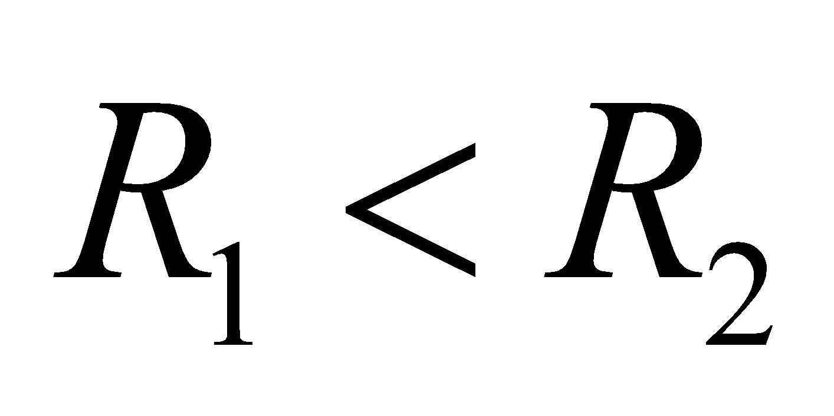 and 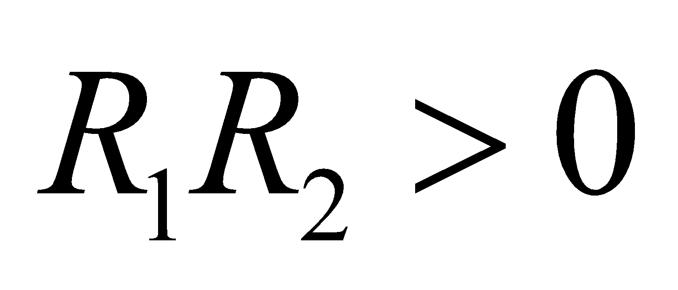. Thus, *R*1 and *R*2 are either both positive or both negative, depending on whether one takes the light coming from the left, as we choose here, or right side of the lens. Under these conditions, *R*2 = 7.80 mm and we can apply the lensmaker’s formula.

**Evaluate** The outer radius of curvature *R*1 is

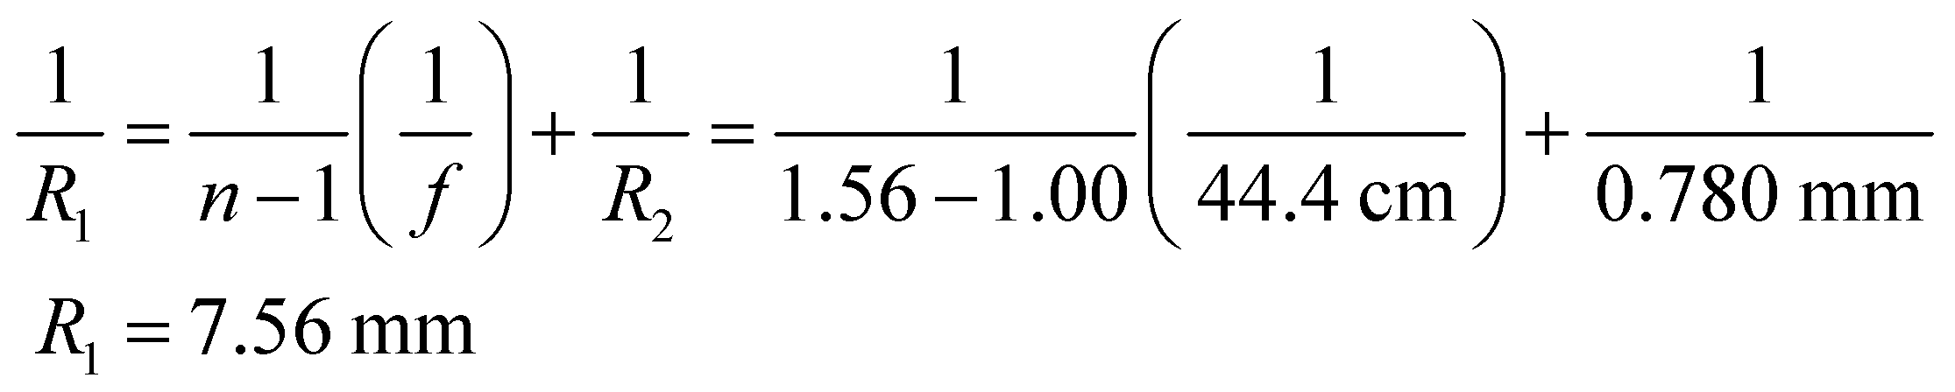

**Assess** To test your understanding of the sign conventions, try taking the light coming from the right, using *R*1 = −7.80 mm. Also note that, for a concave meniscus lens, *R*1 > *R*2 and *R*1*R*2 > 0.

**61. Interpret**We have a plano-convex lens, and we want to know the relationship between its index of refraction and the radius of curvature of the curved surface. In particular, we want to find the refactive index for which the focal length is equal to the radius of curvature.

**Develop** The focal length of the lens is given by the lensmaker’s formula (Equation 31.7),

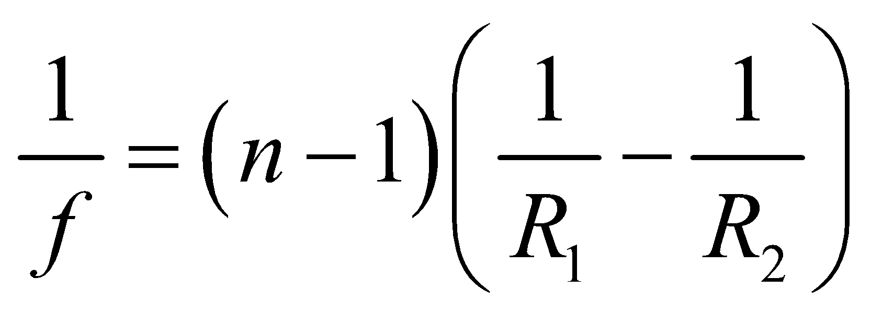

The plano-convex lens has *R*1 = *R* and (or  and 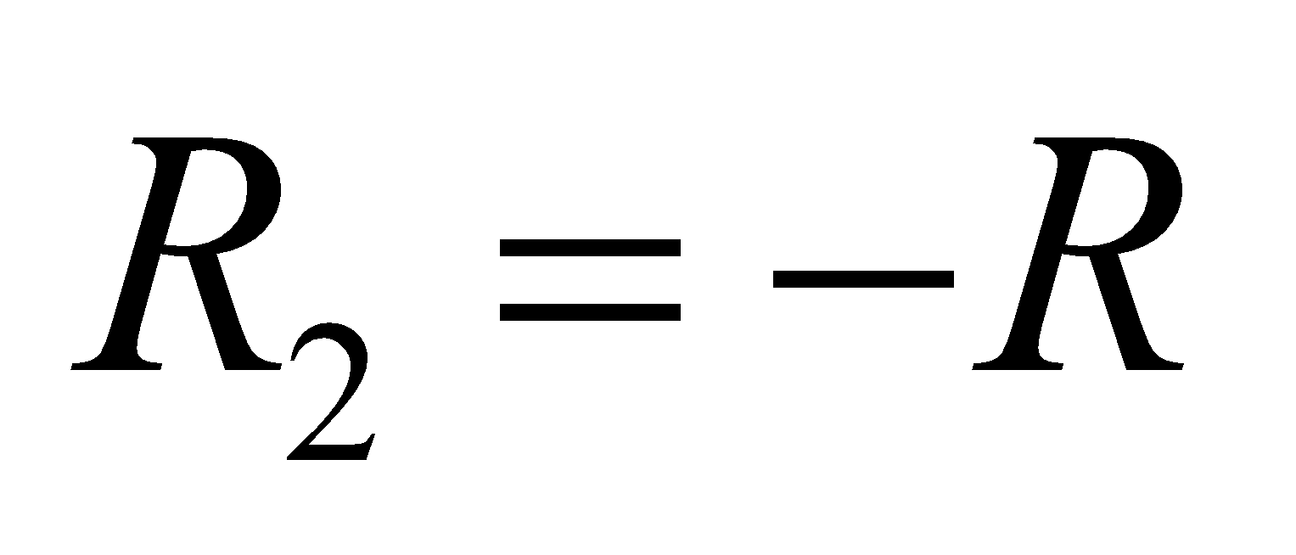). Thus, it has a focal length of

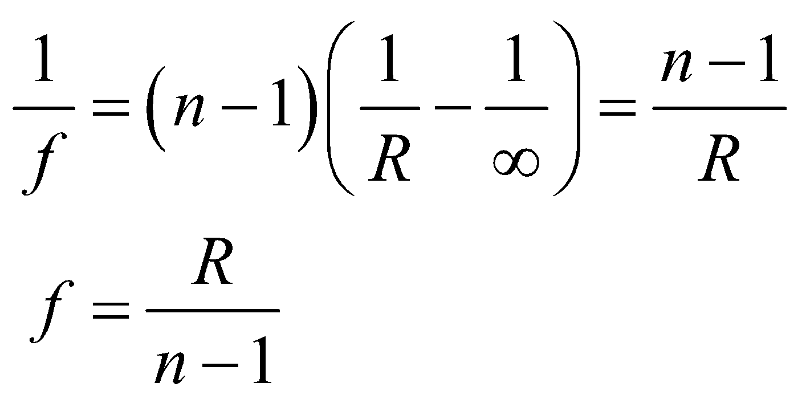

**Evaluate** If *f* = *R*, then the index of refraction is *n* = 2.

**Assess** The smaller *R*, the more curved the lens and the more it bends light. This implies a shorter focal length. The higher refraction index *n*, the greater the refraction, and the shorter focal length.

**62.** **Interpret** For smaller *R*, the lens is more curved and therefore bends light to a greater degree, which implies a shorter focal length. Refraction is greater for higher refractive index *n* so, all else being equal, a lens with a larger index of refraction will have a shorter focal length.

**Develop** Apply Equation 31.7 with *R*1 = 35 cm and *R*2 = 55 cm to find the focal length of the lens, and then insert the result into the lens equation (Equation 31.5) to find the image distance and type.

**Evaluate** The reciprocal of the focal length is



Inserting this into the lens equation gives

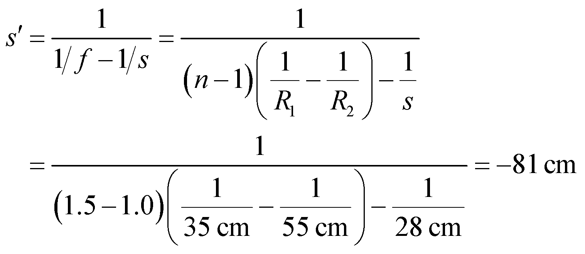

Because *s*′ < 0, the image is virtual and erect.

**Assess** The object distance is less than the focal length, so we expect a virtual image.

**63.** **Interpret** You are comparing two transparent materials with different indices of refraction for use in a lens. The lens must meet certain optical specifications without exceeding the given thickness.

**Develop** You're not told the specific shape of the lens, but for simplicity you assume it is plano-convex, like the one in Example 31.5. In that case, there's only one radius of curvature to consider, and the lensmaker's formula (Equation 31.7) simplifies to 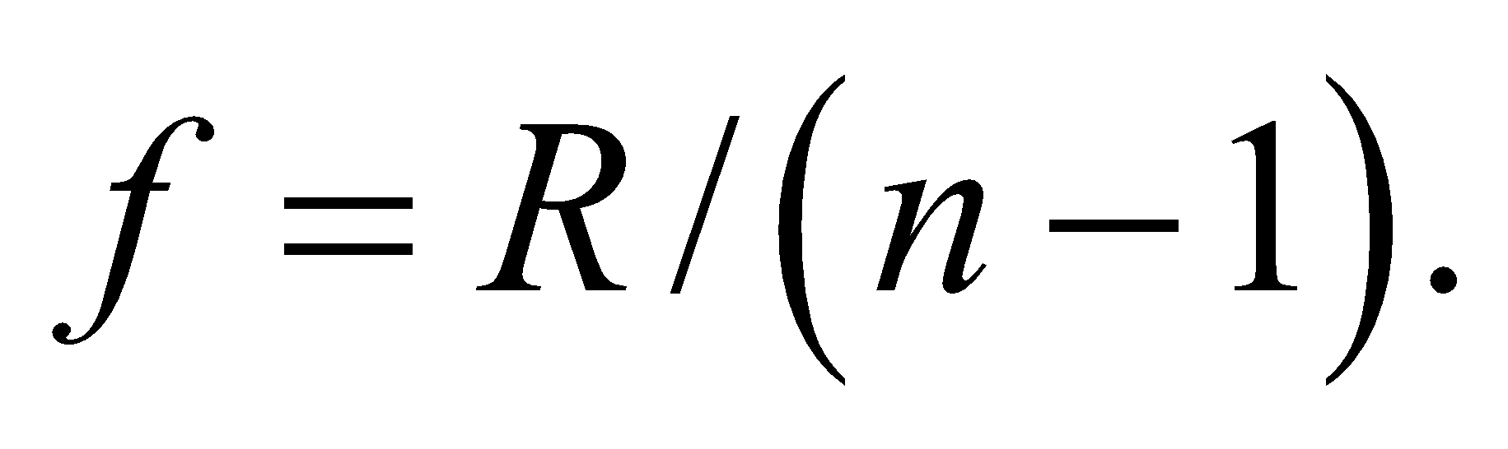 It also means that you can relate the radius of curvature to the lens diameter, *d*, and thickness, *t*, by the Pythagoras formula (see figure below):

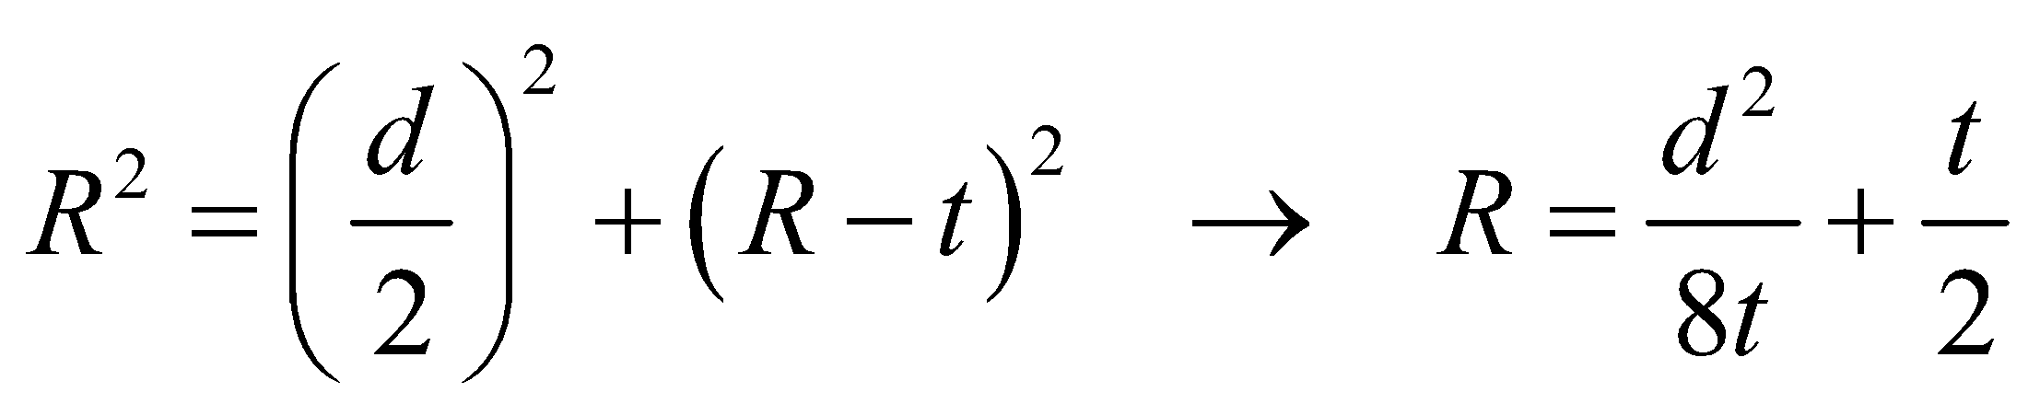

Since 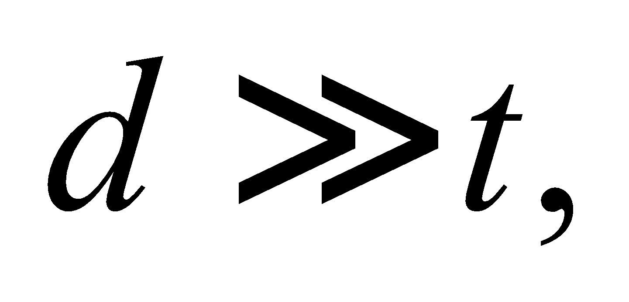the dominant term in this expression is the first term. Therefore, the upper limit on the thickness 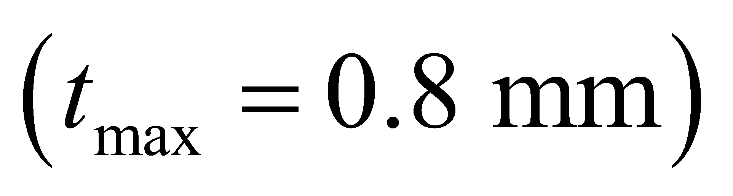 sets the lower limit on the radius: 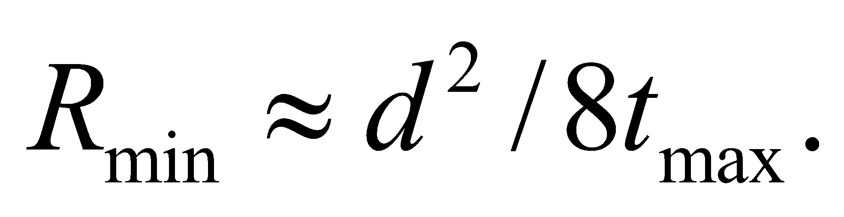



**Evaluate:** The lower limit on the radius gives a lower limit on the index of refraction:

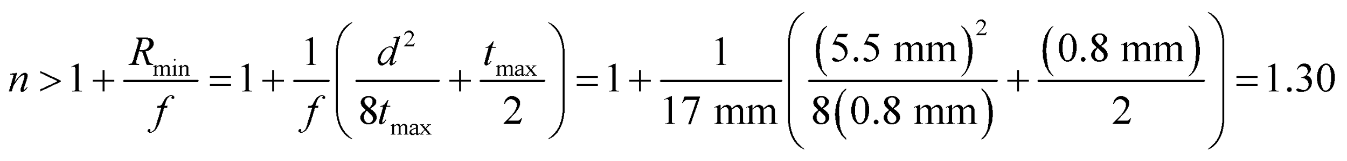

Both materials have indices of refractions greater than this, so you should choose plastic, because it meets the requirements and is cheaper.

**Assess** For other lens shapes, you can show that the thickness is related to the two radii of curvature by:

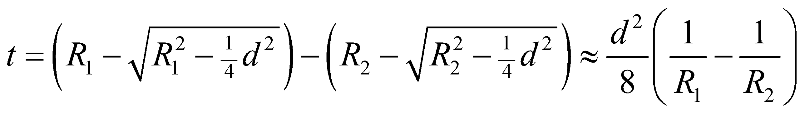

The approximation is valid as long as 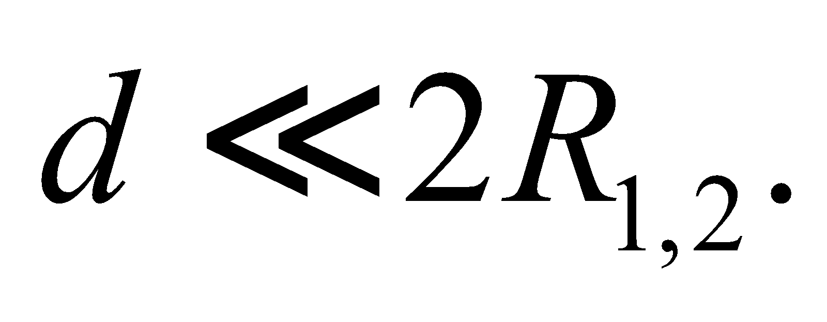 Plugging this into the lensmaker's formula, you get 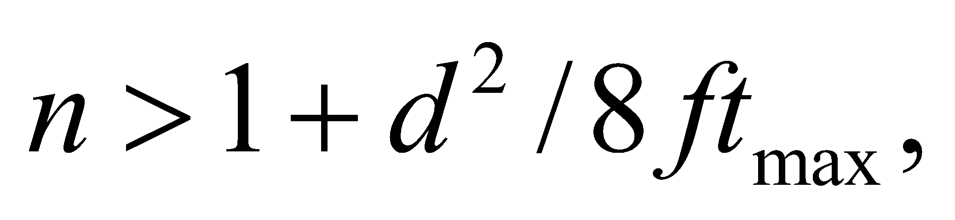which is essentially what we found above for a plano-convex lens.

**64.** **Interpret** We are to characterize the chromatic aberration of a double-convex lens by finding the range over which white light will be smeared with the source placed the given distance from the lens.

**Develop** Using the lensmaker’s formula (Equation 31.7), the focal length of the double convex lens varies from

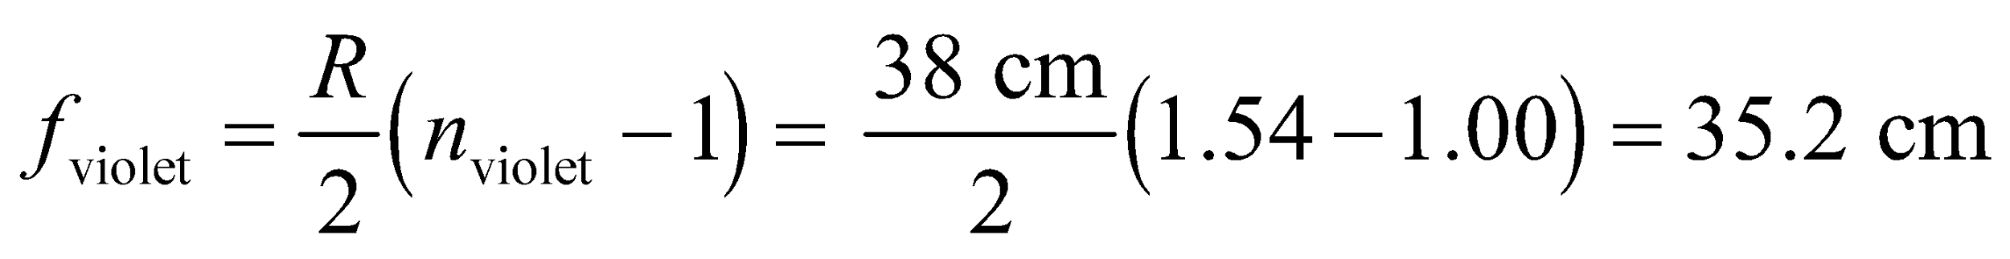

to

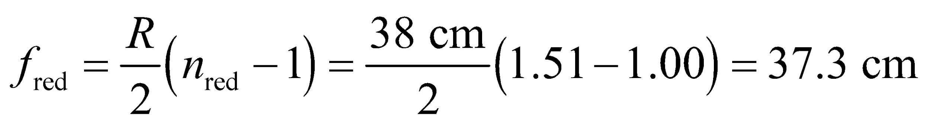

across the visible spectrum (from blue to red) as a result of chromatic aberration. Insert these results in to the lens equation (Equation 31.5) to find the spread in the image distance for *s* = 95 cm.

**Evaluate** The image is spread by



**Assess** This image is real and inverted.

**65. Interpret** Diamond and glass have different indices of refraction, so this problem is about the effect on the image when the index of refraction of the lens is changed. We are to find the what type of image is formed when a glass lens is replaced by a diamond lens.

**Develop** Using the lens equation (Equation 31.5) and Equation 31.4 for the magnification for a thin converging (positive *f* ) lens, we obtain



Magnification is positive for a virtual image. Thus, for the crown glass lens we have

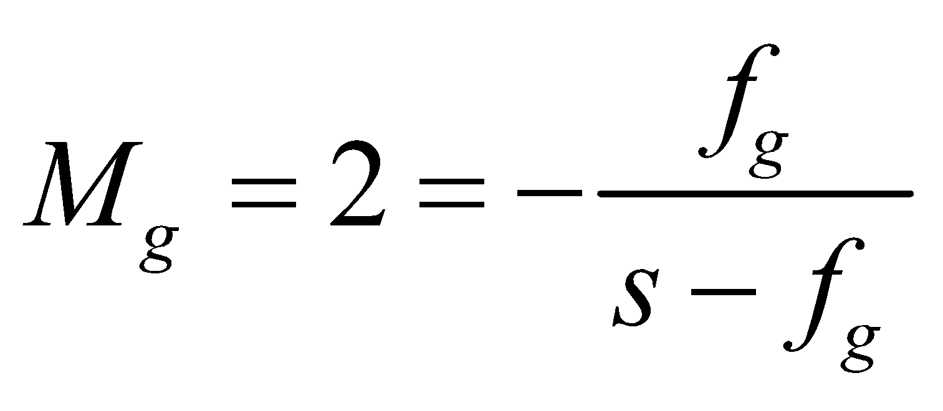

which can be solved to give 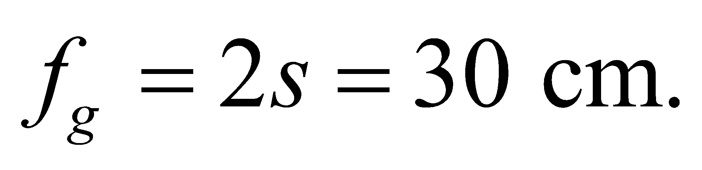 The focal length of a diamond lens with the same radius of curvature is (using Equation 31.7 and Table 30.1)

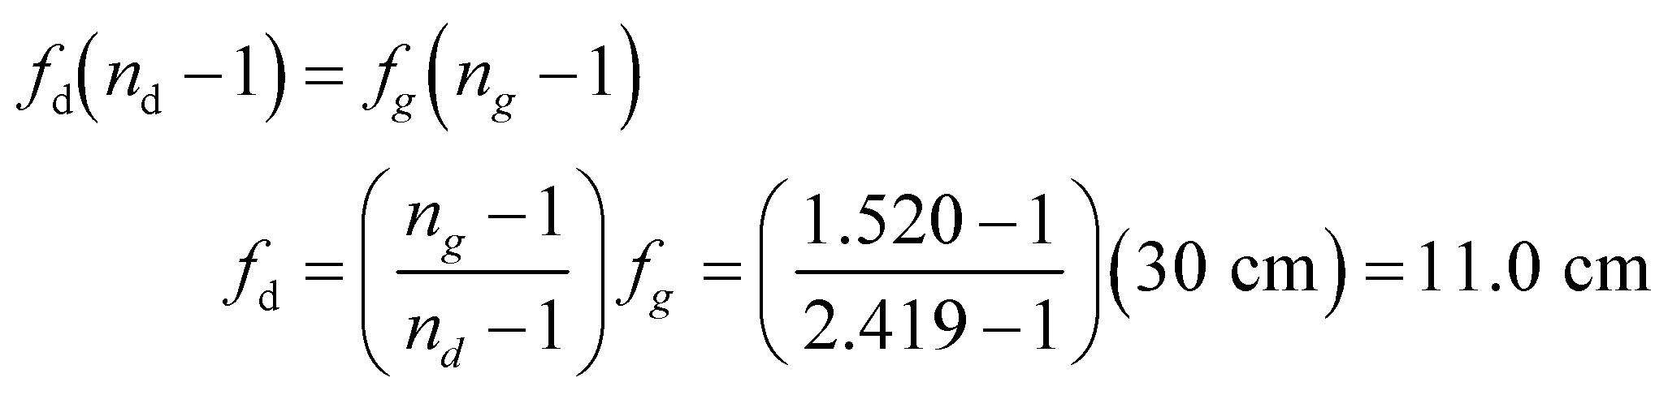

**Evaluate** An object 15 cm from the diamond lens produces a real, inverted image (negative *M*) magnified by

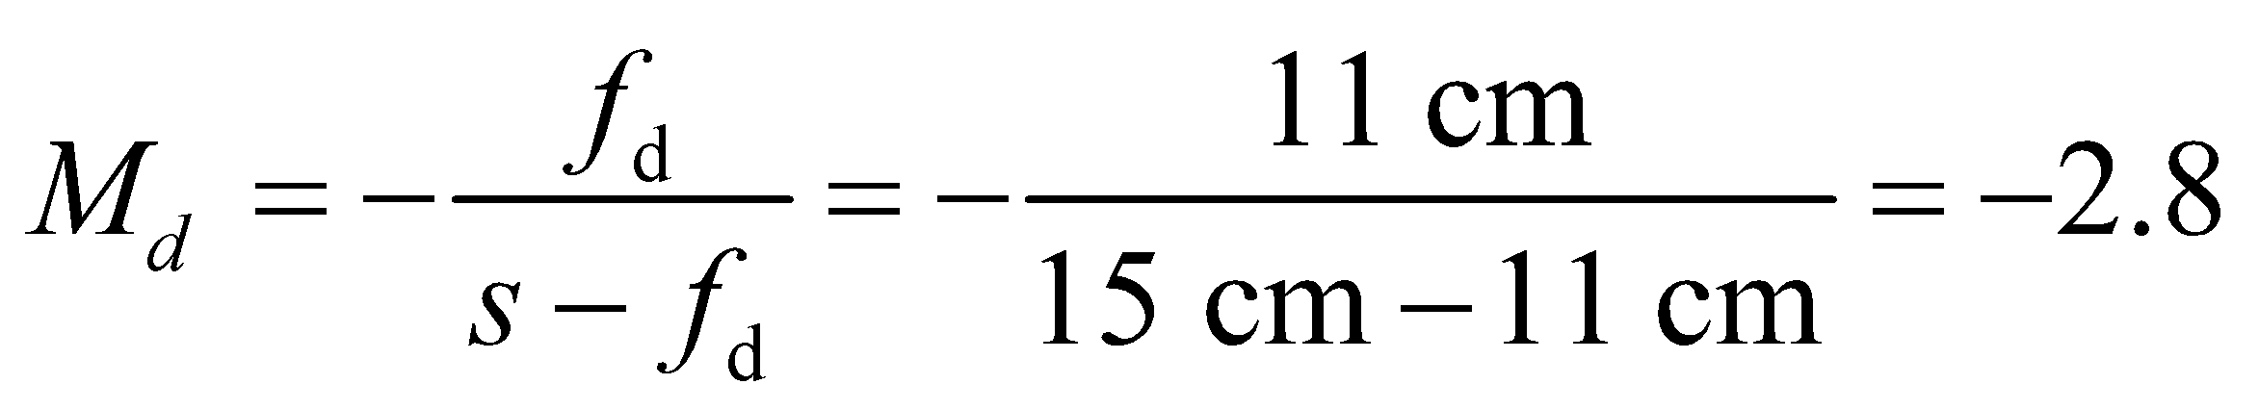

**Assess** In the case of a crown glass, 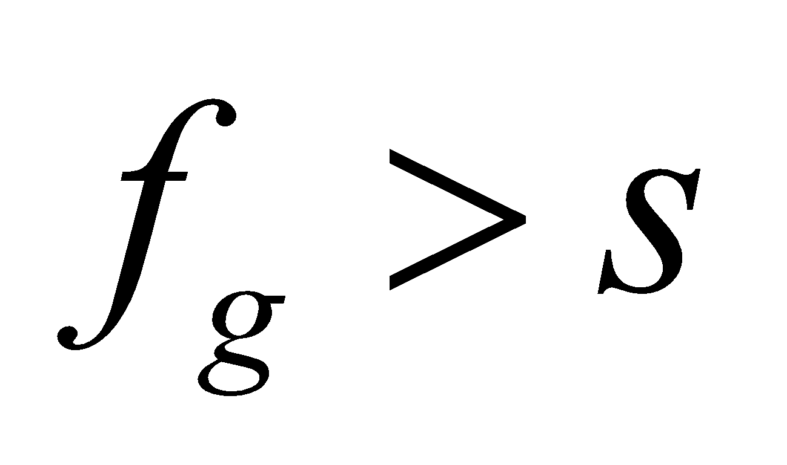 and the image is virtual. For the diamond lens, since 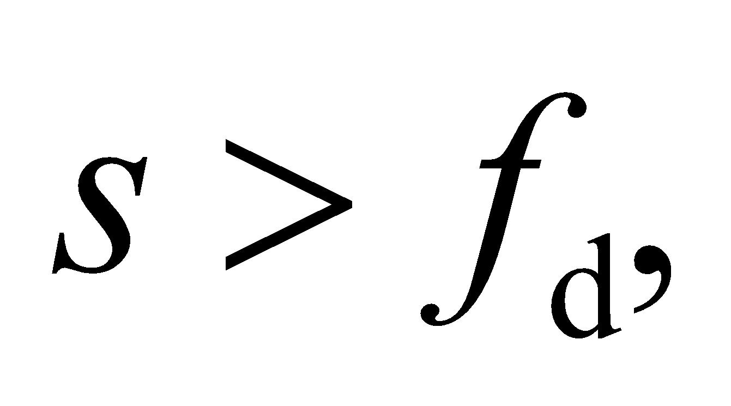 the image is real with 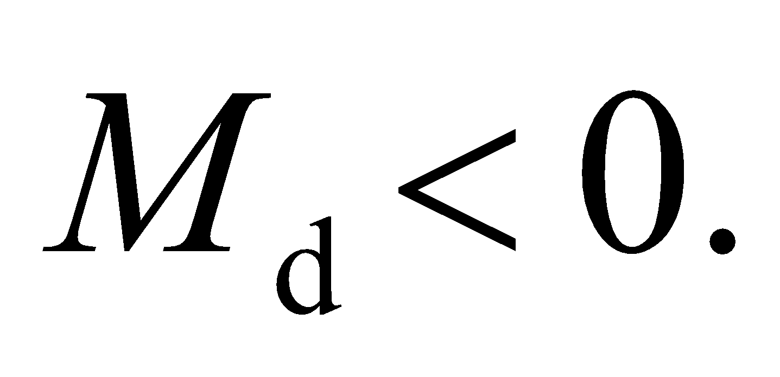

**66.** **Interpret** You want to know the range of image size that can be had with a zoom lens.

**Develop** For a distant object 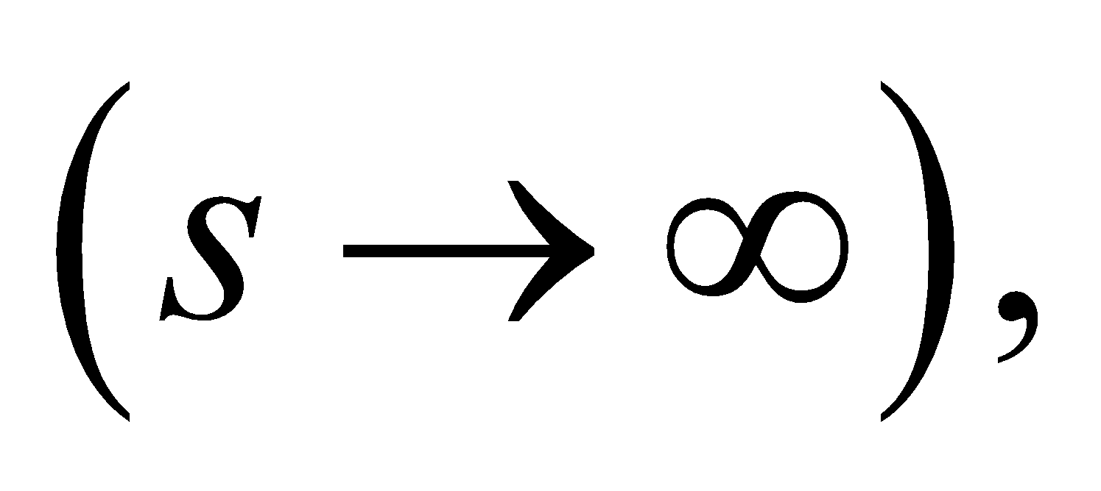 the lens equation, gives 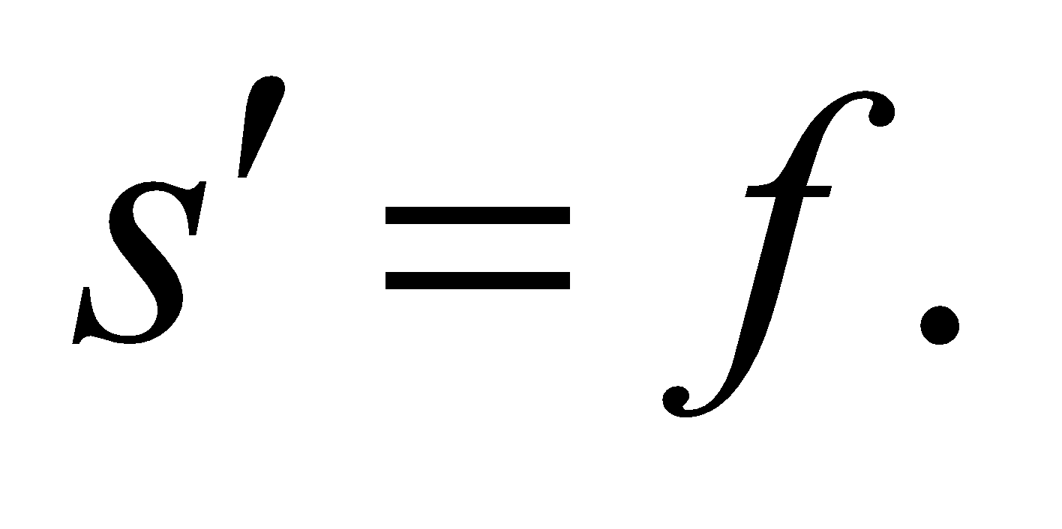 Given the magnification equation 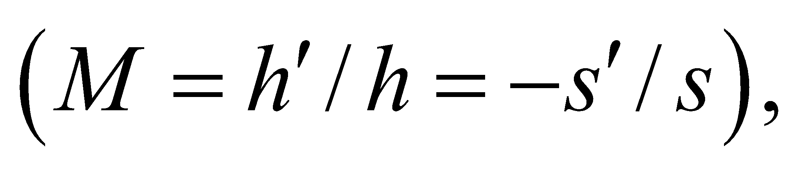 this means the image size will be proportional to the focal length: 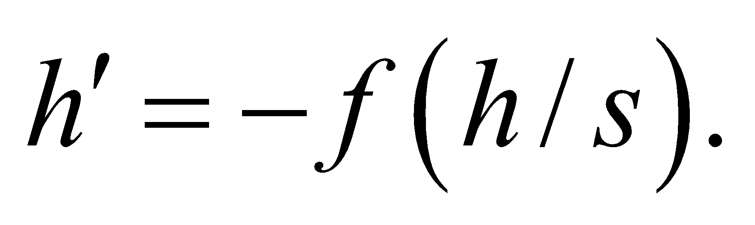

**Evaluate:** On your zoom lens, the focal length can be adjusted from 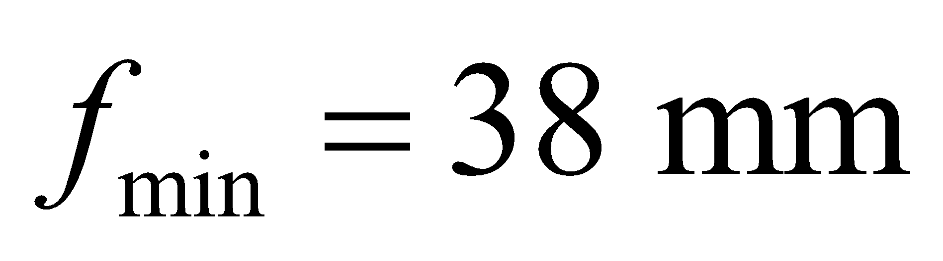 to 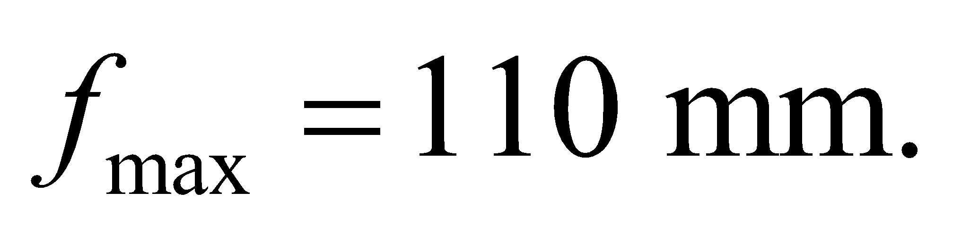 The relative image size for a distant object is then:

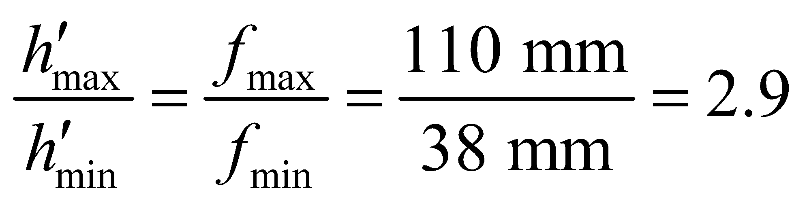

So the image size is nearly 3 times bigger with a focal length of 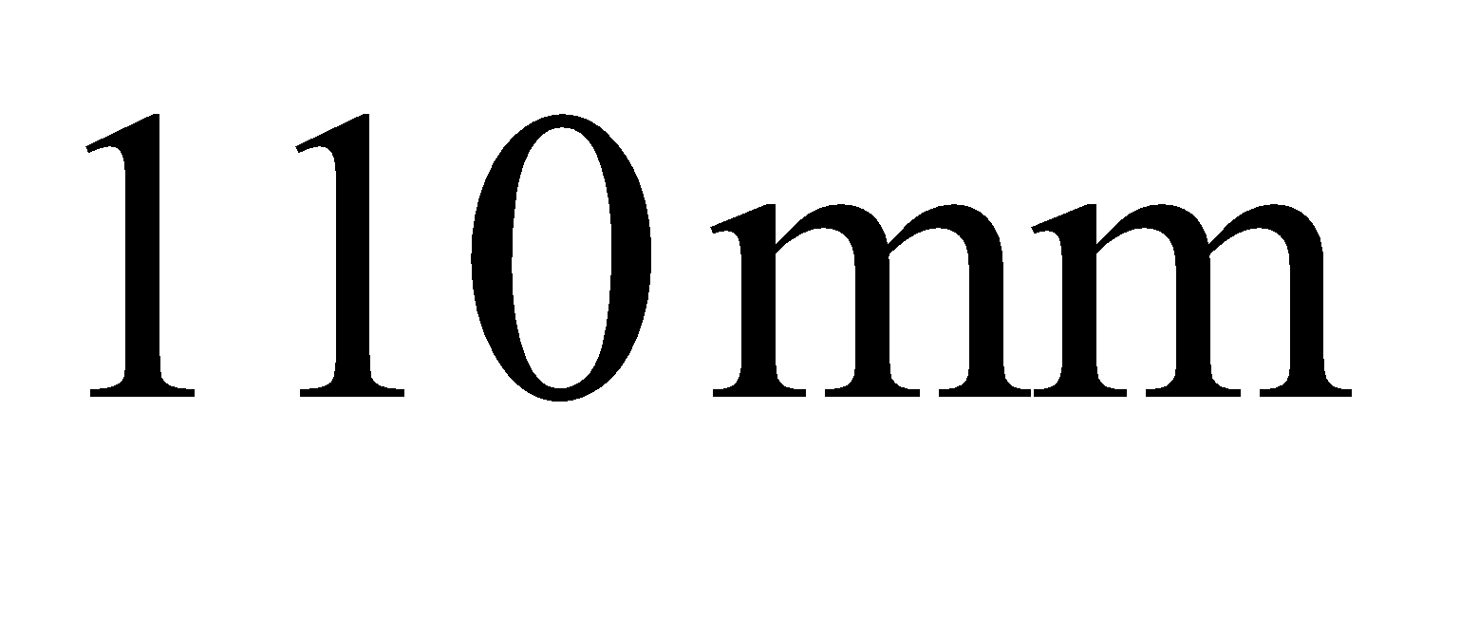 than with a focal length of 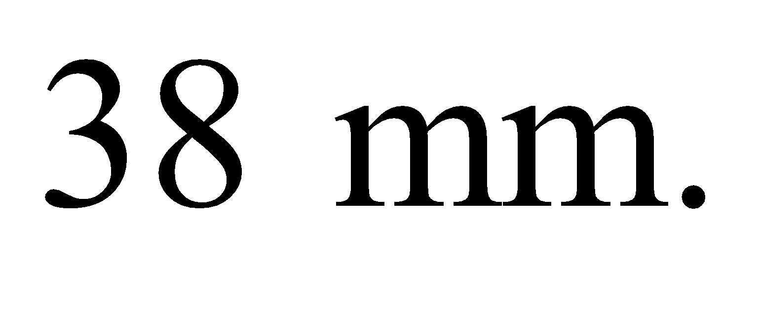

**Assess** A zoom lens is often a complicated combination of several lenses. These lenses are moved relative to each other to alter the net focal length of the combination.

**67. Interpret** We are to find the power and type of lens that must be used in order to improve the close-up capability of a camera. The original camera can focus at 60 cm, and the improved camera must be able to focus at 20 cm.

**Develop** For an object at 20 cm, the auxiliary lens should produce a virtual image at 60 cm from either lens (the distance between the lenses is negligible). The lens power is defined as the reciprocal of the focal length, which can be found using Equation 31.5 with *s* = 20 cm and *s*′ = −60 cm.

**Evaluate** Thus, the required power is

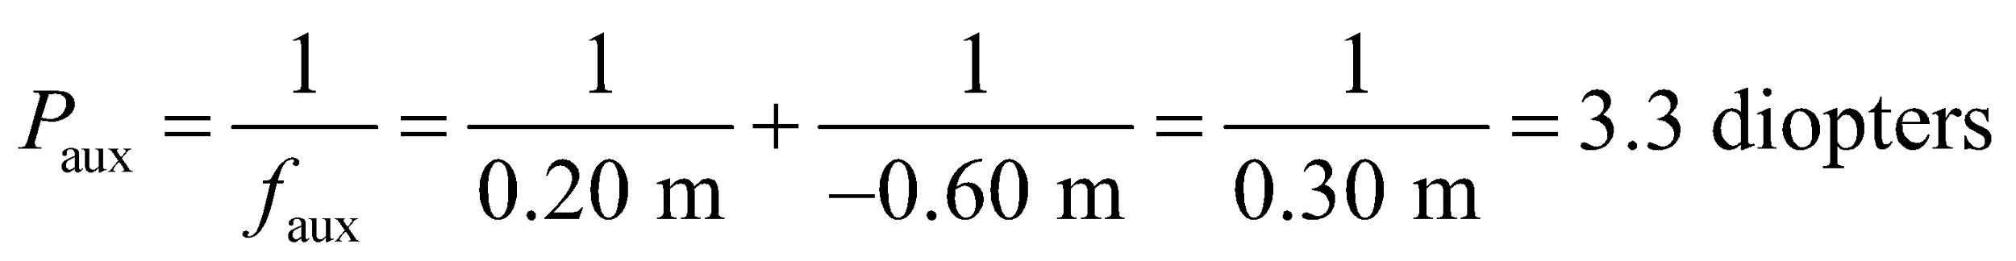

Since the focal length is positive, the lens is converging.

**Assess** The camera without the auxiliary lens can be compared to the eye, in Example 31.6, with a receding near point.

**68.** **Interpret** We are to find the focal length of the eyepiece of a microscope given its objective lens focal length and the distance *L* between the eyepiece and the objective lenses.

**Develop** For a 300 × microscope with 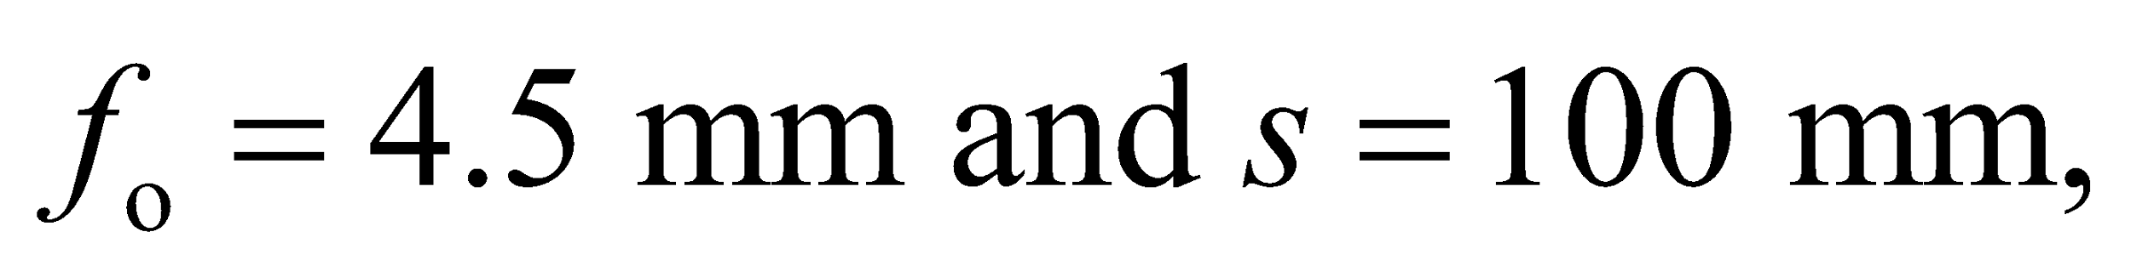 we can solve Equation 31.9 for *f*e.

**Evaluate** The eyepiece focal length is

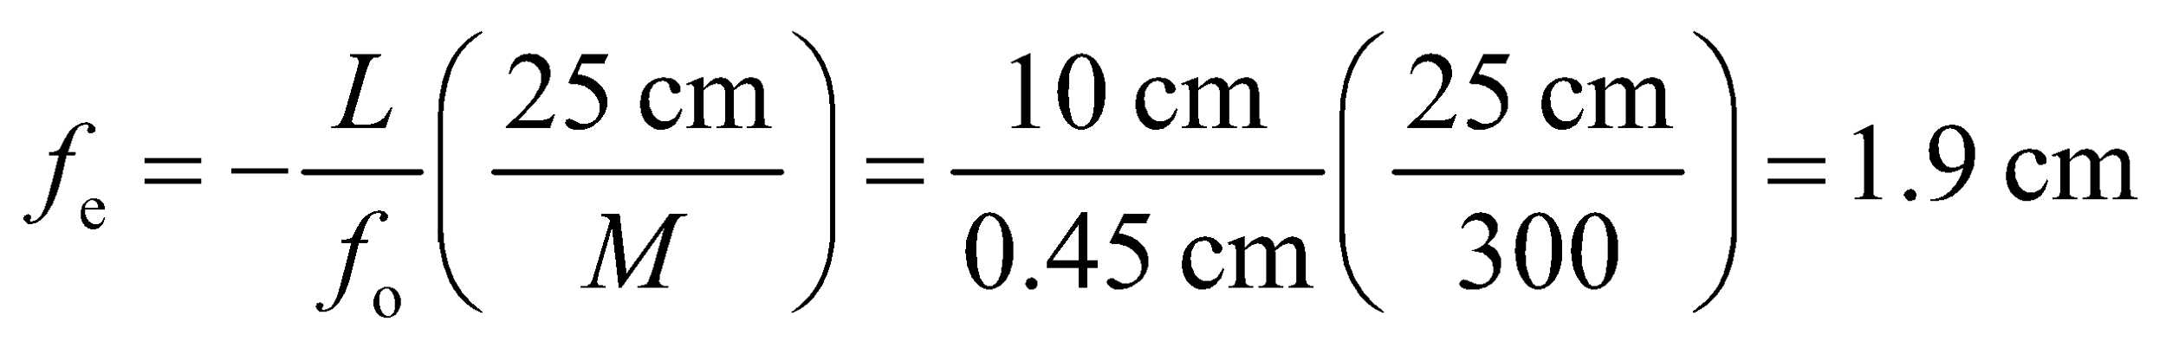

**Assess** This is a typical focal length for a microscope of this power.

**69. Interpret** This problem is about the angular magnification of an astronomical telescope. We are to find the angular magnification of Jupiter given its angular diameter to the unaided eye and the focal length of a refracting telescope and that of its eyepiece.

**Develop** For a refracting telescope, the angular magnification is given by Equation 31.10:

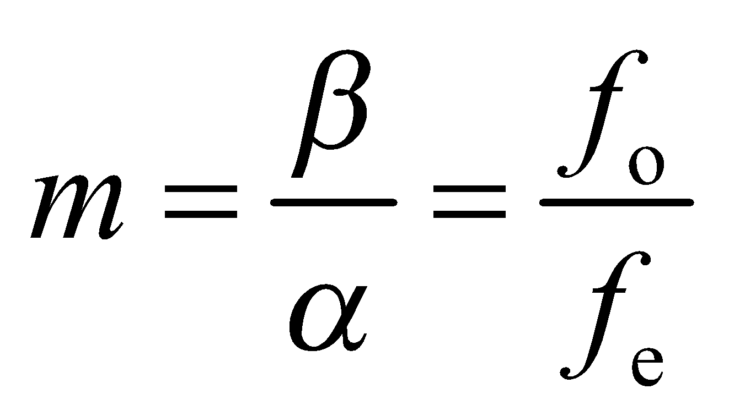

where *α* and *β* are the angles subtended by the actual object and the final image, respectively, while *f*o and *f*e are the focal lengths of the objective lens and the eye piece, respectively. Solve this equation for *β*.

**Evaluate** Substituting the values given, the apparent angular size is

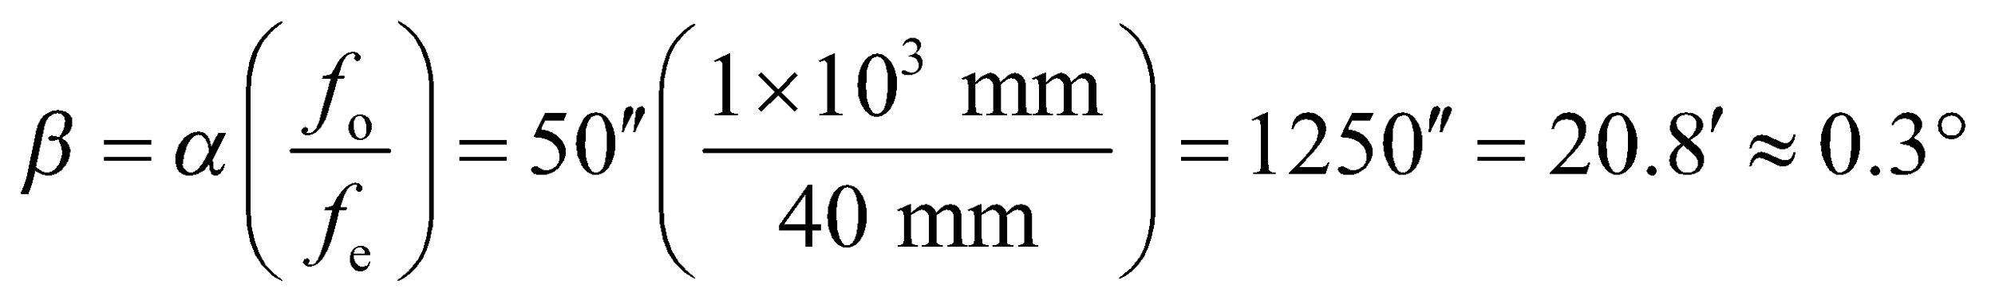

**Assess** The angular magnification in this case is *m* = 25. Note that a two-lens refracting telescope gives an inverted (real) image.

**70.** **Interpret** We are to find the focal length of the secondary mirror of a Cassegrain telescope given the overall focal length and the distance between secondary and primary mirror.

**Develop** Reference to Figure 31.33 shows that parallel rays reflected by the objective mirror converge toward a point, 1.0 m − 0.85 m = 15 cm behind the secondary mirror, and behave as if they came from a virtual object, with *s* = −15 cm in the mirror equation. The final image is located a distance *s*′ = 85 cm + 12 cm = 97 cm from the secondary mirror. We can use Equation 31.5 to find the focal length of the secondary mirror.

**Evaluate** The required focal length is therefore

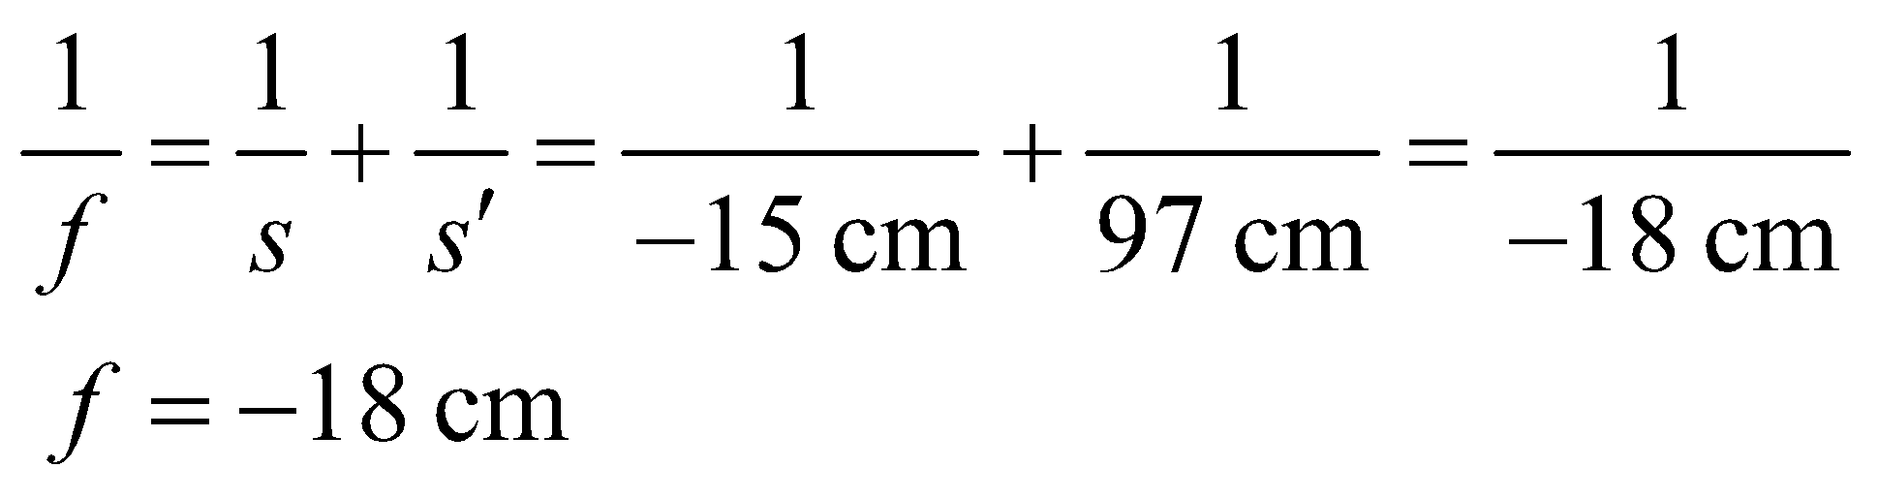

**Assess** Recall that a convex mirror has negative focal length.

**71. Interpret** We are to find the diameter of a reflecting ball given that its magnification for a 6.0-cm object distance. The ball acts as a convex mirror.

**Develop** Using Equations 31.1 and 31.2, the magnification of the image can be written as

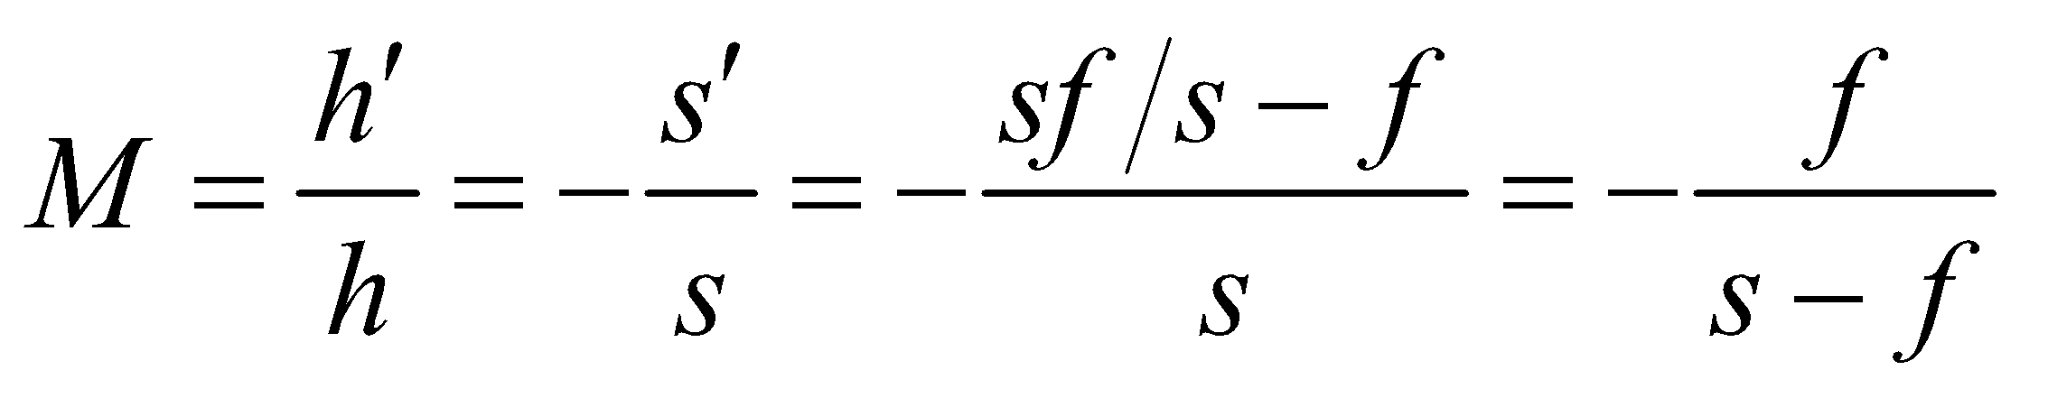

which yields 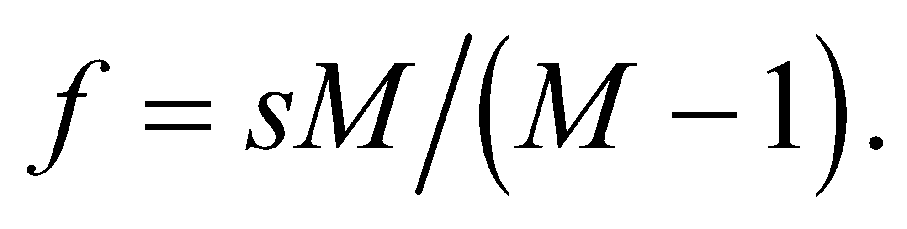 The diameter of the ball is 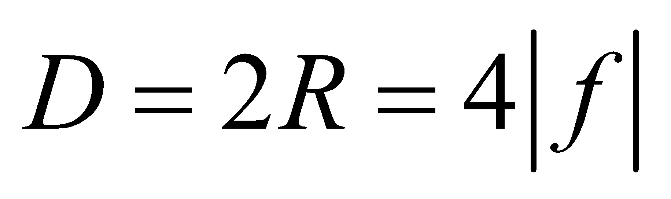, where *f* is the focal length (negative in this case).

**Evaluate** Using the two equations above, the diameter of the ball is

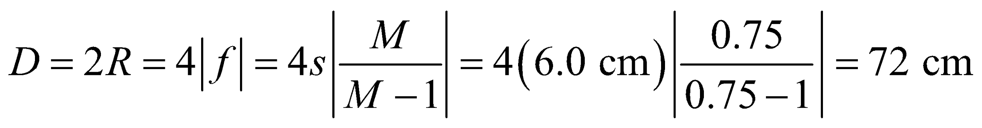

**Assess** The situation corresponds to case 4 illustrated in Table 31.1. With a convex mirror (*f* < 0) the image is virtual, upright, and reduced.

**72.** **Interpret** We are to find the outer curvature radius of a contact lens (i.e., meniscus lens) given its diopter (i.e., focal length), inner curvature radius, and its index of refraction. We are also to find the image distance given an object distance.

**Develop**  This prescription calls for a converging lens (positive dioptric power) of focal length 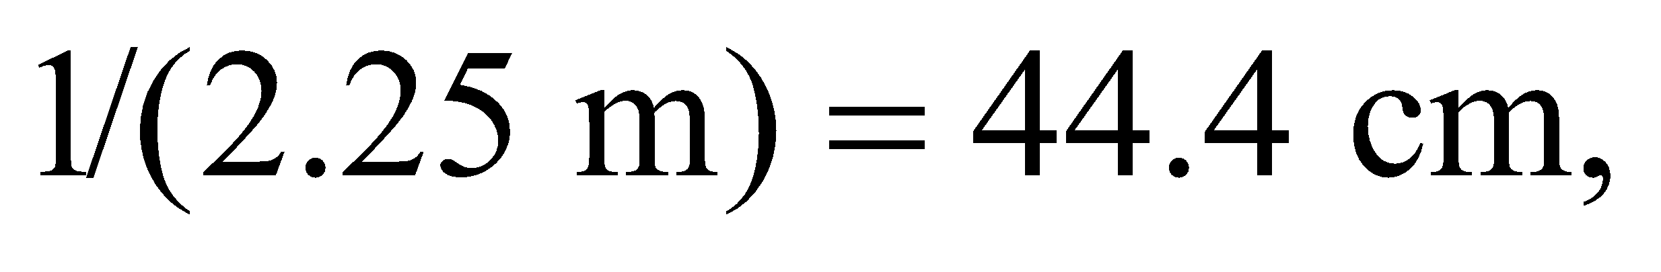 with a convex meniscus shape (Figure 31.25). The analysis in the solution to Problem 60 shows that the outer curvature radius of the meniscus lens (the first surface to intercept light coming to the eye) is

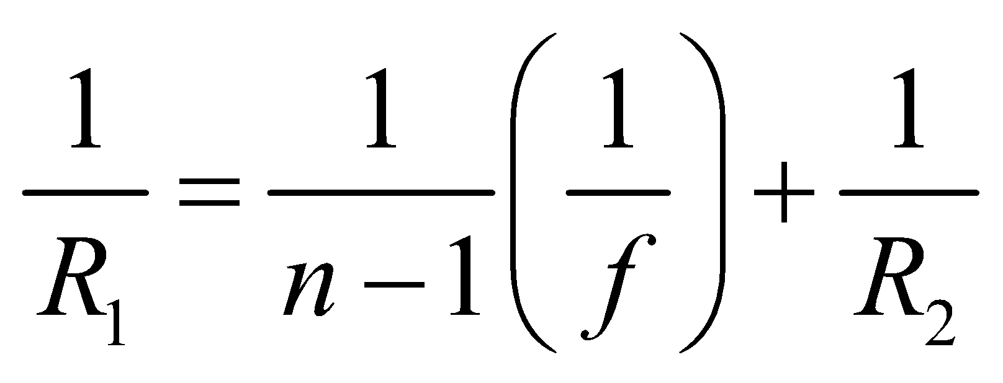

For part (b), apply the lens equation (Equation 31.5) and solve for the image distance *s*′.

**Evaluate** **(a)** The inner radius is

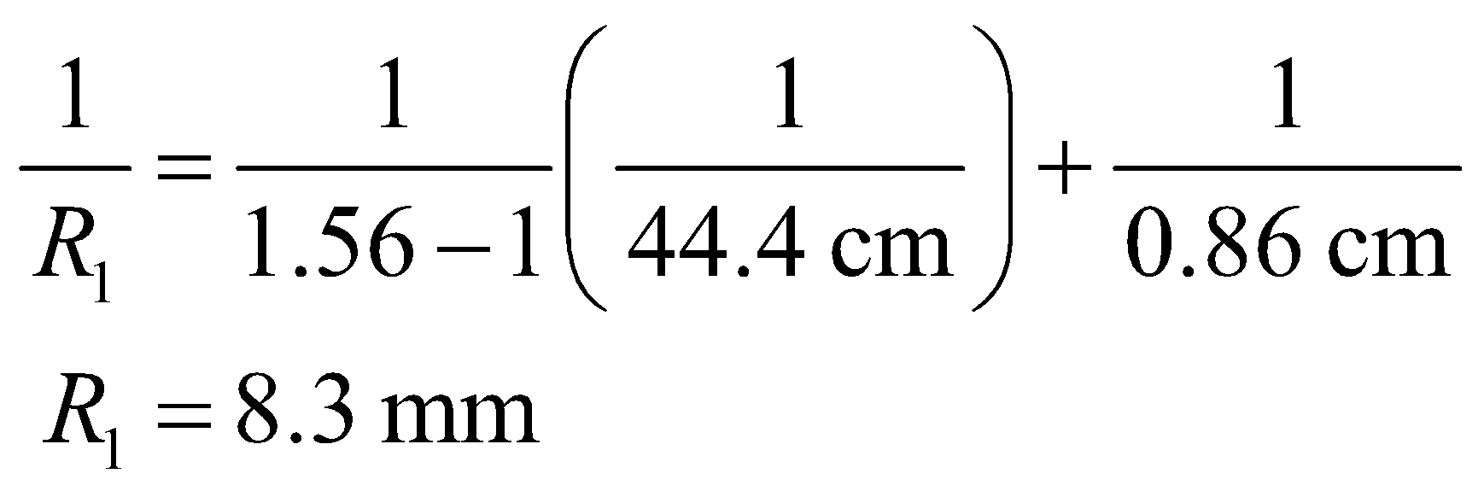

**(b)** The image distance is

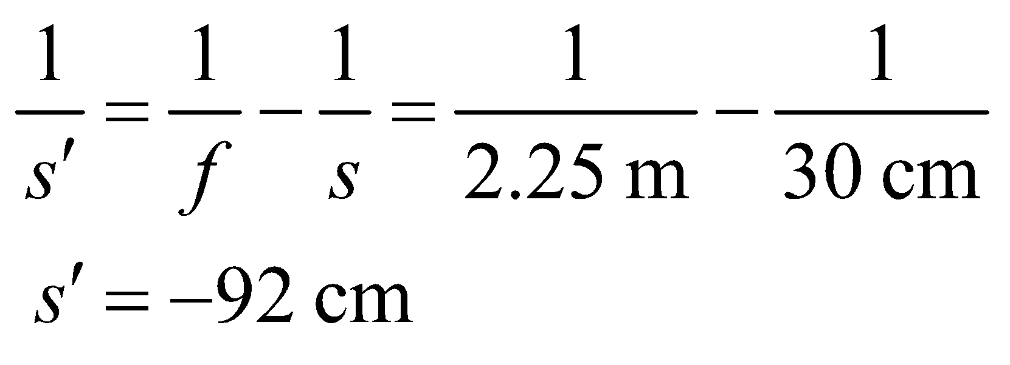

**Assess** The negative sign indicates a virtual, erect image in front of the lens. Of course, the contact lens and the eye together form a real image on the retina.

**73. Interpret** This problem is about the corrective power of lenses. We want to show that for closely spaced lenses, the lens powers are additive.

**Develop** For two closely-spaced thin lenses, distances measured from either lens are the same. We can consider that the image which would be produced by the first lens alone acts as an object for the second lens, where 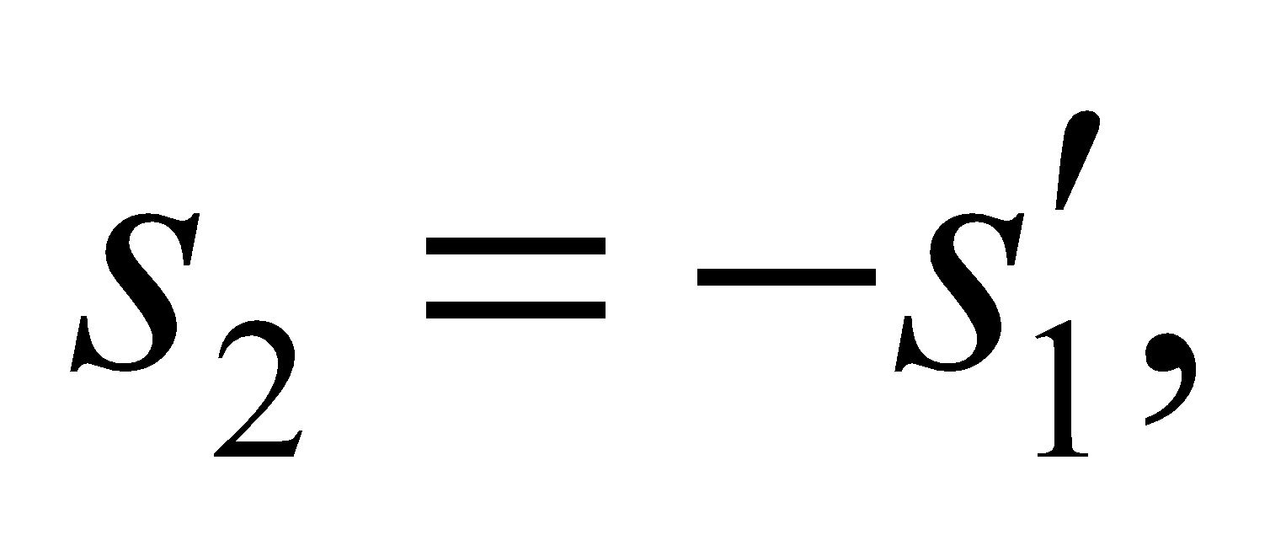 because this image, if real, is on the other side of the second lens or, if virtual (i.e., 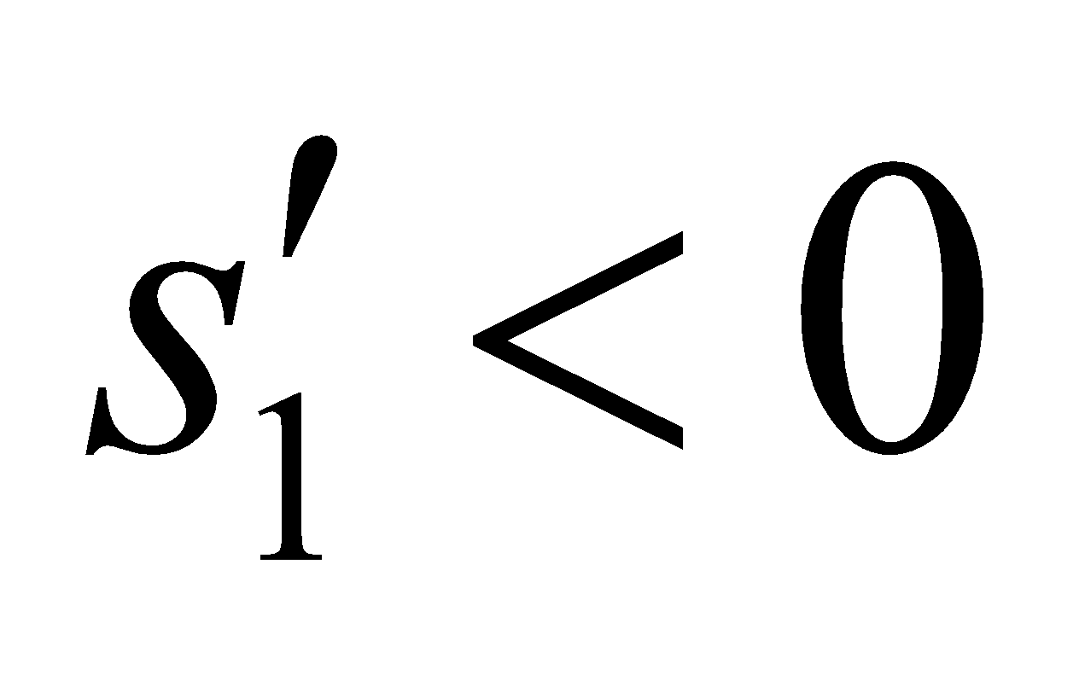), is on the same side. The lens equations for each lens are

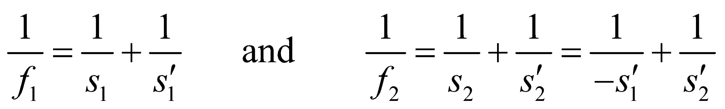

**Evaluate** Adding the two equations yields

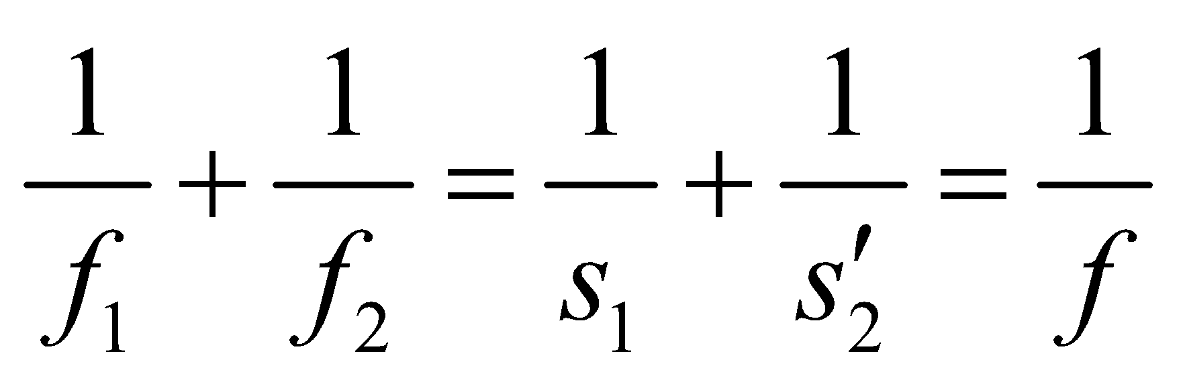

where *f* is the focal length of the lens combination. Since the dioptric power of a lens is the reciprocal of its focal length in meters, the additivity of this quantity follows, under the conditions stated.

**Assess** The additive nature of the corrective power allows an optometrist, during an eye exam, to continue to add lenses until the desired power is attained.

**74.** **Interpret** We're asked to derive a formula for the thickness of a plano-convex lens, given its focal length, diameter and index of refraction.

**Develop** Starting with the lensmaker's formula (Equation 31.7), and letting one of the radii of curvature go to infinity, we get 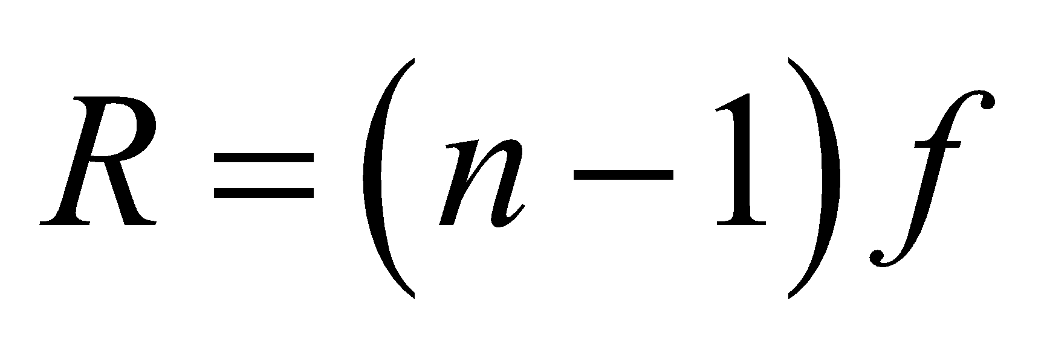 for the other radii. The thickness, *t*, can be related to this radius and the diameter by (see Problem 31.63):

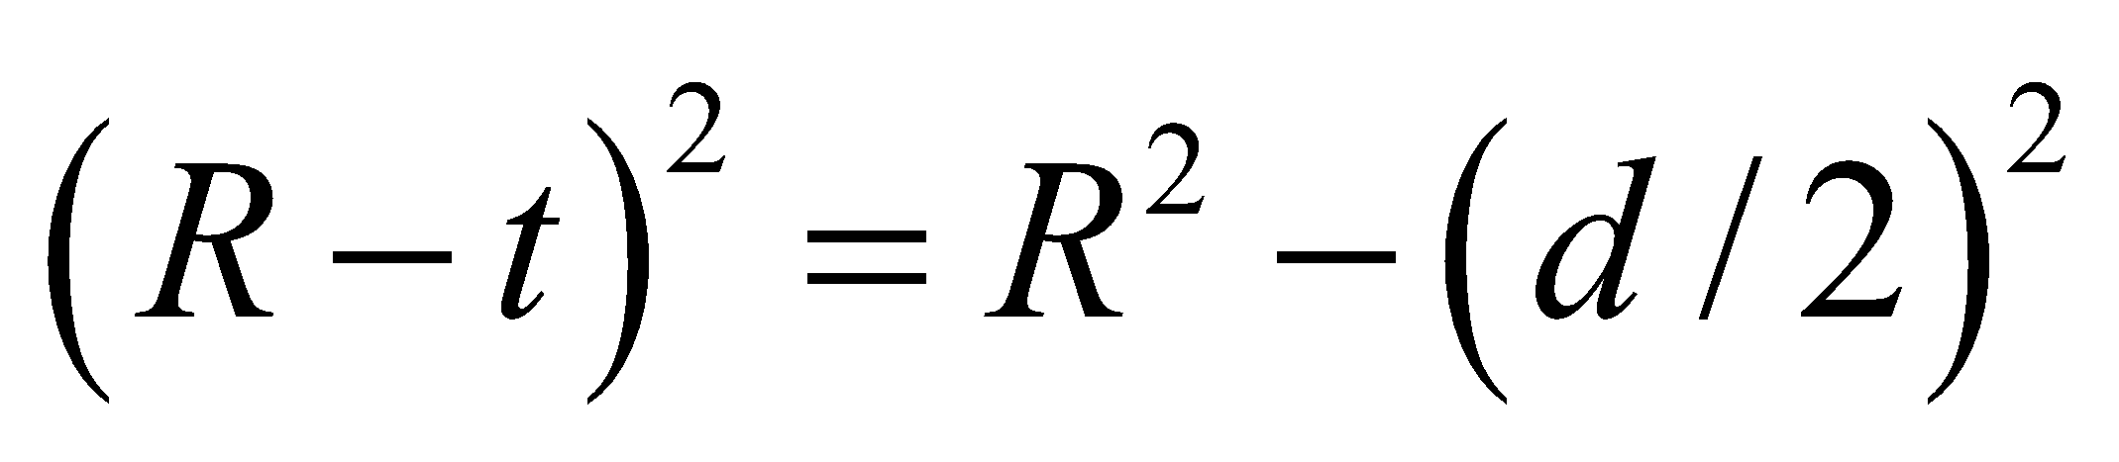

**Evaluate:** Combining the two expressions from above, we find the thickness is

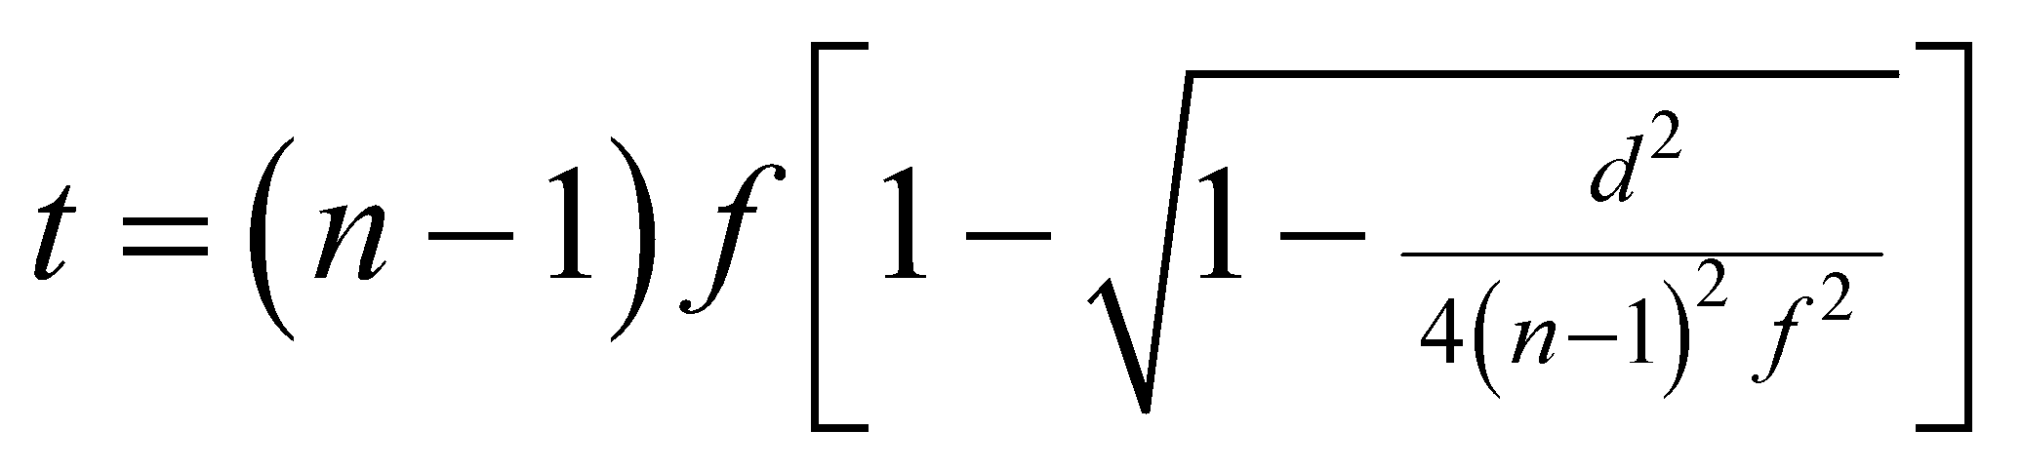

**Assess** Assuming 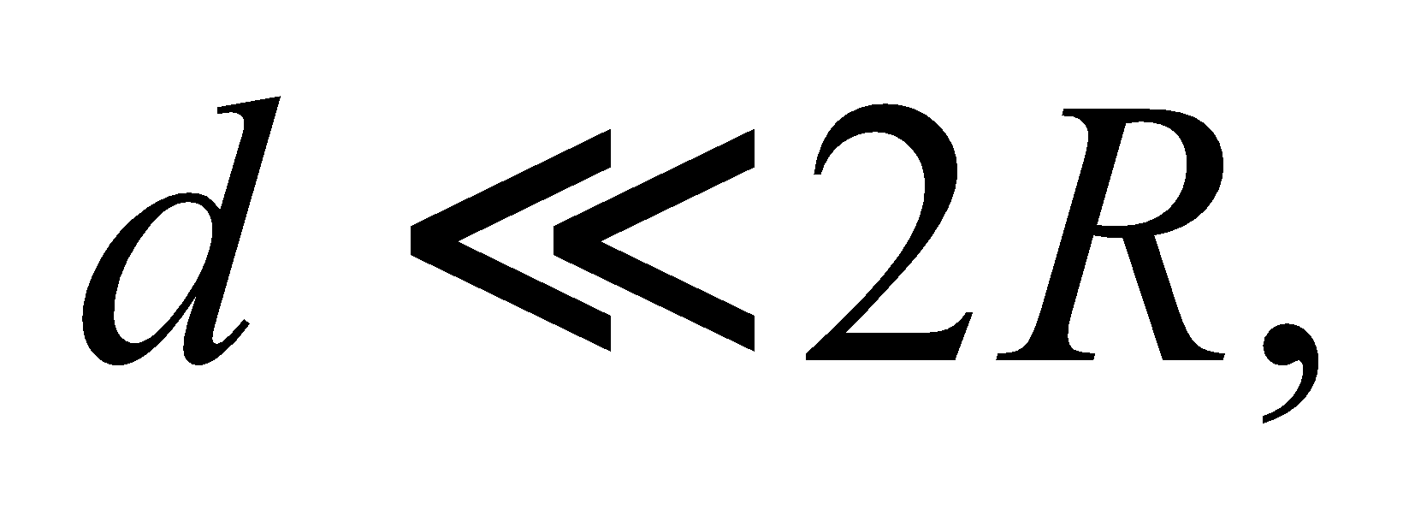this equation simplifies to

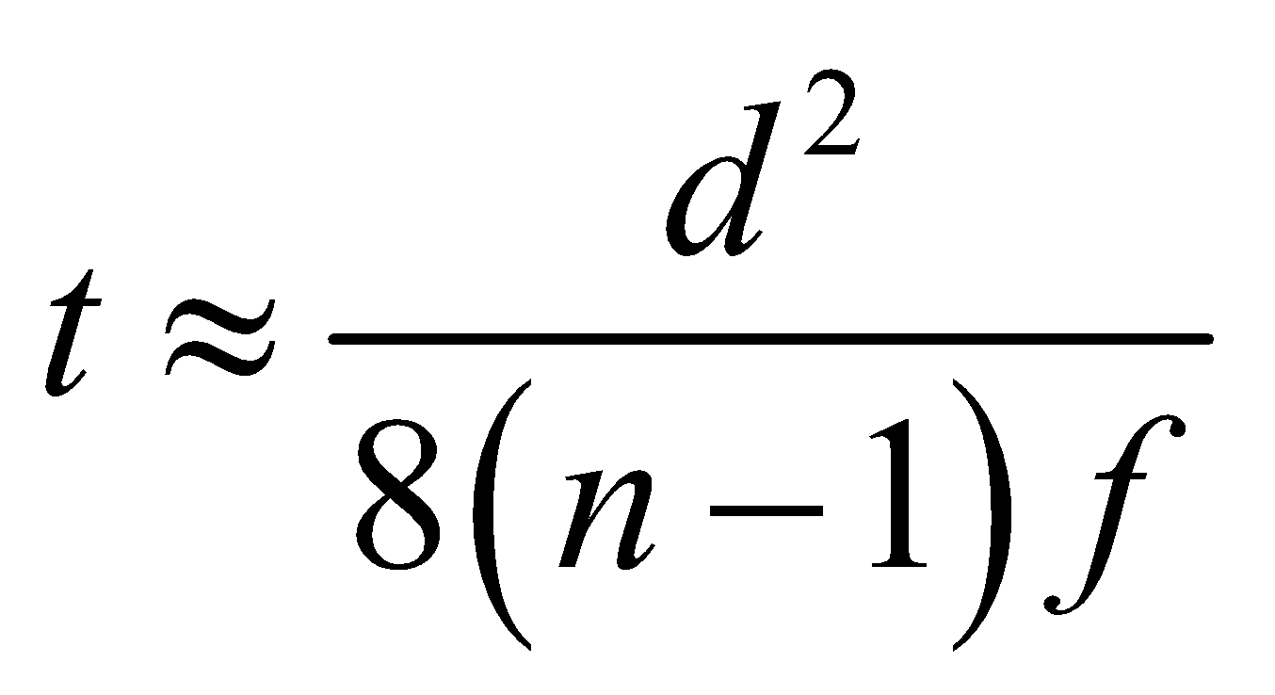

This tells us that if we have two lenses with the same diameter and of the same material, the thicker one will have the smaller focal length, since 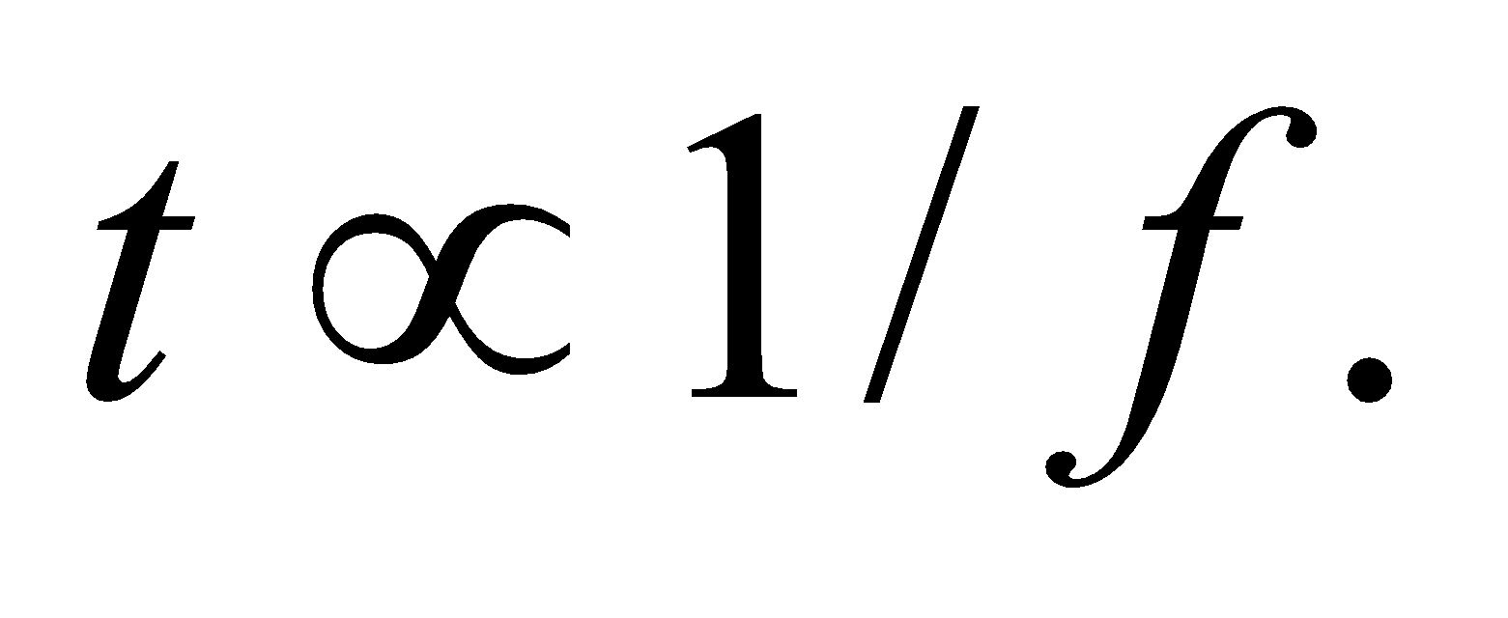

**75.** **Interpret** We are to show that objects placed equidistance on either side of the focal point of either a concave mirror or a converging lens produce equal-sized images.

**Develop** A concave mirror or a converging lens are both represented by positive focal lengths in the lens or mirror equations. For either, the object and image sizes are related by

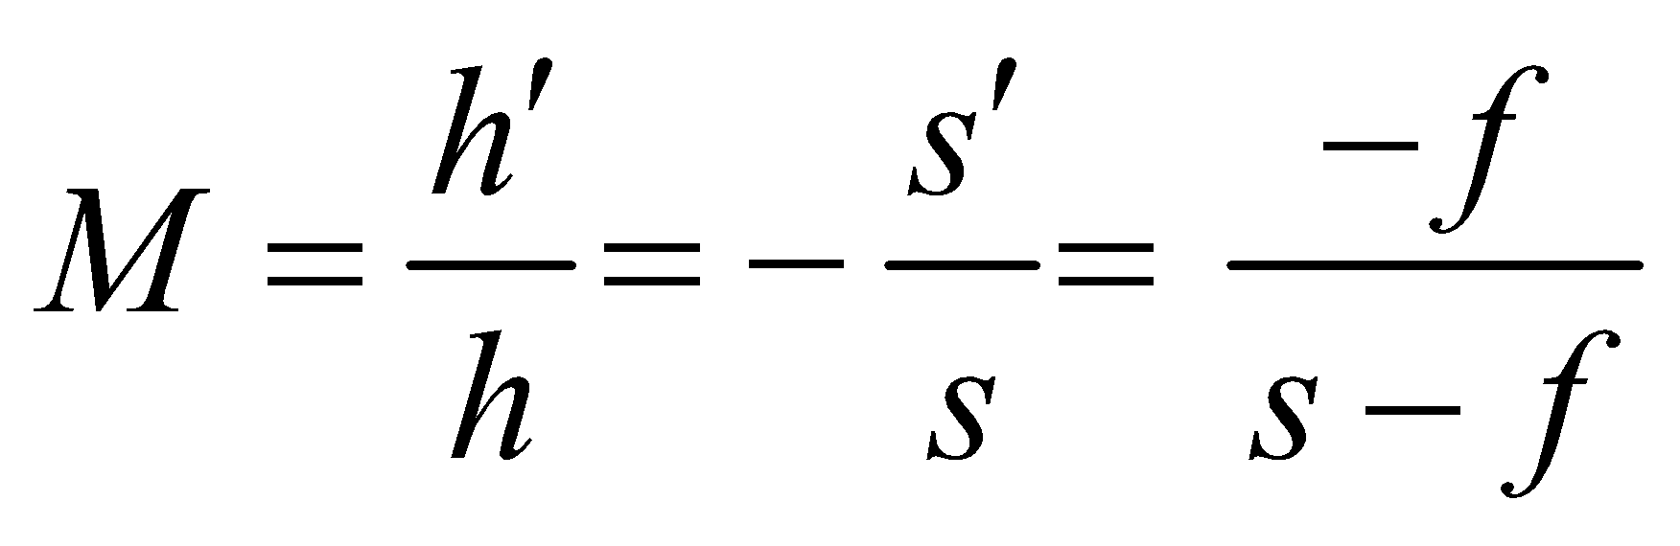

where we have used Equations 31.4 and 31.5. The size of the image is

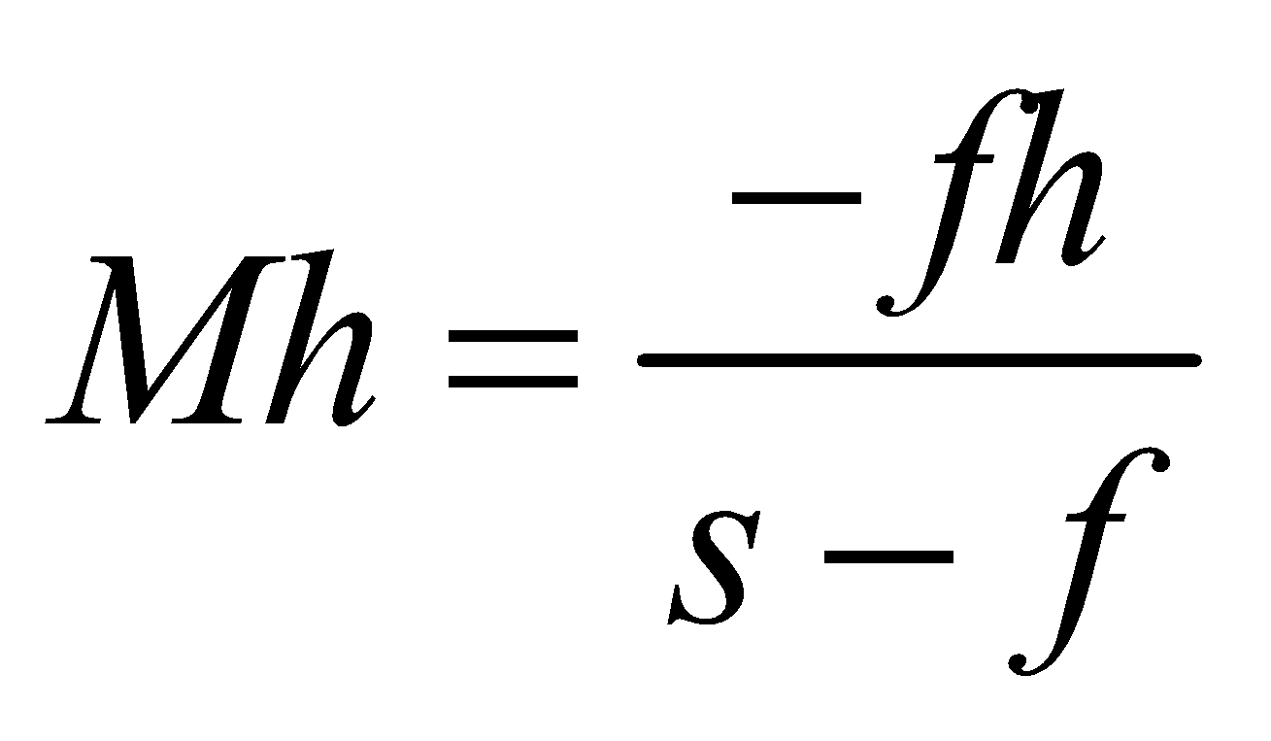

**Evaluate** The distance between the object and focal point is a constant, so 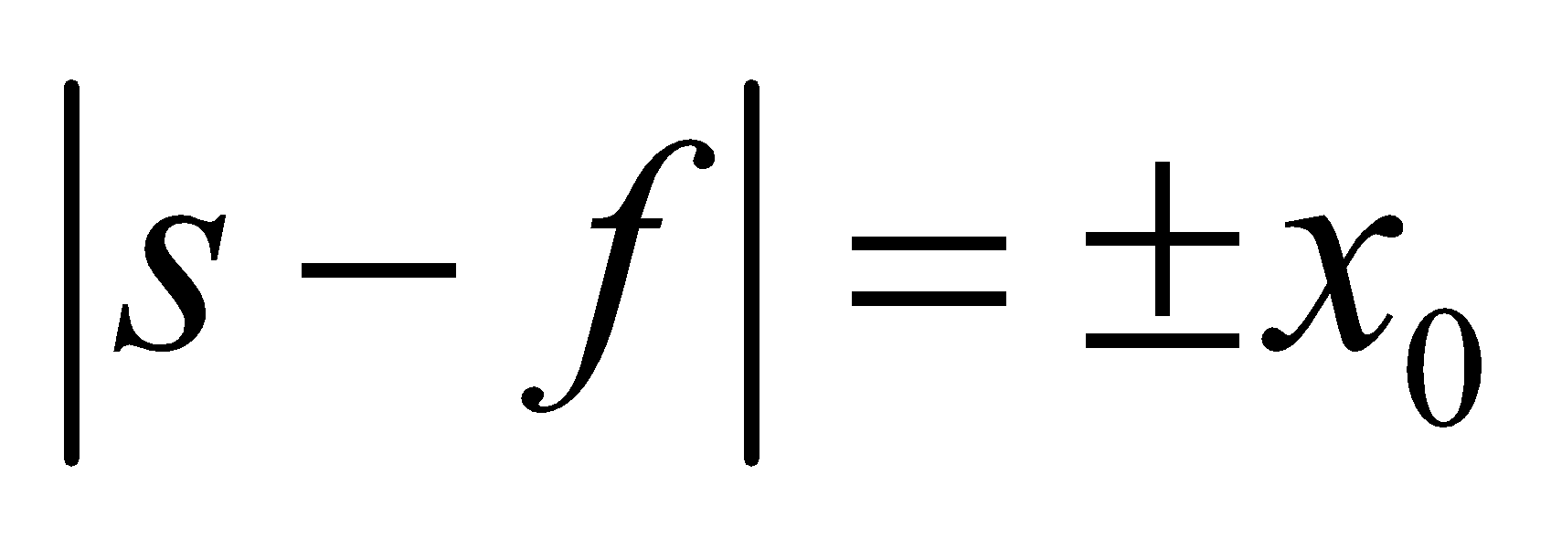. Thus, the two possible image heights are

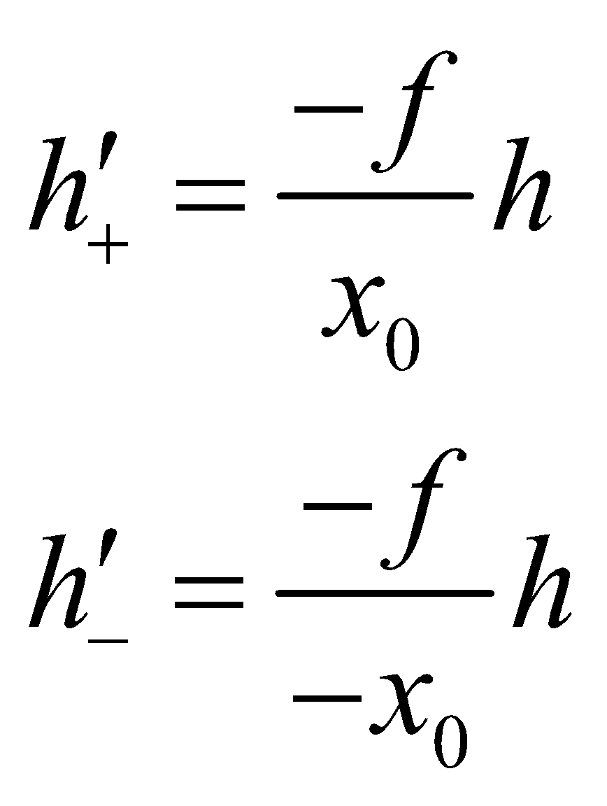

Because 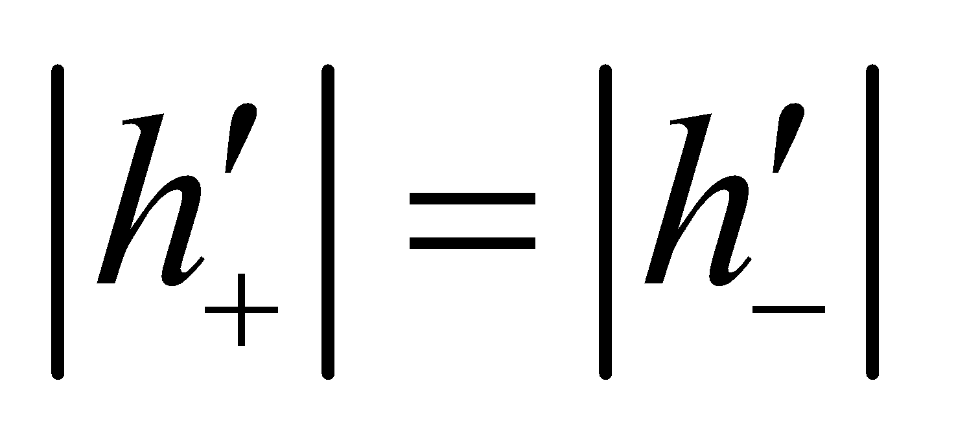, the image size is the same. The image types, however, are different. For 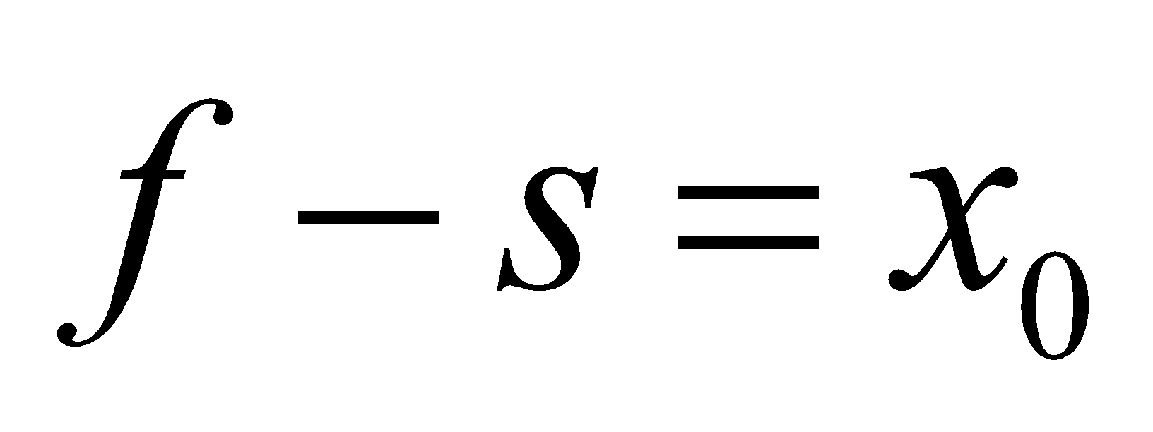, the magnification is negative so the image is a virtual, inverted image. For 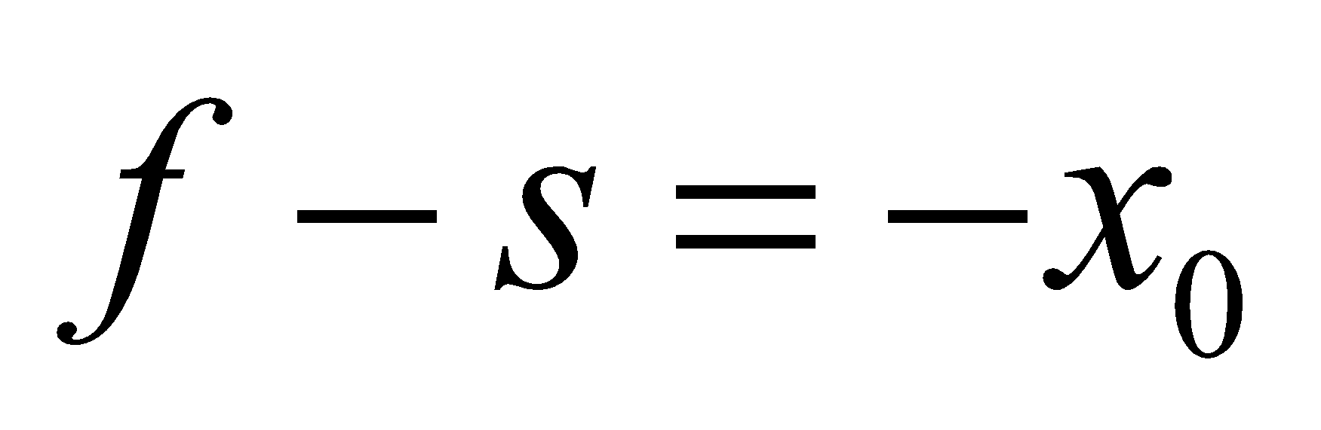, the image is real and upright.

**Assess** Note that the problem statement implies that the 2*f* > *s* > 0 (i.e., the distance from the object to the focal point is less than the focal length).

**76. Interpret** In this problem, we are asked to generalize the lens maker’s equation to the situation where the lens is immersed in an external medium with refractive index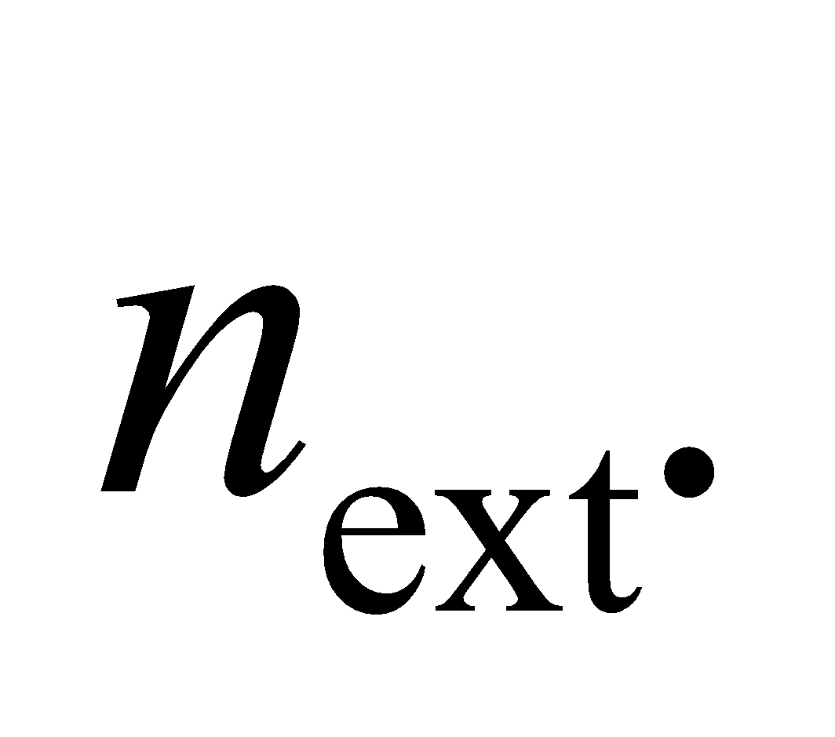

**Develop** Refraction at the two lens surfaces in Figure 31.24, when the surrounding medium has index of refraction *n*ext (instead of *n*1 = 1) is described by equations analogous to the two preceding Equation 31.6:

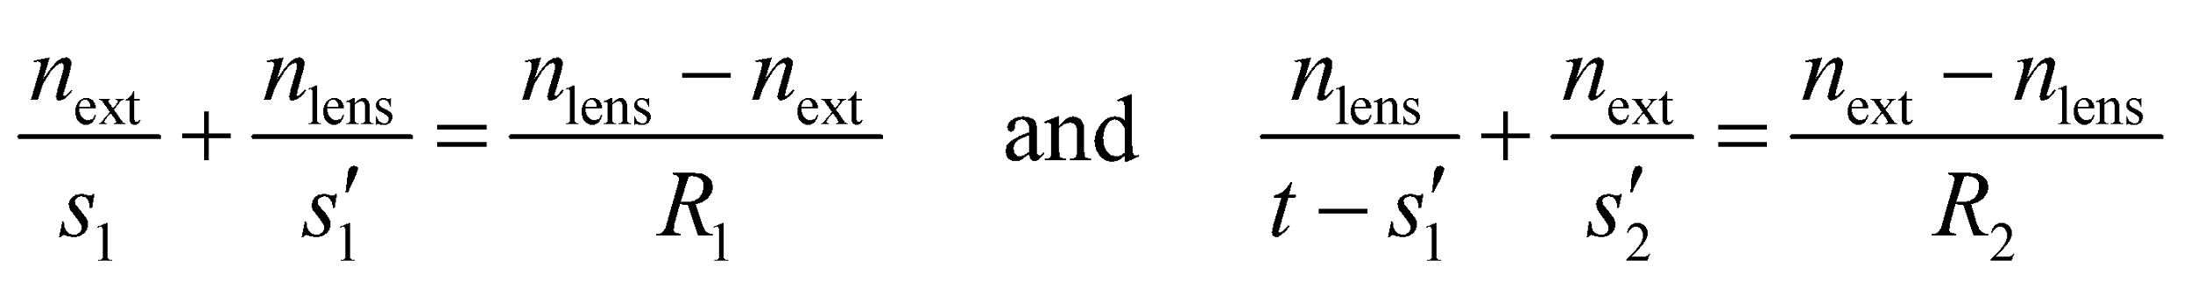

These are just Equation 31.6 applied to the left- and right-hand surfaces. We then take the limit 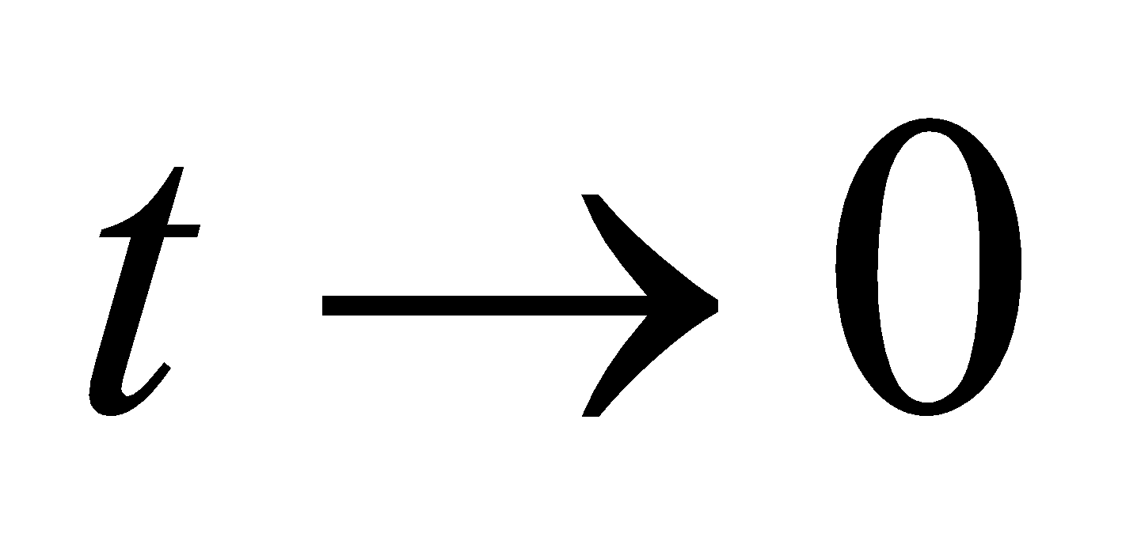 to get the desired result.

**Evaluate** For 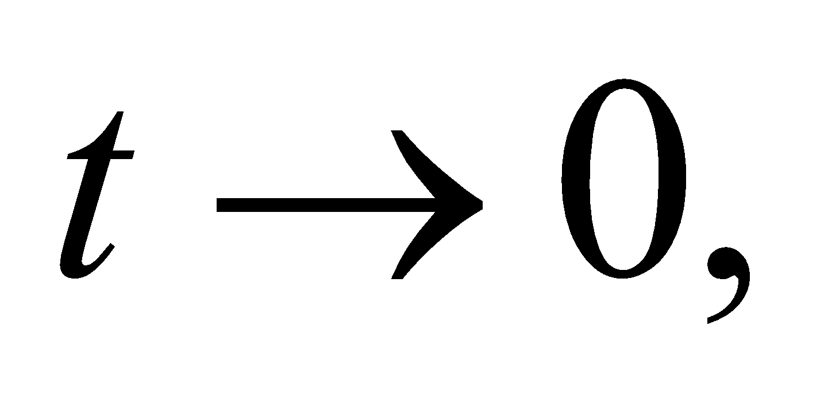 there is no distinction between distances measured from either surface, so adding the equations and dropping the subscripts 1 and 2, we find

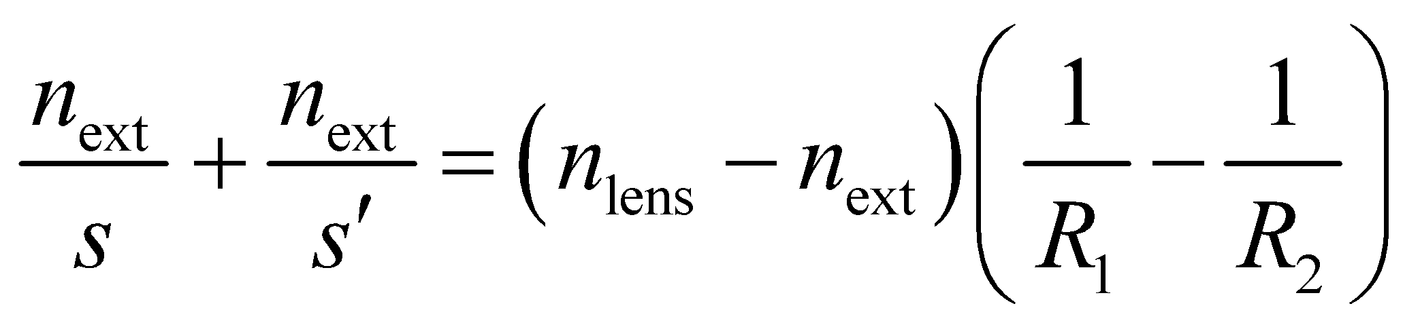

Division by *n*ext gives

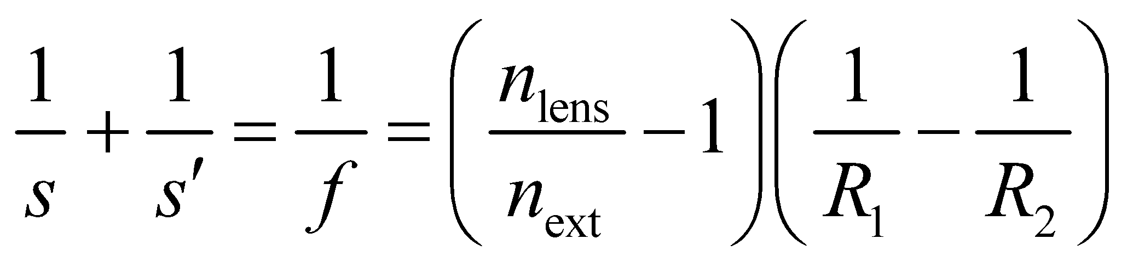

where we have used Equation 31.5. This is the desired generalization of Equation 31.7.

**Assess** The ratio 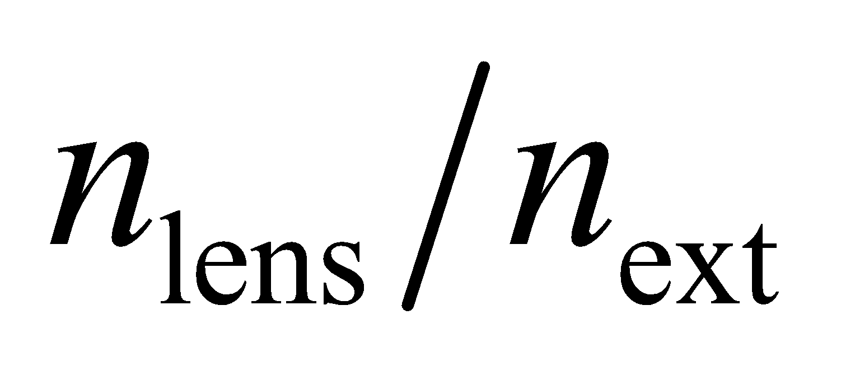 is the relative index of refraction. When 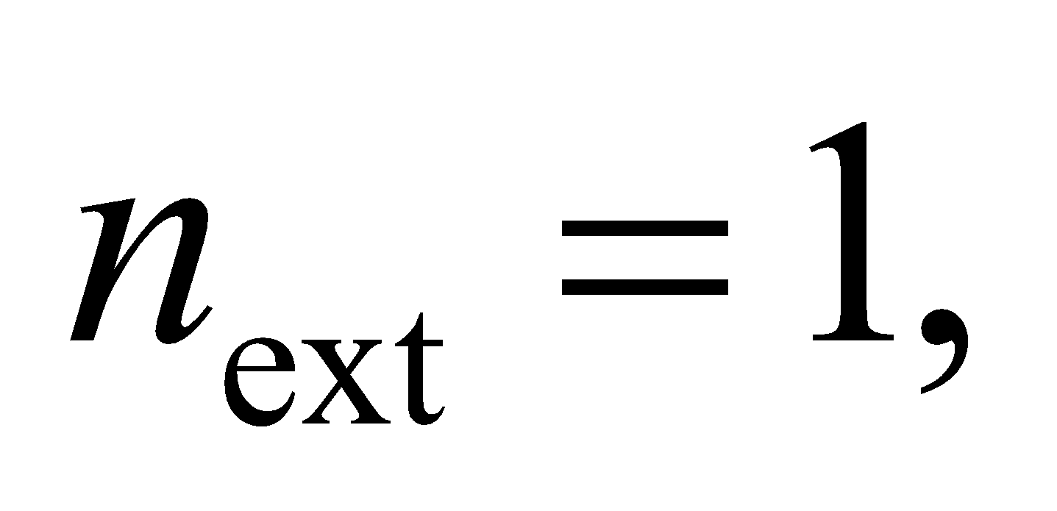 we recover the lens maker’s equation given in Equation 31.7.

**77. Interpret** We add one more diagram to Figure 31.10, but with a ray going from the arrowhead to the center of curvature. With the resulting similar triangles, we are to show that, for a curved mirror, the focal length is half the radius of curvature.

**Develop** Start with a diagram, as shown in the figure below. The shaded triangles are similar, so

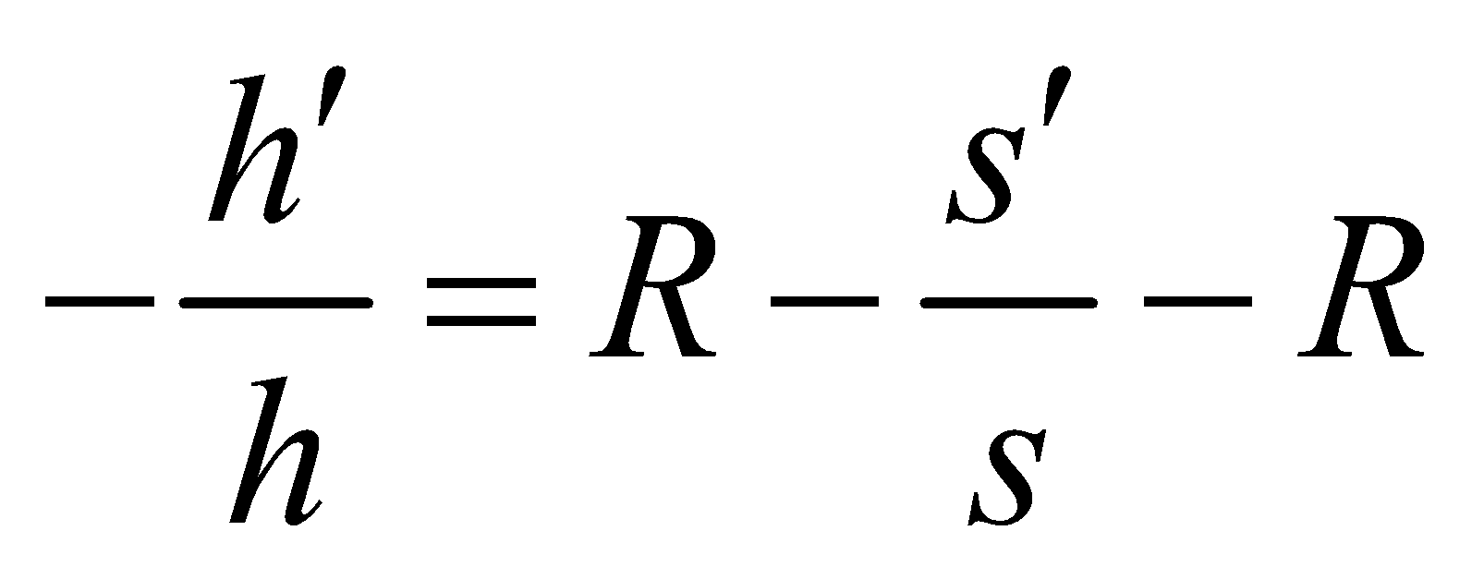

We will also use the results from Figure 31.10a, 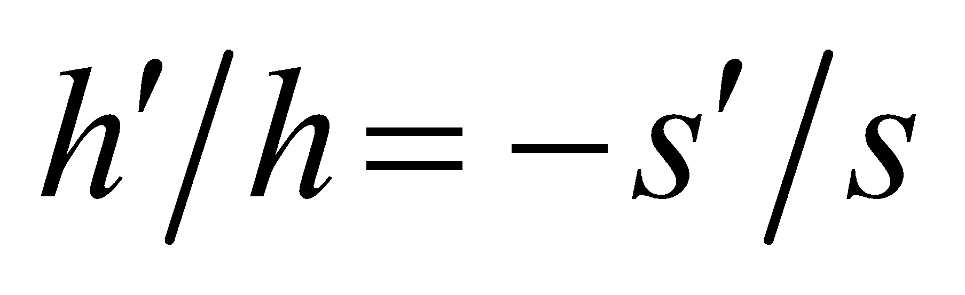 and the mirror equation (Equation 31.2)

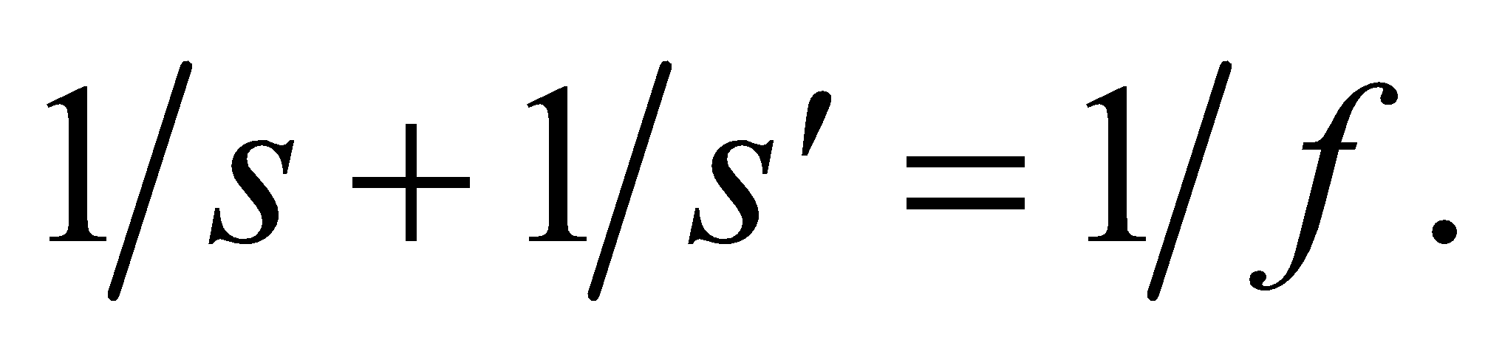 We will solve for *f* in terms of *R*.



**Evaluate** From 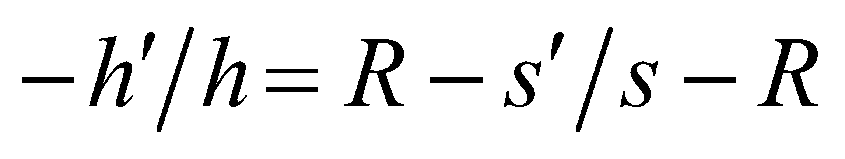 and 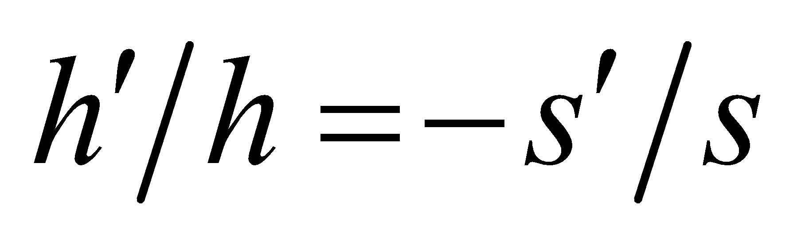 we obtain

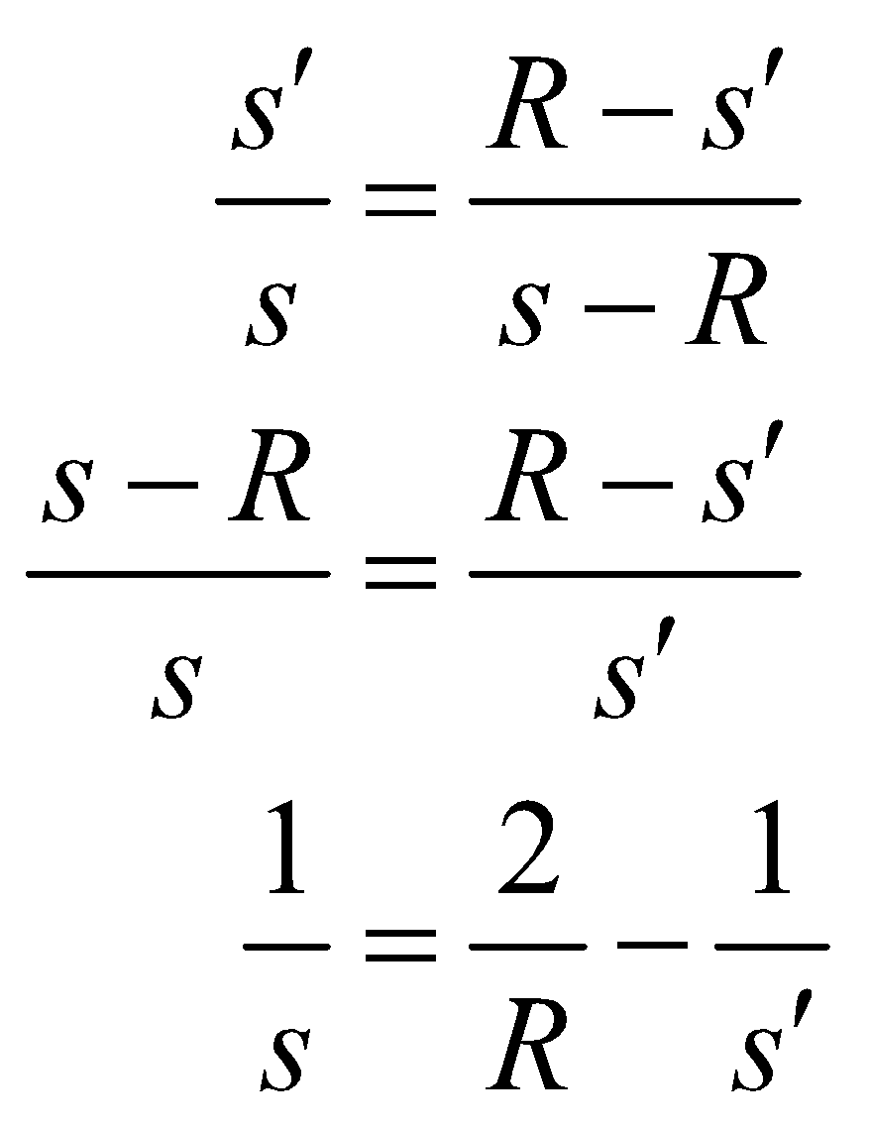

Substitute this into the mirror equation:

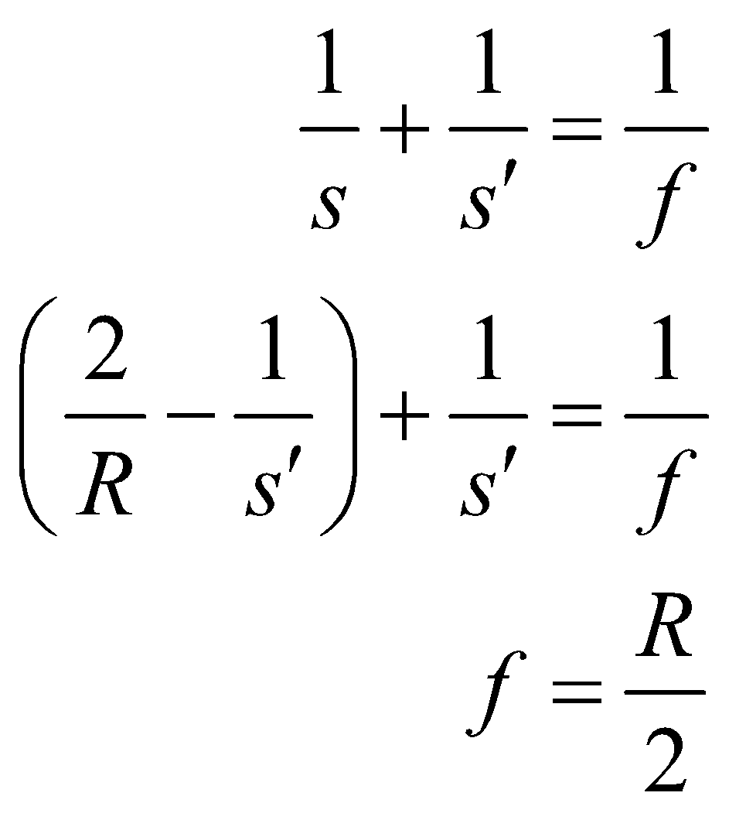

**Assess** We have proven what was required.

**78. Interpret** This problem is about Galileo’s telescope, which consists of a double-concave eyepiece and the usual double-convex objective lens. We are to use ray tracing to show that it produces an upright image.

**Develop** The usual configuration for a Galilean telescope has focal points of the objective and eyepiece coincident, producing a telescope tube of manageable length. The intermediate image *P*′ can be found from rays through the near focal point and the center of the objective. The former ray, which is parallel to the axis between the lenses, diverges away from the near focal point of the eyepiece, after passing through. A third ray, through the center of the eyepiece and the intermediate image *P*′, locates the final image *P*′′.

**Evaluate** The ray diagram is depicted below. The image is virtual and upright.

**Assess** Repeated use of the lens equation confirms this conclusion, and for objects at infinity, gives 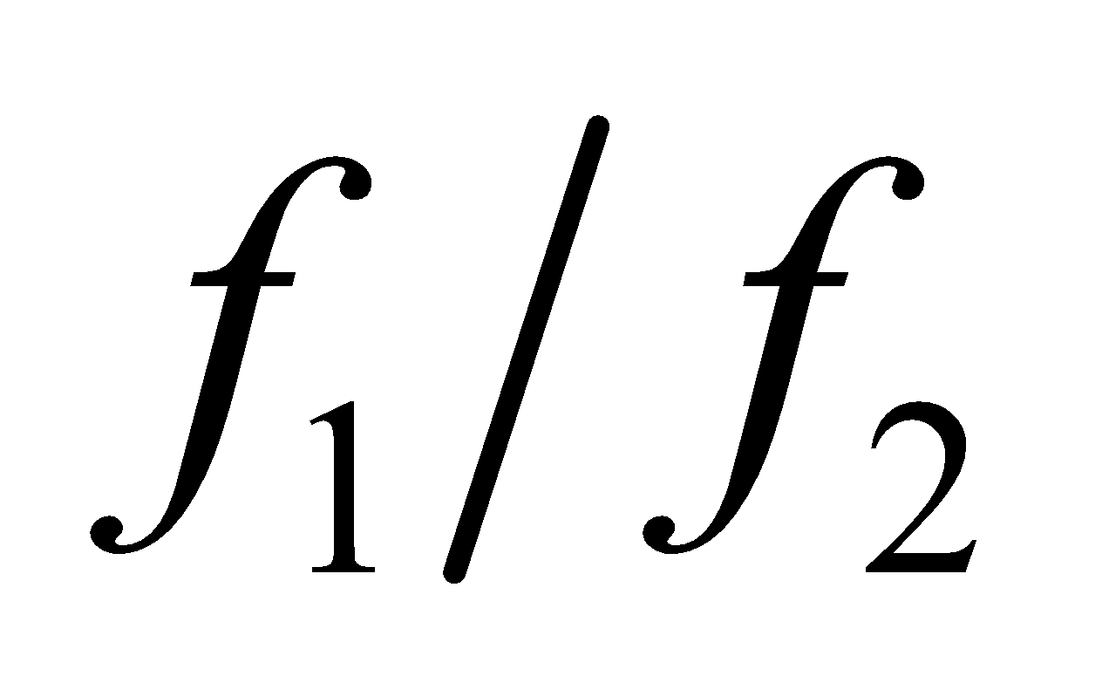 for the angular magnification. Disadvantages of the Galilean telescope are its limited field of view and inability to incorporate cross hairs.



**79. Interpret** We are to show analytically that the maximum angular magnification of a simple magnifier is as given in the problem statement. We will use the definition of linear magnification, and the lens equation.

**Develop** The angular magnification is defined by the ratio of the apparent size of the image to the apparent size of the object at the near point:

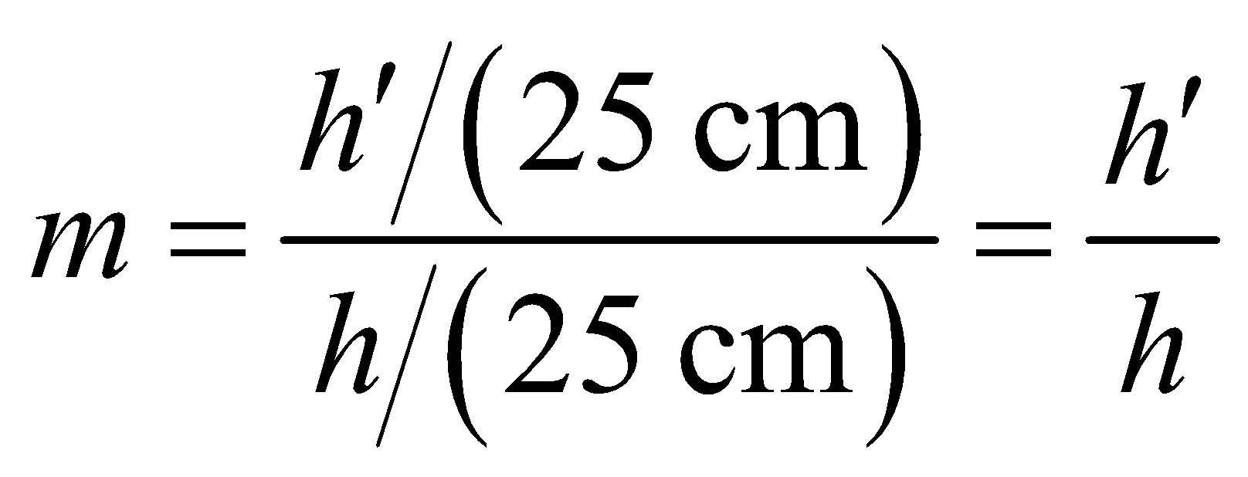

This is just the linear magnification (Equation 31.4), 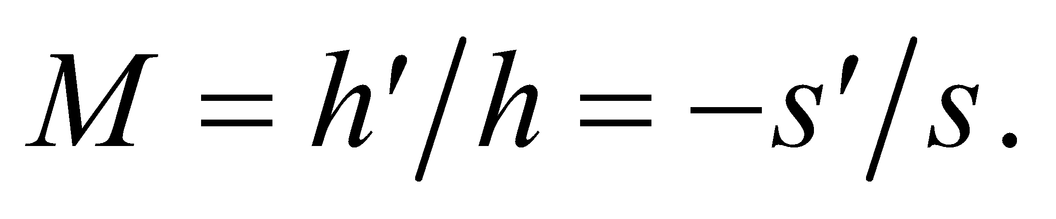 The image distance is s′ = 25 cm. We will solve the lens equation for *s*, and substitute the result into the equation for *m*.

**Evaluate**

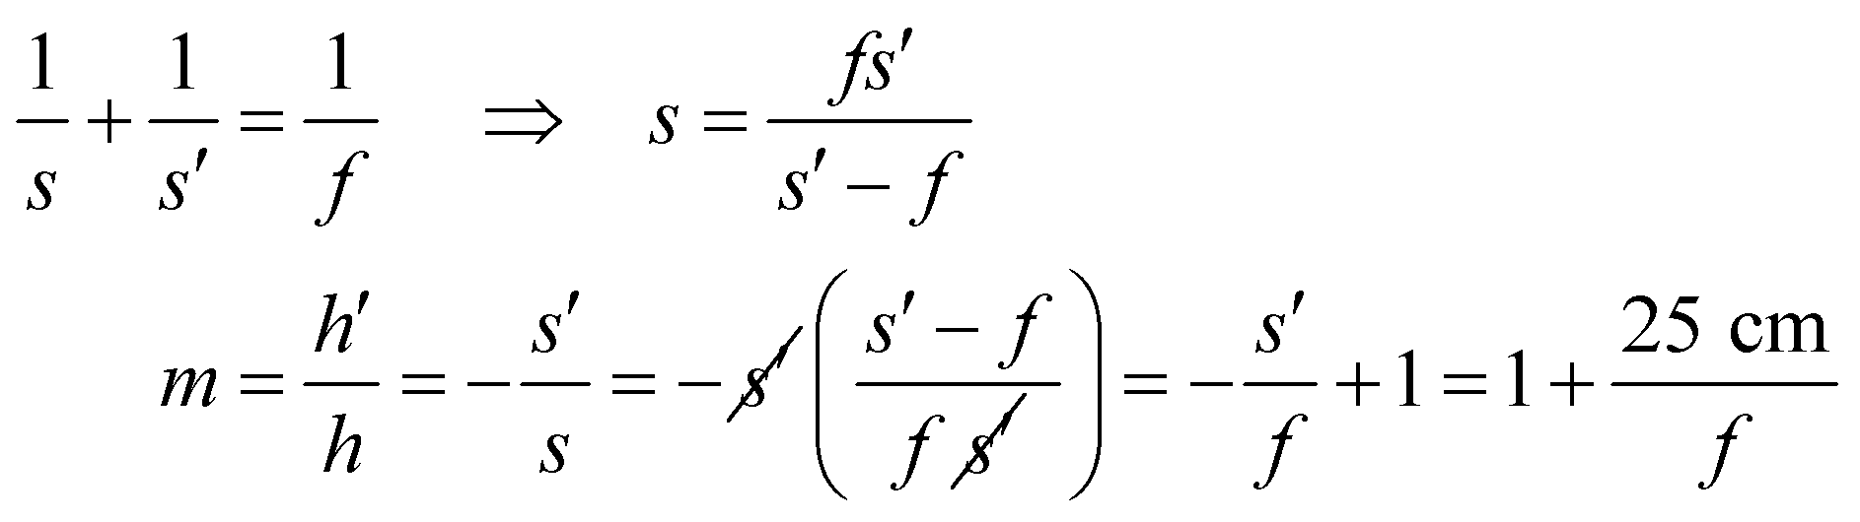

**Assess** We have shown what was required.

**80. Interpret** From the lensmaker’s formula, we are to find the fractional change in focal length as a function of the index of refraction. We will start with the lensmaker’s formula, and differentiate with respect to the index of refraction.

**Develop** The lensmaker’s formula is (Equation 31.7)

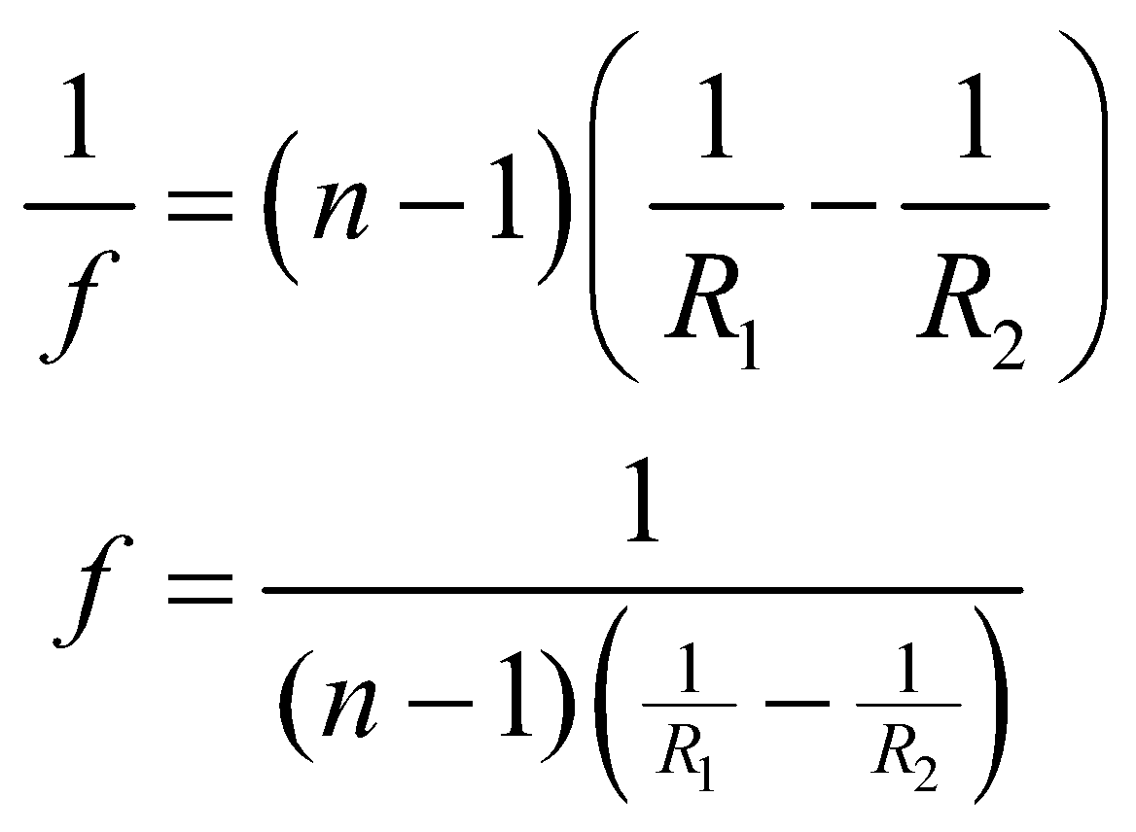

We want to find *df*/*f*.

**Evaluate** Differentiation with respect to the index of refraction gives

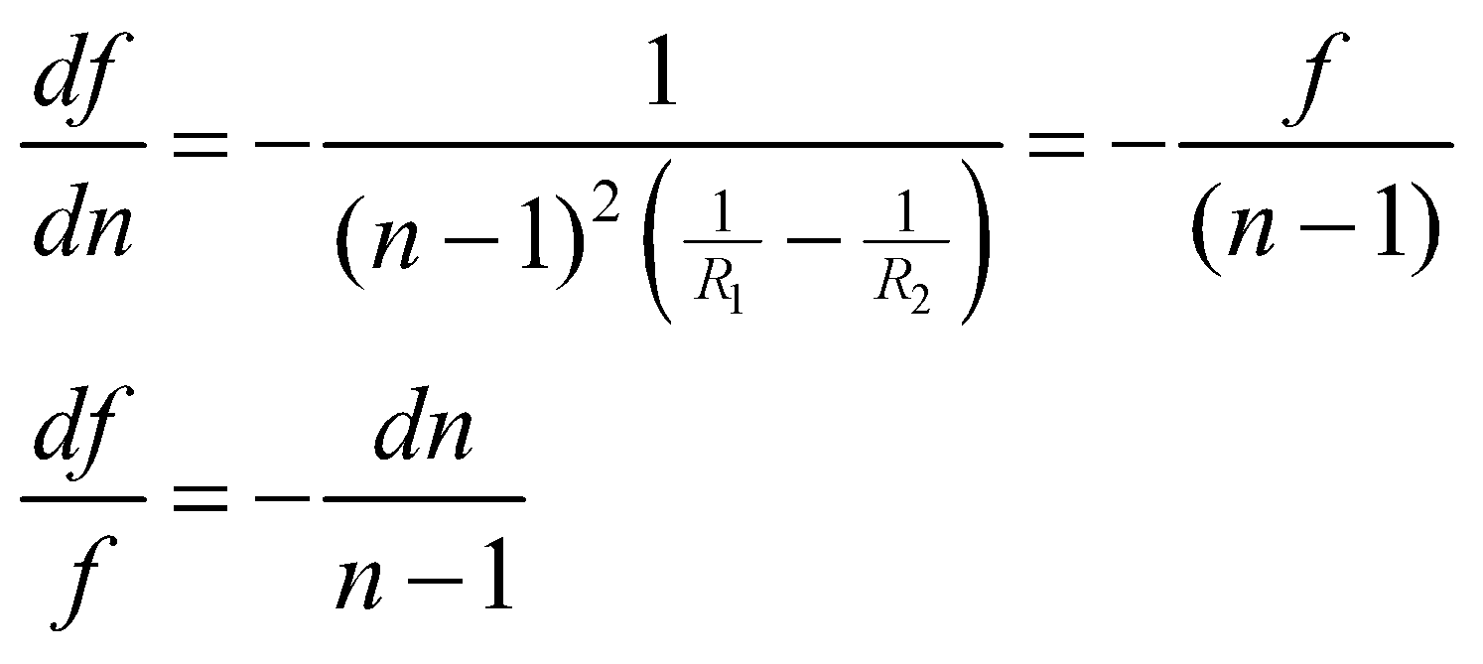

**Assess** This is the fractional change in focal length for any lens of a given material, independent of the focal length of the lens.

**81. Interpret** We will apply the result of Problem 31.80 to an actual lens, given the wavelength dependence of the index of refraction for the material, to find the variation in the focal length over a 10-nm range centered on the central wavelength of 550 nm.

**Develop** Our result from Problem 31.82 is 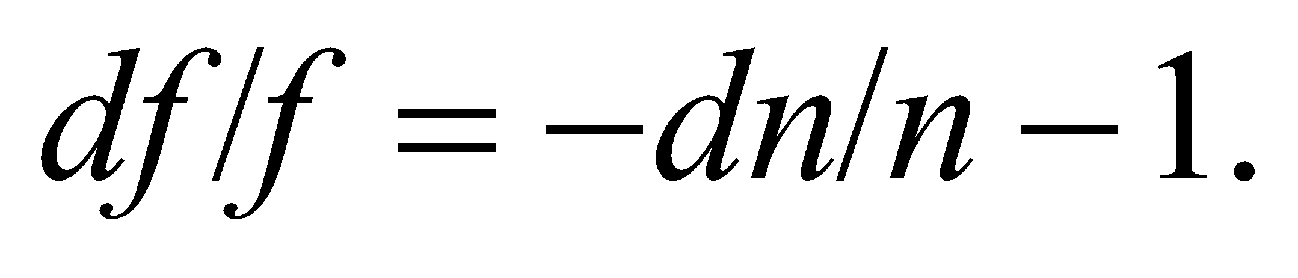 The focal length of the lens is f = 30 cm at *λ* = 550 nm, and the index of refraction is 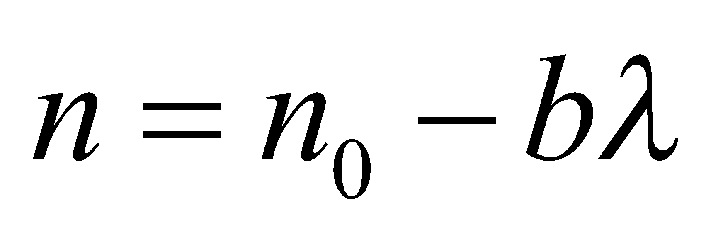 where 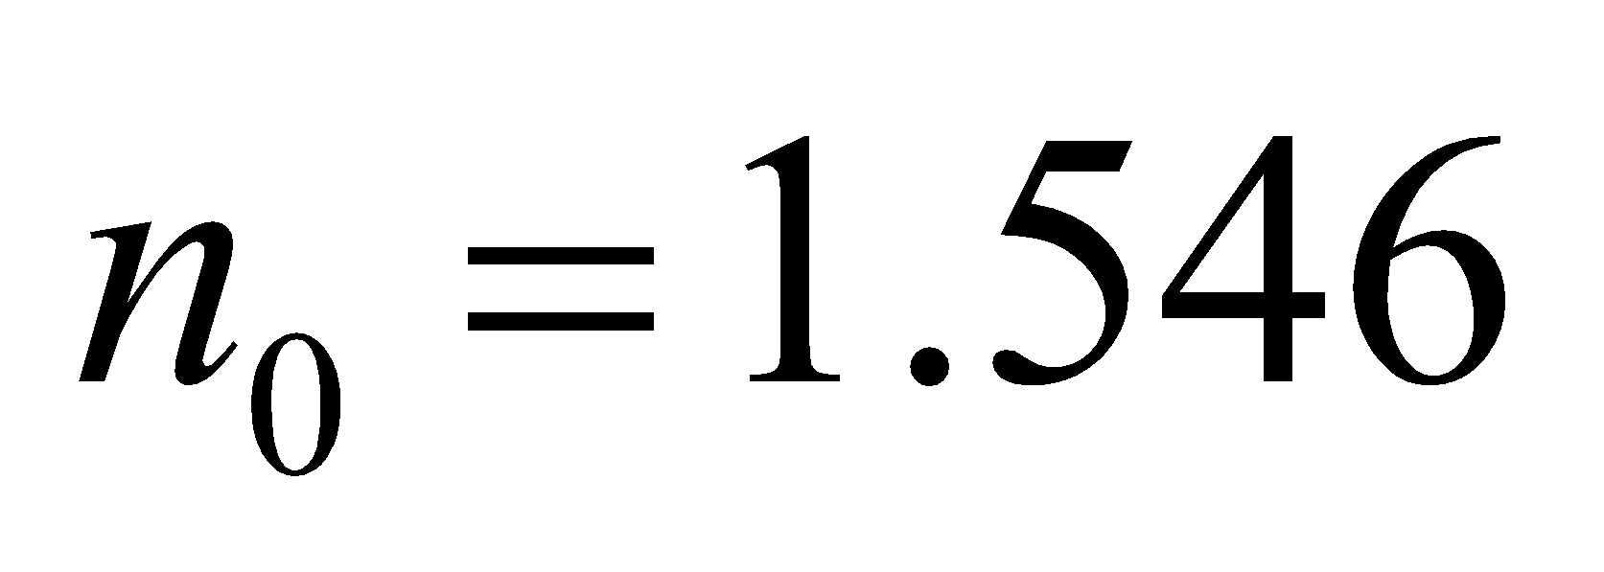 and 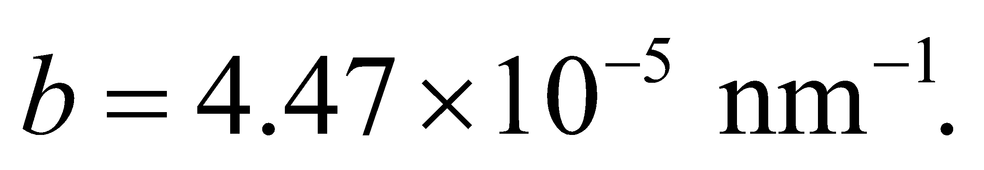 We want to find the total variation in focal length *df* over a 10-nm spread in wavelength centered on 550 nm.

**Evaluate**  so

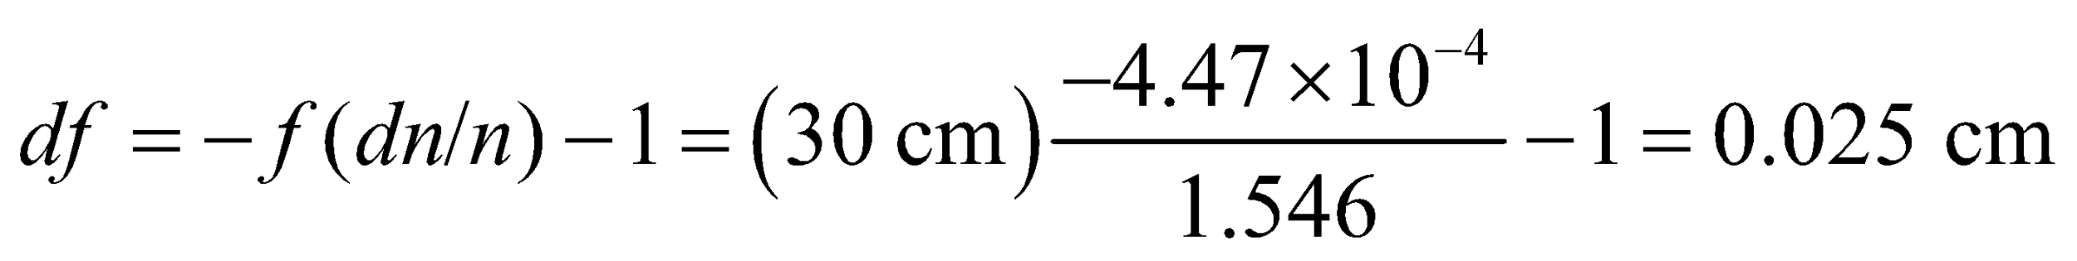

**Assess** This is a small variation, because of the very small change in wavelength. For full-spectrum visible-light applications, the spread of wavelengths is about 200 nm, and the magnitude of *df* can be significant.

**82.** **Interpret** We explore the meaning of a camera's f-ratio.

**Develop** The f-ratio is defined as the focal length divided by the aperture diameter. It is inversely proportional to the amount of light that a lens admits, since intensity is proportional to the aperture area divided by 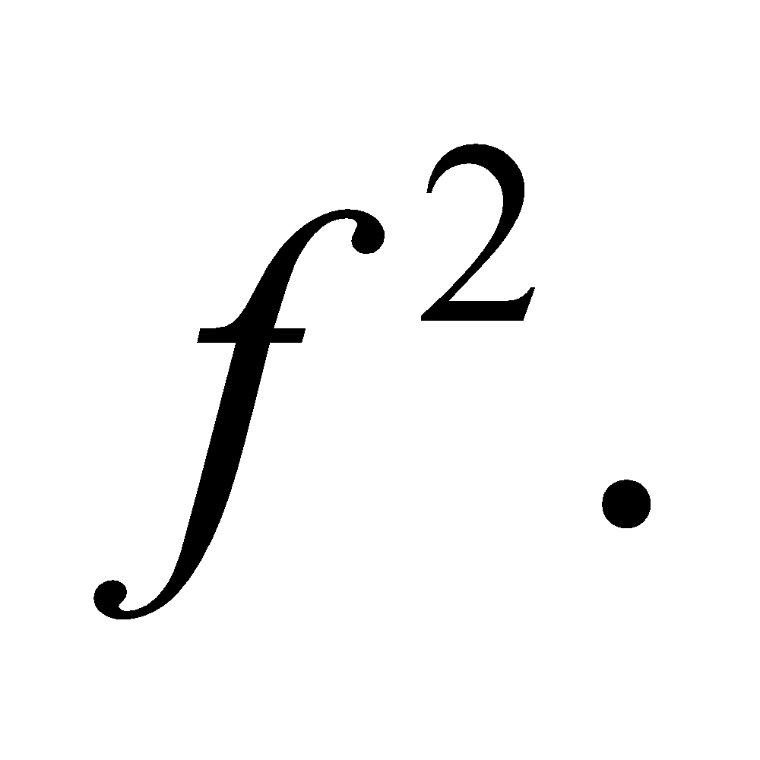

**Evaluate:** Increasing the focal length, while keeping the diameter fixed, will obviously increase the f-ratio. But it will also decrease the amount of light that the lens admits. This means the camera will be less able to work in dim light. The camera is thus in a slower speed setting.

The answer is (c).

**Assess** The term "speed" can be thought of as the length of time that the shutter will optimally be open. For a high f-ratio (low-speed setting), the shutter has to remain open a relatively long time to collect enough light for the image. Conversely, a lower f-ratio can work with a faster shutter speed.

**83.** **Interpret** We explore the meaning of a camera's f-ratio.

**Develop** The light admitted increases with the aperture area, but decreases with the square of the focal length. Therefore, the light admitted is inversely proportional to the square of the f-ratio.

**Evaluate:** The f-ratio in this case is doubling in size, so the light admitted must be decreasing by a factor of 4.

The answer is (b).

**Assess** Many cameras have f-ratio gradations that scale by factors of the square root of 2, as for example: *f*/1, *f*/1.4, *f*/2, *f*/2.8, *f*/4, *f*/5.6, *f*/8, *f*/11, *f*/16. Each step in this sequence corresponds to a decrease in the light admitted by a factor of 2. In other words, *f*/1 is twice as fast as *f*/1.4.

**84.** **Interpret** We explore the meaning of a camera's f-ratio.

**Develop** The only information that we have is that the diameters are different. We can infer nothing about the focal lengths, so answer (b) is out.

**Evaluate:** If the lenses had the same focal length, we could say that the larger lens was faster. But we don't know anything about the focal lengths, so the larger lens could be slower than the smaller lens if its focal length is large enough. As for spherical aberration, it can be reduced by making the focal length much larger than the diameter. But again, since we don't know the focal lengths, we can't say which lens has a larger focal length to diameter ratio. Therefore, none of these choices is correct.

The answer is (d).

**Assess** If the lenses had exactly the same shape, but one was just a larger version of the other, then the focal length would increase with the diameter: 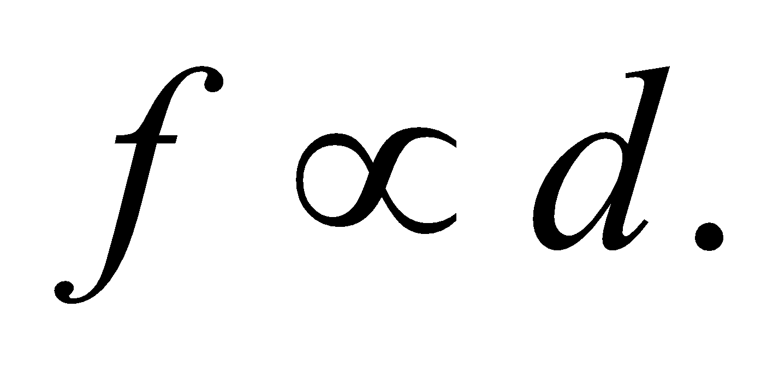 So the smaller lens would have the smaller focal length, but the two lenses would have the same speed and the same spherical aberration.

**85.** **Interpret** We explore the meaning of a camera's f-ratio.

**Develop** Stopping down means reducing the lens area by squeezing closed a camera's adjustable iris. This does not change the focal length.

**Evaluate:** The spherical aberration is due to the fact that the lens is not a parabola and therefore it does not focus all light rays to a single point. The problem is worst for light rays that enter at the edge of the lens, far from the center. Thus, blocking the outer edge of the lens will improve the focus, by eliminating the light rays with the most aberration.

The answer is (b).

**Assess** Stopping down taken to its extreme leads to a pinhole camera, which has superb focus without the need of a lens. The trouble is that the image is very faint.